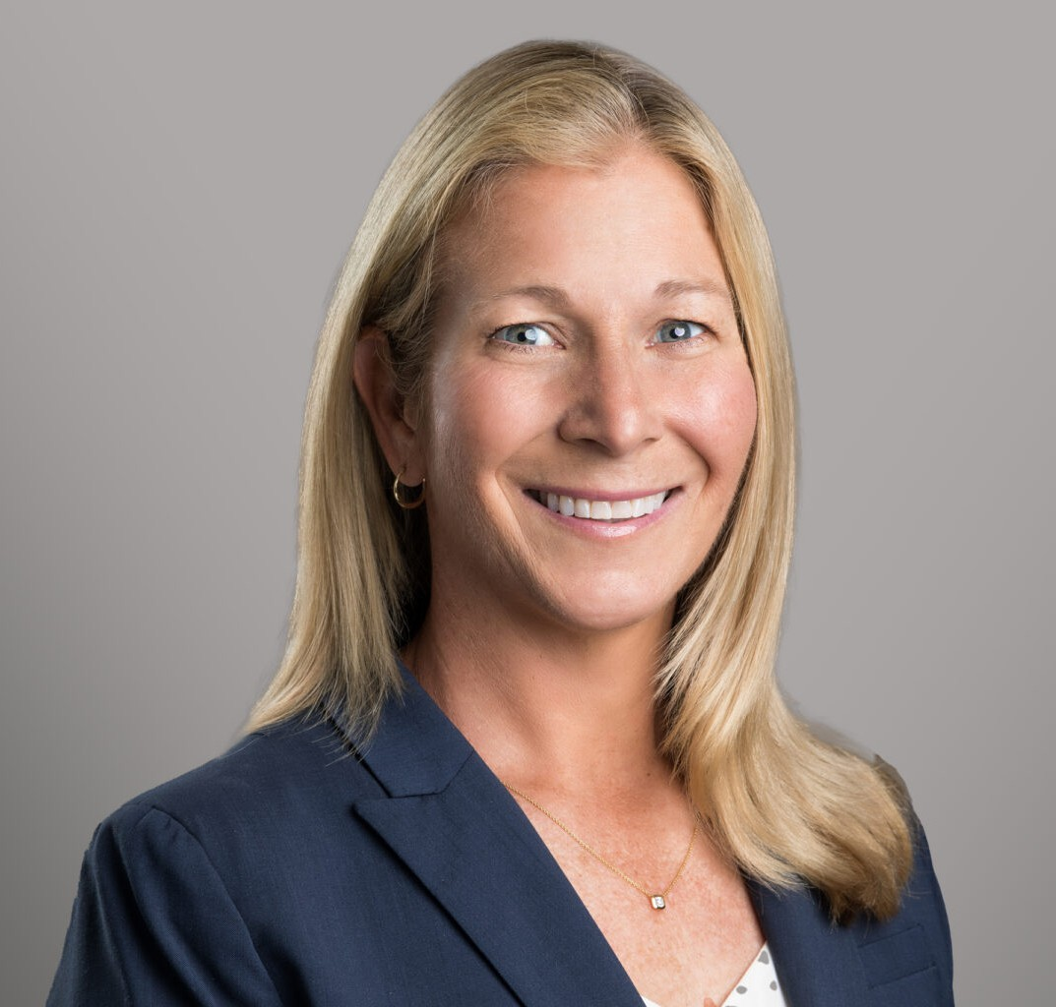

ALISON PULASKI CARTER

Of Counsel

[Employment & Labor](https://www.fennemorelaw.com/services/employment-and-labor-relations/)

[Phoenix](https://www.fennemorelaw.com/contact-us/phoenix/)

P: 602.916.5417

[apulaskicarter@fennemorelaw.com](mailto:apulaskicarter@fennemorelaw.com)

# ALISON PULASKI CARTER

Alison Pulaski Carter practices in the area of labor and employment. Licensed in both Arizona and California, she is an experienced litigator and trusted advisor to her clients. Alison counsels employers across a wide range of industries in both litigation matters and day-to-day issues.

Alison regularly represents employers before state and federal courts, as well as administrative agencies (including the Equal Employment Opportunity Commission, Arizona Civil Rights Division, and California Civil Rights Department). Her employment litigation experience includes claims involving wrongful termination, sexual harassment, and discrimination based on age, gender,

religion, race, and disability. She also handles cases related to disability accommodations, state and federal leave issues, wage and hour disputes, and restrictive covenants enforcement, including noncompete, non-solicitation, and confidentiality agreements. Her experience includes defending employers in multiple complex class-action matters, including national wage-and-hour cases, and actions initiated by the EEOC. By making use of Alternative Dispute Resolution (ADR) processes, including mediation and arbitration, Alison often helps her clients with alternatives to litigation by resolving disputes efficiently and cost-effectively.

Alison’s industry experience is broad and includes health care, education, courier, transportation and logistics, technology, construction, aviation, cannabis, financial services, and hospitality

industries, as well as state and municipal agencies.

In addition to litigation, Alison maintains a robust practice in employment investigations. She regularly conducts investigations and advises employers on highly sensitive matters ranging from Board-of-Director level inquiries to general workplace complaints. In matters involving governmental agencies, Alison handles investigations from inception through the mediation and conciliation process.

To minimize risk and ensure legal compliance, Alison regularly counsels employers on federal and state laws including the Fair Labors Standard Act, Title VII, Section 1981, Family Medical Leave

Act, Americans with Disabilities Act, Age Discrimination in Employment Act, Arizona Wage Act, Arizona Civil Rights Act, California Fair Employment and Housing Act, and a wide range of other California employment statutes. She also assists with drafting and implementing employee

handbooks, workplace policies, and employment agreements.

Beyond her employment practice, Alison has handled a variety of business litigation matters involving restrictive covenants, defamation, breach of contract, business torts, civil rights, professional malpractice, negligence, product liability, and post-judgment enforcement. She has also served as appellate counsel for local and national corporations in commercial litigation matters.

Following law school, Alison clerked for the Honorable Earl H. Carroll of the United States District Court, District of Arizona.

# EDUCATION

J.D., University of Arizona, James E. Rogers College of Law, *Perry Rogers Scholar*

Staff Writer, Arizona Law Review Dean’s Honor List

Ares Fellow, Professor Ellen M. Bublick

B.A., Yale University, *with honors*

Albert Bildner Prize, Latin American History

# AREAS OF PRACTICE

Employment & Labor Business Litigation

# REPRESENTATIVE MATTERS

Successful defense of a healthcare provider in mass action litigation brought by EEOC on behalf of 128 aggrieved individuals alleging violations of disability discrimination under the ADA.

Representation of eight executives in the negotiations of employment agreements in the context of a business acquisition.

Obtained grant of motion to dismiss state defamation (libel and slander) claims.

Successfully defended and prosecuted unfair competition, restrictive covenant (including employee non-compete cases), and trade secret litigation,

Obtained complete dismissal on summary judgment of six causes of action, which included gender discrimination, wrongful termination, retaliation, failure to prevent discrimination,

harassment, and retaliation, and intentional infliction of emotional distress, in the Northern District of California.

Achieved a defense verdict, including collection of attorney’s fees, in arbitration on five counts against individual and employer defendants in a California claim asserting sexual harassment, retaliation, and gender discrimination.

Obtained a complete victory for a leading parcel delivery client on claims of disability

discrimination, failure to accommodate, and failure to engage in the interactive process in California.

Successfully defended employers in class-action litigation, including a national wage and hour class action and EEOC-initiated class actions.

Achieved numerous “no cause” findings on charges filed with the Equal Employment Opportunity Commission, the Arizona Civil Rights Division, and the California Civil Rights Department (formerly DFEH).

# AWARDS AND HONORS

Southwest Rising Star, Super Lawyers, Business Litigation and Employment Litigation, 2012-2017

# ARTICLES AND PRESENTATIONS

Co-Author, “Mandatory Reassignment as an Accommodation,” Arizona Attorney Magazine, January 2024.

Co-Author, Chapter entitled “Recovery of Costs and Fees for Non-Lawyer Services,” Arizona Attorneys’ Fee Manual, 5th, 2010

# PROFESSIONAL AND COMMUNITY ACTIVITIES

Vice President, Board of Directors, Childsplay Theatre, 2018-Present Member, Executive Committee, Childsplay Theatre, 2009-Present Member, Alumni Board, Phoenix Country Day School, 2024-Present Panel Judge, Ninth Circuit Annual Civics Contest, 2018-Present

Chair Mock Interview Committee, Maricopa Bar Associate, Young Lawyers Division, 2009-2011 Member, Maricopa Bar Associate, Young Lawyers Division, 2008-2011

Arizona Bar Association California Bar Association American Bar Association Federal Bar Association

# ADMISSIONS

Arizona California

U.S. District Court, District of Arizona