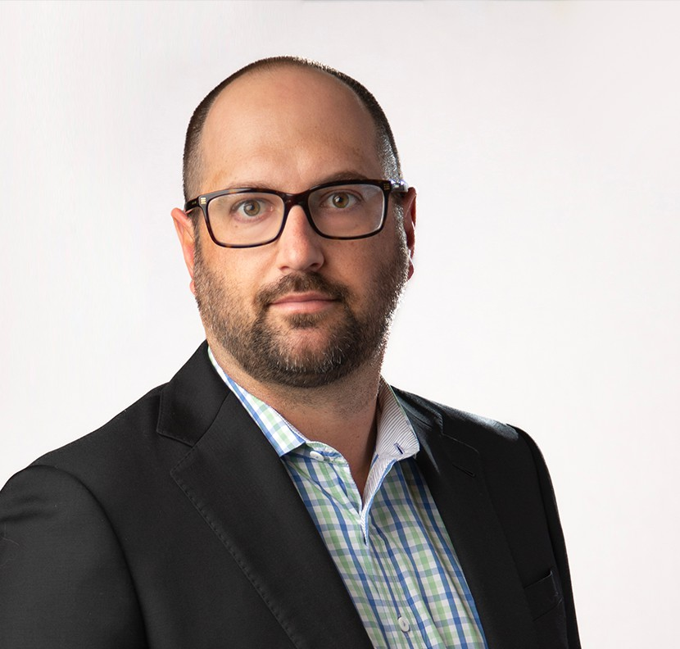

ANTON BORTOLUSSI

Of Counsel

[Business & Finance](https://www.fennemorelaw.com/services/business-and-finance/)

[Fresno](https://www.fennemorelaw.com/contact-us/fresno/)

P: 559.753.2806

F: 559.753.2806

[abortolussi@fennemorelaw.com](mailto:abortolussi@fennemorelaw.com)

# ANTON BORTOLUSSI

Anton Bortolussi is an Of Counsel in our Fresno office where his work centers on mergers and acquisitions, real estate and business transactions, estate planning, trust and estate administration law, and related tax matters.

Anton has a proven track record of advising, negotiating and closing transactions on behalf of both buyers and sellers across a wide variety of business transactions. In addition, Anton aids

new businesses with entity formation, and established businesses with restructuring,

management and maintenance, mergers and acquisitions and capital needs. Anton has represented clients in a variety of capital market transactions, including private offerings of securities, secured, convertible, and straight debt offerings, and the formation capital funds.

Anton also routinely advises clients on all aspects of real estate transactions, including the

acquisition, development, leasing, management and sale of commercial, multi-family, farm and agriculture industrial properties. Anton has extensive experience with respect to issues related to agriculture properties, and having grown up as a farmer’s son brings a unique understanding, experience and perspective in advising his ag clients. Anton’s experience also extends to guiding families through multi-generational estate and business planning, helping preserve their legacy precisely utilizing wills, living trusts, and powers of attorney while handling all aspects of the administration of trusts and probate estates. In addition, Anton assists clients and outside

CPA’s with estate tax issues, including the preparation of Estate Tax Returns (Form 706) and Gift Tax Returns (Form 709).

During his distinguished career, Anton also possesses experience working at a prominent workers’ compensation defense firm, representing an array of clients across the breadth of California’s

workers’ compensation law.

# EDUCATION

J.D., University of California, Davis, School of Law B.A., California State University, Fresno, *cum laude*

# AREAS OF PRACTICE

Business & Finance Estate Planning Trusts & Estates

Tax Law Agribusiness

Mergers & Acquisitions Real Estate

# AWARDS AND HONORS

*Northern California Super Lawyers® Rising Stars®,* 2025

# PROFESSIONAL AND COMMUNITY AFFILIATIONS

Member, California State Bar

Member, Fresno County Bar Association

Co-Chair, Trusts and Estates Section, Fresno County Bar Association Member, Kingsburg chapter of the Lions Club

Former Vice President, Board of Directors of the Kings River Golf and Country Club

# ADMISSIONS

California