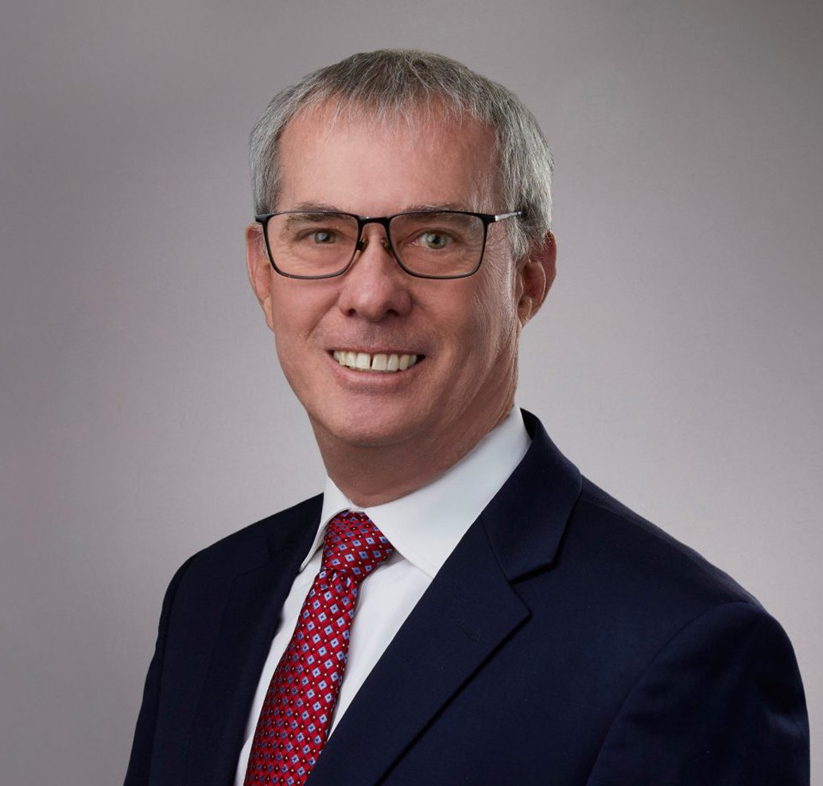

BRENT MCMANIGAL

Director

[Land Use](https://www.fennemorelaw.com/services/land-use/)

[San Bernardino](https://www.fennemorelaw.com/contact-us/san-bernardino/)

P: 909.723.1807

F: 909.890.9877

[bmcmanigal@fennemorelaw.com](mailto:bmcmanigal@fennemorelaw.com)

“

Society cannot exist without law. Law is the bond of society: that which makes it, that which preserves it and keeps it together. It is, in fact, the

essence of civil society.

- Joseph P. Bradley

”

# BRENT MCMANIGAL

Brent McManigal is a director in our San Bernardino office who counsels clients through the numerous local, state, and federal laws related to project management, permitting, and environmental compliance, including compliance with the California Environmental Quality Act (CEQA), Porter Cologne Act, and Endangered Species Act. He has experience in all aspects of commercial, industrial, residential, and waste management projects, including preliminary

market and business analysis, contract negotiations, permitting, and public relations.

Brent has also assisted both public agencies and private businesses with public bidding and compliance with prevailing wage and public works requirements. He is experienced in working with state and federal agencies including the California Alcoholic Beverage Control Board, the State Water Board, the Air Resources Board Department of Industrial Relations, and the Federal Environmental Protection Agency.

In the past, Brent spent time as a city planner, as well as a key manager with one of the nation’s leading waste management companies. While in the waste management industry, he was involved in mergers and acquisitions, permitting, construction, and the start-up of a waste-to- energy facility, in addition to leading operations across several states. Through this work, Brent worked closely with and obtained permits through not only the United States Environmental Protection Agency, but also numerous states across the country and throughout California.

Throughout his career, Brent has been involved in leading controversial and high-profile projects. With his extensive experience in local and regional planning, business management, regulatory

compliance, and construction management, he is uniquely suited to assist clients in all aspects of business and development activities to successfully bring their projects to completion.

# EDUCATION

J.D., University of La Verne, College of Law B.A., The Evergreen State College

# AREAS OF PRACTICE

Land Use

Government Relations & Regulatory Logistics

Mining Law Natural Resources Food & Beverage

# REPRESENTATIVE MATTERS

Liquor licensing of over 150 retail stores across California during the past six years. Focus on land use approvals, including compliance with the California Environmental Quality Act, for large shopping centers, public contracting, protests against public contracts, prevailing wage law and groundwater sustainability.

# ARTICLES AND PRESENTATIONS

Author, “[Understanding Force Majeure in Land Use](https://www.fennemorelaw.com/understanding-force-majeure-in-land-use/),” Fennemore Blog, June 6, 2024

Co-Author, “Superior Court Analyzes the Housing Accountability Act and a Vesting Tentative Tract Map,” California Land Use Law And Policy Reporter, April 2025

Author, “California Assembly Bill 52 – A Study in Frustration or a Legislative Success?”, California Land Use Reporter, November 2015

Author, “California Department of Water Resources Study Prepared by NASA shows Central Valley Land Dropping at a Faster Pace Due to Groundwater Pumping,” California Water Reporter, October 2015

Author, “One Billion Dollars in Emergency Funds for Drought Relief Approved by California Legislature and signed by Governor Brown,” California Water Reporter, May 2015

# PROFESSIONAL AND COMMUNITY ACTIVITIES

Member, State Bar of California Member, American Bar Association

# ADMISSIONS

California