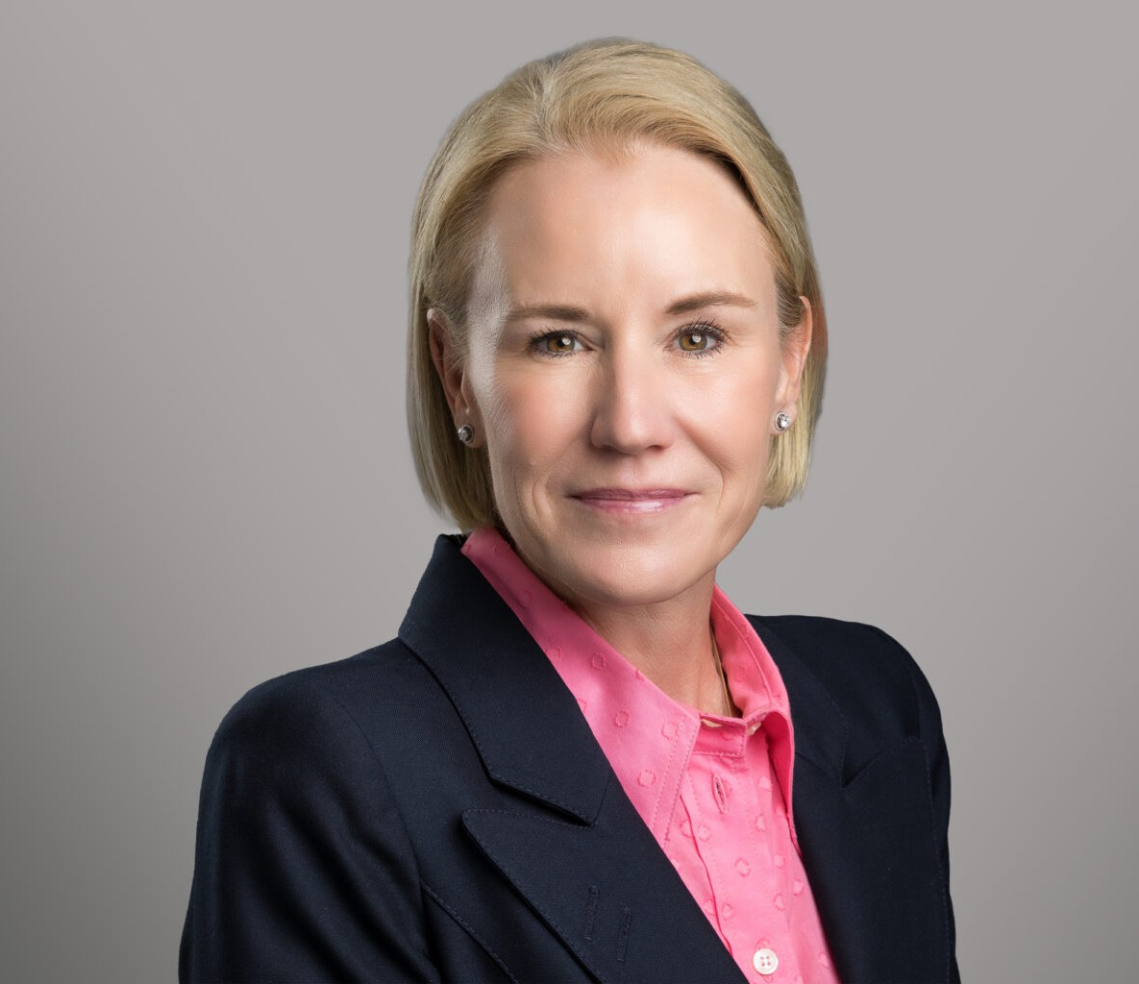

CHRISTINE BURNS

Director

[Employment & Labor](https://www.fennemorelaw.com/services/employment-and-labor-relations/)

[Phoenix](https://www.fennemorelaw.com/contact-us/phoenix/)

P: 602.916.5412

[cburns@fennemorelaw.com](mailto:cburns@fennemorelaw.com)

# CHRISTINE BURNS

Christine Burns is an attorney in Fennemore’s [Employment & Labor](https://www.fennemorelaw.com/services/employment-and-labor-relations/) practice group. She counsels and defends employers in every aspect of human resource law. Christine provides employers with day-to-day employment advice on matters involving sexual harassment, age, gender,

religion, race, and disability discrimination, wage and hour disputes, and federal and state leave issues. She prepares and implements policies and handbooks and regularly conducts employee training in all areas of employment law. Christine’s experience spans a wide range of industries, including health care, state and municipal agencies, education, transportation and logistics,

technology, financial services, and hospitality.

While Christine works closely with employers to provide advice and counseling that helps them comply with the law and avoid claims, when litigation occurs, Christine regularly represents employers before state and federal courts, as well as administrative agencies such as the EEOC and the ACRD. Christine loves both the big-picture strategy and the fine details behind litigating a case, and she particularly enjoys working with witnesses to prepare them for discovery and

trial. Her recent experience includes obtaining defense verdicts in single and multi-plaintiff jury trials involving claims under the Family and Medical Leave Act, the Americans with Disabilities

Act, Title VII, Section 1981, and the Age Discrimination in Employment Act. She has also litigated business litigation matters involving breach of contract, defamation, and restrictive covenants, and she has extensive state and federal appellate experience.

Christine’s knack for connecting with witnesses has evolved into a significant practice of conducting workplace investigations. She is often retained in executive-level or highly sensitive investigations, and has a reputation for conducting respectful, efficient, candid investigations with little disruption in the workplace. Christine’s balanced approach to counseling and

litigation, together with her depth of experience, make her a trusted partner for employers navigating high-stakes employment matters.

When she is away from work, Christine can be found on the sideline of a soccer match or on a cross-country course, cheering on her three children, all of whom are collegiate athletes.

# EDUCATION

J.D., University of Arizona James E. Rogers College of Law, *magna cum laude*

Order of the Coif

Research and Development Editor, Arizona Journal of International and Comparative Law

Recipient, American Jurisprudence Awards Award of Excellence in Clinical Practice

Assistant to Prof. Thomas A. Mauet, University of Arizona College of Law

B.A., Queen’s University, Ontario, Canada Major in Sociology

# AREAS OF PRACTICE

Employment & Labor Business Litigation

# REPRESENTATIVE MATTERS

Obtained complete dismissal on motion to dismiss federal due process claims under 42 U.S.C.

§ 1983. (U.S. District Court for the District of Arizona, October 2024)

Obtained complete affirmation of District Court’s award of summary judgment on the issue of standing and judicial estoppel. (Ninth Circuit Court of Appeals, February 2024)

Successfully defended a healthcare provider in litigation brought by EEOC on behalf of 128 aggrieved individuals alleging violations of disability discrimination under the ADA. (U.S. District Court for the District of Arizona, 2023)

Obtained dismissal of all claims against individual defendants on motion to dismiss 42 U.S.C.

§1983 claims. (U.S. District Court for the District of Arizona, March 2022)

Obtained summary judgment on claims pursuant to Title VII and 42 U.S.C. § 1981 for hostile work environment based on race and national origin. (U.S. District Court for the District of Arizona, 2022)

Achieved a complete victory in affirming the District Court’s denial of a preliminary injunction, which ultimately led to dismissal of the lawsuit with prejudice. (Ninth Circuit Court of Appeals, 2022)

Following an evidentiary hearing, obtained award of sanctions against plaintiff for spoliation and destruction of relevant electronically stored information. (U.S. District Court for the District of Arizona, 2022)

Obtained complete dismissal of all claims in an FMLA and gender discrimination claim. (U.S. District Court for the District of Arizona, 2022).

Obtained complete dismissal on motion to dismiss claims under the Arizona Constitution (due process) and Peace of Officers Bill of Rights, and defamation. (Arizona Superior Court,

Maricopa County, April 2021)

Obtained complete dismissal on summary judgment of claims of age discrimination under the ADEA and state law. (U.S. District Court for the Northern District of Iowa, 2021)

Successfully dismissed claims under the Arizona Medical Marijuana Act (AMMA) and the

Arizona Employment Protection Act on summary judgment, establishing – for the first time in Arizona – the standard by which employers can determine impairment and that there is no private right of action under the AMMA. (Arizona Superior Court, Maricopa County, 2020; aff’d Ariz. Ct. App., 2022)

Following an evidentiary hearing, obtained award of sanctions against plaintiffs for spoliation of social media, including complete dismissal of race discrimination claims. (U.S. District Court for the District of Arizona, 2020)

Obtained summary judgment on claims for Title VII sex harassment and retaliation. (U.S. District Court for the District of Arizona, 2020)

Obtained complete dismissal on summary judgment of claims of age discrimination under the ADEA and state law. (U.S. District Court for the District of Idaho, 2020)

Obtained a complete defense verdict in claims brought by the EEOC for disability discrimination and retaliation. (U.S. District Court for the District of Arizona, 2018)

Successfully dismissed a five-count complaint on ERISA preemption grounds. (U.S. District Court for the District of Arizona, 2017)

Obtained a complete defense award (arbitration) and collecting attorney fees on five counts against three defendants in a California claim asserting sexual harassment, retaliation, and gender discrimination. (JAMS Arbitration, 2016)

Obtained a complete defense verdict in an FMLA interference lawsuit. (U.S. District Court for the District of Arizona, 2013); successfully defending verdict on appeal (Ninth Circuit Court of Appeals, 2016)

Obtained a complete defense verdict and award of costs in an ADA disability discrimination and retaliation lawsuit. (U.S. District Court for the District of Arizona. (2013); successfully defending verdict on appeal (Ninth Circuit Court of Appeals, 2015)

Obtained a defense verdict and collecting costs from the plaintiff in an ADA disability and failure to accommodate lawsuit, with Arizona Civil Rights Act claims. (U.S. District Court for the District of Arizona, 2015); successfully defending verdict on appeal (Ninth Circuit Court of

Appeals, 2016)

Obtained a defense verdict in a multi-plaintiff race discrimination case brought under Title VII and Section 1981. (U.S. District Court for the District of New Mexico, 2012)

Defeated conditional certification in Rule 23 Class and FLSA §216 collective action, resulting in dismissal of litigation. (U.S. District Court for the District of Arizona, 2013

# AWARDS AND HONORS

Southwest Super Lawyers®, Labor & Employment Litigation, 2015-present Martindale-Hubbell, AV Preeminent Peer Review Rating

# ARTICLES AND PRESENTATIONS

Presenter, Workplace Investigations, Public Practice Legal Seminar and HR Summit, April 2025 Presenter, Political Science 294: Careers in Law, Arizona State University, March 2025

Moderator, Fireside Chat with Arizona Supreme Court Justices Kathryn Hackett King and Maria Elena Cruz, NAMWOLF, February 2025

Presenter, Developments under the PWFA, Arizona SHRM Legislative Conference, February 2025

Presenter, State Bar of Arizona Course on Professionalism, State Bar of Arizona, December 2024 (have presented at this course annually for approx. 10 years)

Presenter, Access to Justice – Employment & Labor Law Considerations, State Bar of Arizona Employment & Labor Law, June 2024

Presenter, Employment Law Nuts & Bolts, Brophy College Preparatory, November 2023, March 2024

Presenter, Cultivating HR Excellence, 10 Qualities that Make HR Superstars in the Eyes of Outside Counsel, Arizona SHRM Employment Law & Legislative Conference, February 2024

Presenter, Labor and Employment Law: Hot Topics Past, Present, and Future, Arizona Association of Defense Counsel, October 2023

Presenter, Social Media in Litigation: Do’s, Don’ts and Distractions, Arizona Supreme Court Judicial Conference, June 2023

Presenter, Legal Issues Regarding Service Animals, U.S. District Court for the District of Arizona Annual Conference, May 2023

Presenter, Social Media Discovery, Need-to-Know Basics, U.S. District Court for the District of Arizona Annual Conference Annual Conference, August 2022

Presenter, The Kumbaya Moments Envisioned by the Federal Rules and the Mandatory Initial Discovery Pilot Project, U.S. District Court for the District of Arizona Annual Conference, August 2018

# PROFESSIONAL AND COMMUNITY ACTIVITIES

Board of Trustees, Brophy College Preparatory, 2021-present

Federal Civil Rules Committee, U.S. District Court for the District of Arizona, 2018-present Board Member, Federal Bar Association, Phoenix Chapter, 2023-present

Board of Visitors, University of Arizona James E. Rogers College of Law, 2010-present Co-Chair, Ninth Circuit Judicial Conference, 2020-2022

Ninth Circuit Lawyer Representative Coordinating Committee, 2020-2022 Lawyer Representative, Ninth Circuit Judicial Conference, 2017-2022 Board of Regents, Brophy College Preparatory, 2020-2021

Board of Trustees, All Saints’ Episcopal Day School, 2015-2022 Board of Directors, Phoenix Rising Youth Soccer Club, 2011-2020

Chair and Panel Judge, Ninth Circuit Annual Civics Contest, 2018-present

Co-Chair, Annual Leadership Conference, National Association of Minority & Women Owned Law Firms, 2025

Arizona Bar Association | American Bar Association | Federal Bar Association

# ADMISSIONS

Arizona

U.S. Supreme Court

U.S. Court of Appeals, Ninth Circuit

U.S. Court of Appeals, Fourth Circuit

U.S. District Court, District of Arizona