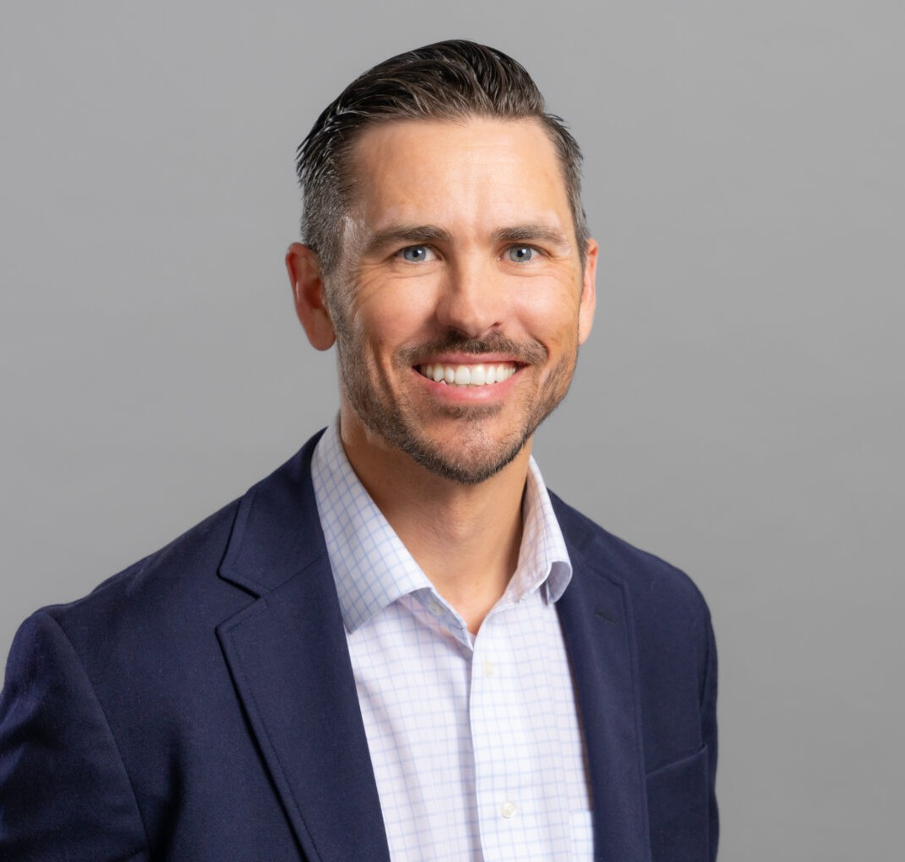

DAVID

LEWANDOWSKI

Director

[Business & Finance](https://www.fennemorelaw.com/services/business-and-finance/)

[Reno](https://www.fennemorelaw.com/contact-us/reno/)

P: 775.788.2235

F: 775.788.2261

[dlewandowski@fennemorelaw.com](mailto:dlewandowski@fennemorelaw.com)

“

People don't buy what you do; they buy why you do it.

Simon Sinek

**DAVID LEWANDOWSKI**

”

David Lewandowski is a Director in our Reno office who works in the firm’s business and finance practice group where he brings an entrepreneurial spirit to a variety of corporate matters, including debt and equity financing issues for emerging businesses, transactional and capital financing counsel, complex buying and selling strategies, as well as mergers and acquisitions

tactics. He works with publicly-traded companies and privately held entities on issues such as governance and contract matters, and he’s also passionate about helping advise budding entrepreneurs and start-ups in Reno’s vibrant Tech Hub on business law issues that arise during the formation and operational phases of a business.

Known for solving the problem, and getting the deal done, David takes great pride in providing effective, honest and transparent counsel to his clients. He has a track record of understanding deals and risks, and knowing exactly what business owners and entrepreneurs are actually

signing, so he can help them avoid the common pitfalls that they often face. Before joining Fennemore, David worked for a technology-based business accelerator/incubator.

David gives back to the community serving as a Big Brother in the Big Brother Big Sister program since 2011. David also serves as an adjunct professor teaching a business law course each semester to 50+ students at the University of Nevada. He also frequently volunteers his time by serving as a guest lecturer for entrepreneurship classes at the University of Nevada, the Davidson Academy, Entrepreneurship Assembly, and NxLevel Entrepreneur Training Courses.

When he is not working, David enjoys golfing, fly-fishing on a ladder at Pyramid Lake, and spending time with his family, which includes coaching his son and daughter’s little league baseball teams.

# EDUCATION

J.D., Gonzaga University School of Law M.B.A., Gonzaga University

B.B.A., University of San Diego, *cum laude*

Business Editor, *Gonzaga Law Review*

Omicron Delta Epsilon – Lifetime Induction, International Economics Society

# AREAS OF PRACTICE

**OTHER EXPERIENCE**

Trademark and Copyright Law Business & Finance

Intellectual Property

Emerging Businesses & Technologies Real Estate

Blockchain & Cryptocurrency Privacy & Data Security Venture Accelerator

Mergers & Acquisitions

# AWARDS AND HONORS

*Best Lawyers in America*®, Ones to Watch – Corporate Law, 2023 – 2025, Real Estate Law, 2025 2025 Top Rank Attorney List, Nevada Business Magazine

*Mountain States Super Lawyers Rising Stars®,* Business/Corporate Law, 2015-2021 “Legal Elite,” *Nevada Business Magazine,* 2014-2015, 2017-2020

Twenty Under 40, Reno Tahoe Young Professional Network/*Northern Nevada Business View,* 2018

Nevada Innovators (Problem Solvers), *Northern Nevada Business Weekly* Readers’ Choice Best in Business Award, 2018

Technology Advocate of the Year, NCET and EDAWN, 2017

# ARTICLES AND PRESENTATIONS

Author, “[A guide for businesses complying with 2025 Corporate Transparency Act deadlines](https://www.fennemorelaw.com/a-guide-for-businesses-complying-with-2025-corporate-transparency-act-deadlines/),” Fennemore Blog, November 20, 2024

Author, “[NCET Biz Tips: Beneficial ownership information reports (and why they matter)](https://www.nnbw.com/news/2024/feb/19/ncet-biz-tips-beneficial-ownership-information-reports-and-why-they-matter/),” Northern Nevada Business Weekly, February 19, 2024

Author, “[Artificial Intelligence’s Growing Impact on Copyright Law](https://www.fennemorelaw.com/artificial-intelligences-growing-impact-on-copyright-law/),” Fennemore Blog, February 1, 2024

[Interview, “Staying true to himself,” Fennemore Blog, July 25, 2021](https://www.fennemorelaw.com/staying-true-to-himself-with-david-lewandowski/)

Quoted, “Starting Up a Nevada Business Enterprise? Don’t Forget These Legal Dos and Don’ts,” *Northern Nevada Business View*, May 20, 2019

Co-author, “All Dollars Are Not Created Equal,” *Northern Nevada Business Weekly Smart Money,* March 19, 2018

Co-author, “This Revitalization – This RENOvation – is No Quirk of Fate,” NCET, March 11, 2018

Quoted, “Legally Speaking…What Needs to be Done to Launch a Startup in Northern Nevada?” *Northern Nevada Business Weekly,* March 12, 2018

Co-author, “RENOvation,” *Link Magazine*, March 11, 2018

Quoted, “Start Me Up,” *Northern Nevada Business Weekly*, January 29, 2018

# PROFESSIONAL AND COMMUNITY ACTIVITIES

Adjunct Professor, University of Nevada, Reno, 2025 Board Member, Safe Kids Washoe County, 2012-2016

Board Member, Women and Children’s Center of the Sierra Mentor, Big Brothers Big Sisters, matched since 2011

Barrister, Bruce R. Thompson Chapter of the American Inns of Court Past President and Board Member, Entrepreneurship Nevada

# ADMISSIONS

Nevada