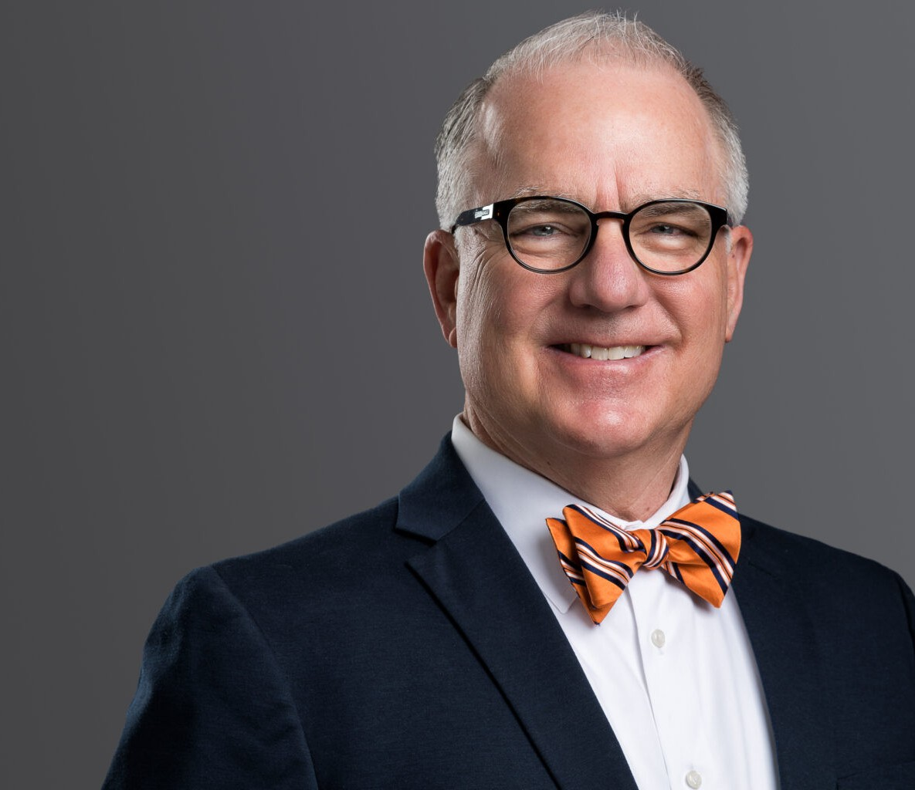

DAVID T. BARTON

Director

[Employment & Labor](https://www.fennemorelaw.com/services/employment-and-labor-relations/)

[Phoenix](https://www.fennemorelaw.com/contact-us/phoenix/)

P: 602.916.5413

[dbarton@fennemorelaw.com](mailto:dbarton@fennemorelaw.com)

# DAVID T. BARTON

David Barton is an attorney in Fennemore’s Employment & Labor practice group, where his practice focuses on labor and employment law and litigation. With a strong track record of defending employers in high-stakes matters, David represents clients in cases involving wrongful discharge, sexual harassment, disability and age discrimination, and wage and hour disputes. He regularly appears before state and federal courts, as well as agencies such as the EEOC and the Arizona Civil Rights Division.

David’s litigation experience spans a wide range of industries, including health care, aviation, technology, financial services, and retail. His recent work includes securing multiple defense

verdicts in complex jury trials involving claims under the Family and Medical Leave Act, Title VII, Section 1981, and the Americans with Disabilities Act. He has successfully defended clients in whistleblower actions, OSHA proceedings, and unfair competition disputes involving non- compete agreements and trade secrets.

Notably, David has prevailed in several multi-plaintiff discrimination lawsuits and has defended employers in arbitration and administrative proceedings across multiple jurisdictions. He also advises clients on employment contracts, executive agreements, and employee handbooks, helping businesses navigate compliance across various states.

In addition to his work in the courtroom, David spends much of his time counseling with employers related to employee discipline and discharge matters. He has prepared and regularly updates a form policy manual that he uses to assist employers in the creation and improvement of employee policies and handbooks. He is particularly adept at guiding employers through reductions in force and layoffs and has helped executives from several companies negotiate favorable agreements during mergers and acquisitions.

Prior to joining Fennemore, David and his partner, Christine Burns, founded the boutique

employment law firm, BurnsBarton, PLC, where they practiced in Phoenix for over 15 years. He also previously served with the Utah Attorney General’s Office and Johnson and Hatch in Salt Lake City.

His depth of experience and practical approach make him a trusted advocate for employers facing challenging legal issues in the workplace.

# EDUCATION

J.D., Brigham Young University, J. Reuben Clark Law School, *magna cum laude*

Articles Editor, Brigham Young Law Review

B.A., Brigham Young University, *magna cum laude*

Order of the Coif

# AREAS OF PRACTICE

Employment & Labor Business Litigation

# REPRESENTATIVE MATTERS

Successfully defended a healthcare provider in class action litigation brought by the EEOC for alleged discrimination under the ADA.

Successfully appealed an adverse finding from the New Mexico Labor and Industrial Commission and obtained a reversal of that decision from the Labor Relations Division of the New Mexico Department of Workforce Solutions related to alleged violations of the Davis- Bacon Act and the New Mexico Public Works Minimum Wage Act.

Defeated an application for a preliminary injunction in a gender discrimination case and successfully defended that decision on appeal. Doe v. Snyder, 28 F.4th 103 (9th Cir. 2022)

Obtained a defense verdict in an FMLA interference and retaliation case where the plaintiff also alleged sexual harassment, retaliation, and violations of the FLSA.

Defended a breach of contract and unpaid wage case to a jury verdict in favor of a large medical practice in a claim brought by one of the founding members of that practice.

Secured a defense verdict and award of fees and costs in a race discrimination and retaliation lawsuit in the U.S. District Court for the District of Arizona.

Obtained a complete defense verdict in a difficult multi-plaintiff race discrimination case brought under Title VII and Section 1981 in the U.S. District Court for New Mexico.

Successfully defended against an OSHA whistleblower complaint in proceedings before the

U.S. Department of Labor and the 10th Circuit Court of Appeals. Mizusawa v. United Parcel Service, 524 Fed.Appx. 4431 (10th Cir. 2013)

Obtained a defense verdict in favor of a hospital in a lawsuit alleging unlawful race discrimination and retaliation under Title VII and 42 USC §1981.

Successfully defended an aviation client in arbitration against claims for unpaid wages and discrimination under the California Fair Employment and Housing Act.

Obtained a jury verdict and award of costs in favor of an employer charged with discrimination under the Americans with Disabilities Act.

Obtained a defense judgment and award of costs in a racial discrimination and retaliation claim in the United States District Court for the District of Nevada.

Obtained a TRO and permanent injunction against an Arizona town that attempted to stop an RV show by refusing to issue a business license.

Obtained a defense judgment and award of attorney fees against an employee who claimed an ownership interest in his employer’s company.

Obtained a defense judgment for a high-tech employer in a whistleblower claim before the Department of Labor.

Obtained a defense verdict for a leading parcel delivery client in an ADA retaliation case and successfully defended that verdict before the Ninth Circuit Court of Appeals. Gribben v. United Parcel Service, 528 F.3d 1166 (9th Cir. 2008)

Obtained a defense judgment for a high-tech company against an employee who complained that he was the victim of same-sex harassment and retaliation by the company CEO.

Successfully defended a food service employer against a sexual harassment lawsuit brought by the EEOC on behalf of five former employees.

# AWARDS AND HONORS

AV Rated, Martindale Hubble

“Top Lawyers,(Labor and Employment Law)” Arizona Business Magazine Southwest Super Lawyers® list, Employment & Labor, 2012-2014

# ARTICLES AND PRESENTATIONS

David’s energetic and humorous style makes him a sought-after trainer and lecturer. His recent presentations and publications include:

Presenter, Animals as Accommodations, Arizona SHRM Employment and Legislative Conference, February 2025

Presenter, Cultivating HR Pros through Proper Documentation, Southern Arizona Human Resources Association AZ SHRM Chapter (SAHRA), October 2024

Presenter, Violence & ADA: Exploring the Intersection of ADA, Mental Illness, & Employee Safety, Arizona Industry Liaison Group, 49th Annual Conference, October 2024

Author, Violence and the ADA, Arizona Attorney Magazine, February 2024.

Presenter, Violence and the ADA, Arizona SHRM Employment Law & Legislative Conference, February 2024

Presenter, Cultivating HR Excellence, 10 Qualities that Make HR Superstars in the Eyes of Outside Counsel, Arizona SHRM Employment Law & Legislative Conference, February 2024

Presenter, Labor and Employment Law, ASU Law School, November 2023

Presenter, Finding and Keeping the Best Talent, Arizona SHRM Annual Conference, August 2023

Presenter, Leave Abuse: How to Manage Employee Attendance While Complying with a Growing Number of Protected Absences, Arizona SHRM Employment Law & Legislative Conference, February 2023

Presenter, COVID-19 Workplace Issues and the Future, State Bar of Arizona Annual Employment and Labor Law Fall Seminar, October 2021

Presenter, COVID-19 Changes to Arizona Employment Law, Arizona Paralegal Association, May 2020

Presenter, The Rise of Local Employment Law, States and Municipalities Take Control in Light of Federal Gridlock, State Bar of Arizona Annual Convention, June 2018

# PROFESSIONAL AND COMMUNITY ACTIVITIES

Scoutmaster, Team Coach, Climbing Instructor, and District Eagle Coordinator, Boy Scouts of America

Homeroom Parent, Capital Elementary School Court Advisor, Children’s Law Center

Lawyer Representative, Ninth Circuit Court of Appeals Member, Volunteer Lawyer Program

Reuben Clark Law Society, Leadership Team, Phoenix Chapter.

Moderator and Panel Judge, Ninth Circuit Annual Civics Essay Writing Contest Active in leadership and service positions within his church community Regular Blood Donor

# ADMISSIONS

Arizona Utah

New Mexico Colorado

U.S. Supreme Court

U.S. Court of Appeals, 9th Circuit

U.S. Court of Appeals, 10th Circuit

U.S. District Court, District of Arizona

U.S. District Court, District of Utah

# LANGUAGES

Portuguese