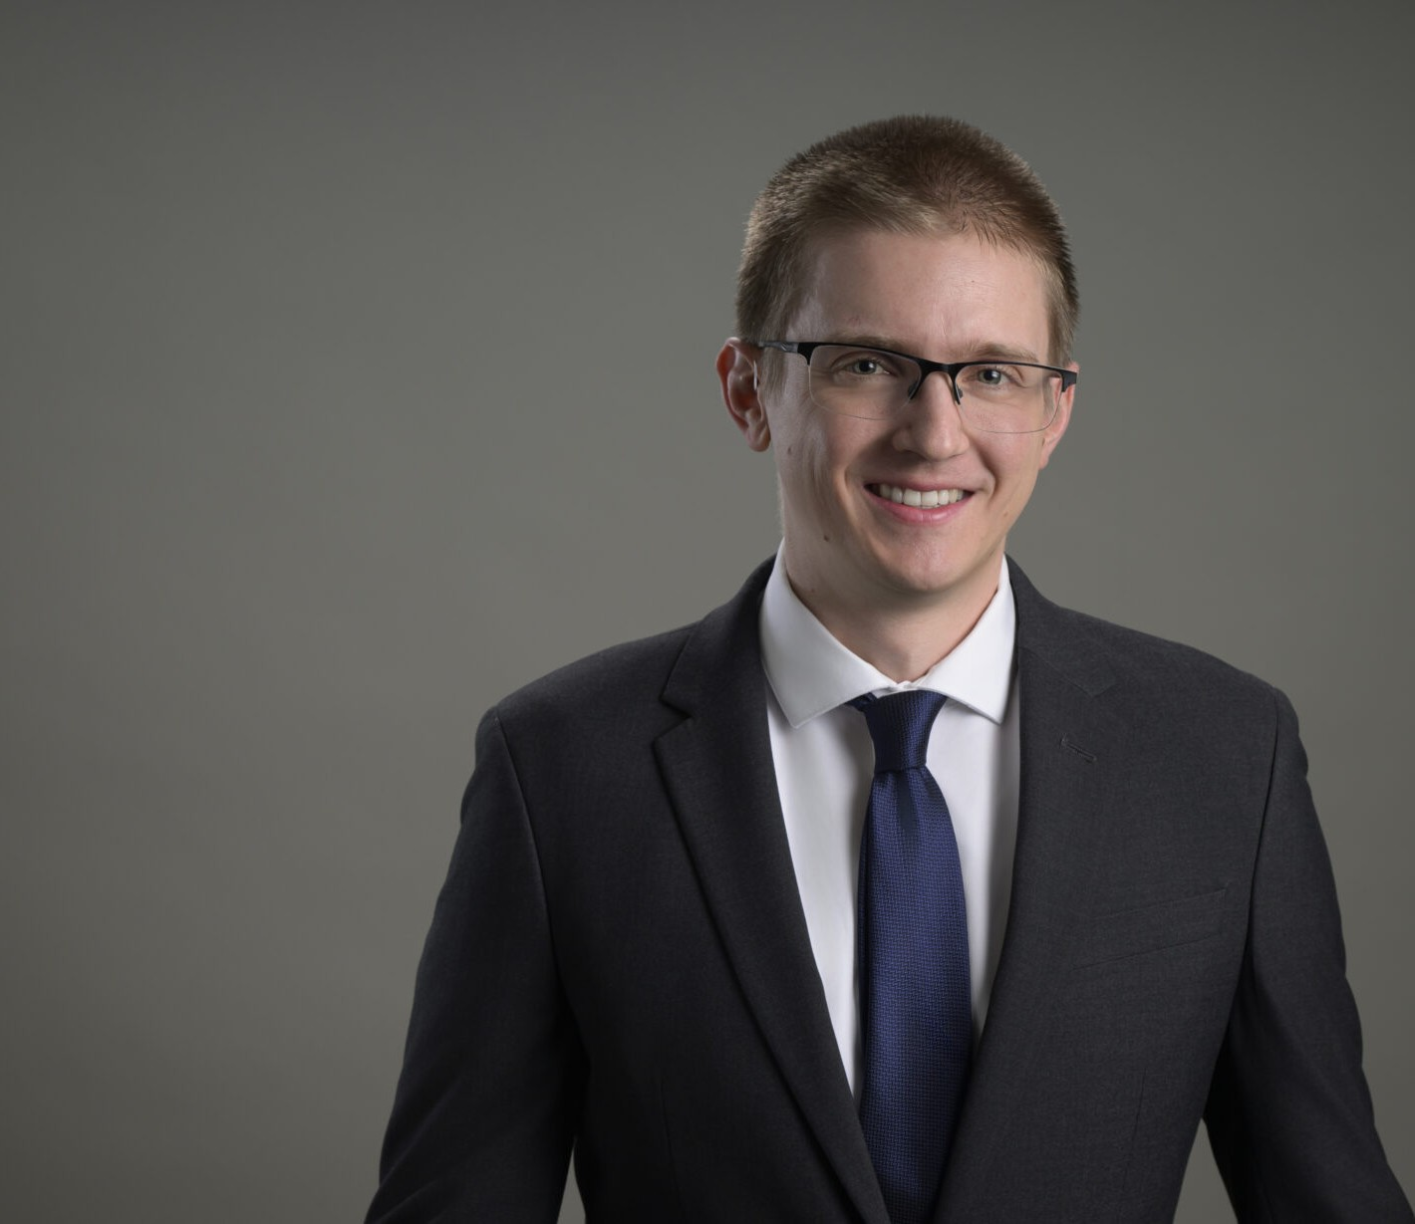

EVAN KLOUSE

Associate

[Natural Resources](https://www.fennemorelaw.com/services/natural-resources-energy-and-environmental/)

[Reno](https://www.fennemorelaw.com/contact-us/reno/)

P: 775.788.2201 F: 775.786.1177

[eklouse@fennemorelaw.com](mailto:eklouse@fennemorelaw.com)

# EVAN KLOUSE

Evan focuses on natural resources and environmental law, where he applies his engineering knowledge to address the complex legal challenges faced by clients in these sectors. His analytical skills and practical approach make him a vital resource for clients navigating

regulatory, environmental, and operational issues.

Evan’s prior experience includes roles in underground mine engineering and public works civil engineering . These positions have provided him with a deep understanding of the technical and operational aspects of the natural resources sector, which he now leverages in his legal career.

In addition to his professional pursuits, Evan is passionate about outdoor activities such as hiking, running, and swimming. He also enjoys playing guitar and spending time with his family.

# EDUCATION

J.D., University of Arizona James E. Rogers College of Law, *summa cum laude*

B.S., University of Nevada, Reno, *summa cum laude*

# AREAS OF PRACTICE

Natural Resources Business & Finance Mining Law

# ARTICLES AND PRESENTATIONS

Co-Author, “Assembly Bill 104: Nevada Adopts Water Rights Retirement Program,” Western Water Law and Policy Reporter, June 2025

Co-Author, “Lower Colorado States Call for Improvements to Glen Canyon Dam,” California Water Law & Policy Reporter, June 2025

Co-Author, “Lower Colorado States Call for Improvements to Glen Canyon Dam,” Western Water Law & Policy Reporter, May 2025

Co-Author, “Additional Funding from the US Bureau of Reclamation Announced for Southern Nevada Water Authority Conservation Initiatives,” Western Water Law and Policy Reporter, March 2025

# ADMISSIONS

Arizona Nevada