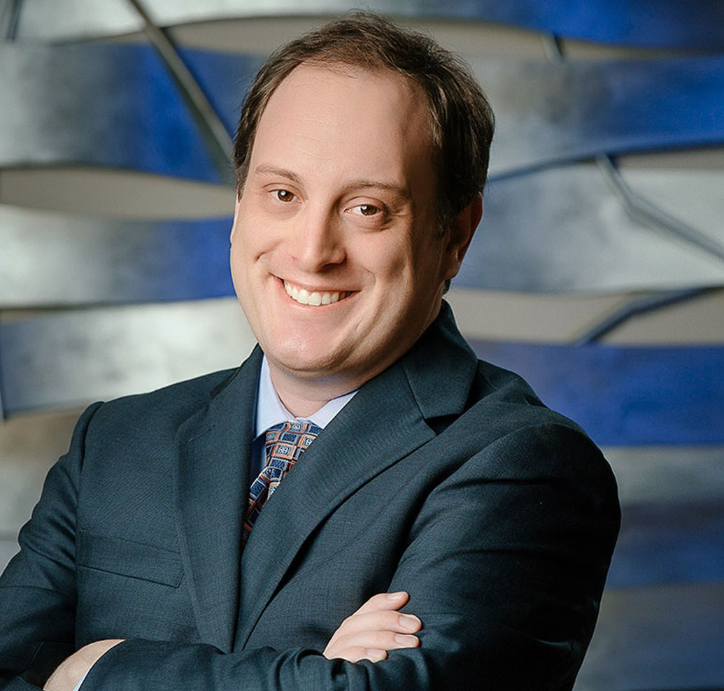

JARED C. MARSHALL

Director

[Trusts & Estates](https://www.fennemorelaw.com/services/trusts-estates/)

[Fresno](https://www.fennemorelaw.com/contact-us/fresno/)

P: 559.432.4500

F: 559.432.4590

[jmarshall@fennemorelaw.com](mailto:jmarshall@fennemorelaw.com)

**JARED C. MARSHALL**

Jared Marshall is an attorney in our Fresno office where his practice is primarily focused on trust and estate litigation, guardianship, and conservatorship litigation. He regularly represents

beneficiaries, heirs, fiduciaries, and family members in disputes regarding inheritance, the administration of trusts and estates, and the care of elderly persons and minors. Most commonly these disputes involve conflicts over the distribution of assets after the death of a friend or loved one, challenges to the validity of estate planning documents, or disagreements about the care or treatment of an elderly, disabled, or incompetent person. Such cases are often complex and emotionally charged. Jared’s goal is to help clients resolve these difficult issues favorably, whether through informal negotiations or in front of a judge at trial. He also has experience in intellectual property litigation, and general business litigation experience in both state and federal courts.

As someone skilled at writing – and persuasively arguing – Jared knew from an early age that his life’s calling was to be a lawyer. To this day, he enjoys coming up with a novel argument and selling it successfully to the court. Prior to joining us, Jared attended law school at the University of Southern California in Los Angeles. Taking advantage of U.S.C.’s location and relationship to the entertainment industry, Jared also studied entertainment and intellectual property law, ultimately winning the Los Angeles Copyright Society’s Peter D. Knecht Memorial Award for excellence in the field of contract and entertainment law. Shortly thereafter, Jared put his knowledge of federal copyright, trademark, and patent law to work in the chambers of the Honorable Lawrence J. O’Neill in the United States District Court for the Eastern District of California.

Away from work, Jared pays his knowledge forward as an adjunct professor of legal research and writing at Fresno City College. He’s also a member of the board of directors for the Fresno County Young Lawyers Association, and a member of the California State Bar, Fresno County Bar Association, and the Association of Business Trial Lawyers.

## EDUCATION

J.D., University of Southern California, Gould School of Law B.A., Philosophy, University of California, Davis, with honors

**AREAS OF PRACTICE**

# OTHER EXPERIENCE

Trust and Estate Administration Trust and Estate Litigation Trusts & Estates

Estate Planning Intellectual Property Business Litigation Estate Litigation

## AWARDS AND HONORS

*Northern California Super Lawyers® Rising Stars®,* 2021, 2023-2025 Peter D. Knecht Memorial Award, Los Angeles Copyright Society

## ARTICLES AND PRESENTATIONS

[Interview, “Enjoy yourself. The process will be stressful and difficult, but it will also be a lot of](https://www.fennemorelaw.com/enjoy-yourself-the-process-will-be-stressful-and-difficult-but-it-will-also-be-a-lot-of-fun/) [fun,” Fennemore Blog, January 5, 2023](https://www.fennemorelaw.com/enjoy-yourself-the-process-will-be-stressful-and-difficult-but-it-will-also-be-a-lot-of-fun/)

[Podcast, “Understanding the Difference Between a Will and a Trust with Jared Marshall,”](https://www.youtube.com/watch?v=iRJdLnzX0uU) [Fenn.Talks Podcast, May 20, 2021](https://www.youtube.com/watch?v=iRJdLnzX0uU)

Presenter, “Legal Research and Writing for Law and Motion,” California Alliance of Paralegal Associations Annual Conference, 2020

## PROFESSIONAL AND COMMUNITY ACTIVITIES

Member, Association of Business Trial Lawyers Adjunct Professor, Fresno City College, Probate

Former Adjunct Professor, Fresno City College, Advanced Legal Research and Writing Former Adjunct Professor, San Joaquin College of Law, Moot Court

Former Coach, San Joaquin College of Law Traynor Moot Court team Past President, Fresno County Young Lawyers Association

## ADMISSIONS

California

U.S. District Court, Central District of California

U.S. District Court, Eastern District of California

U.S. District Court, Northern District of California

U.S. District Court, Southern District of California