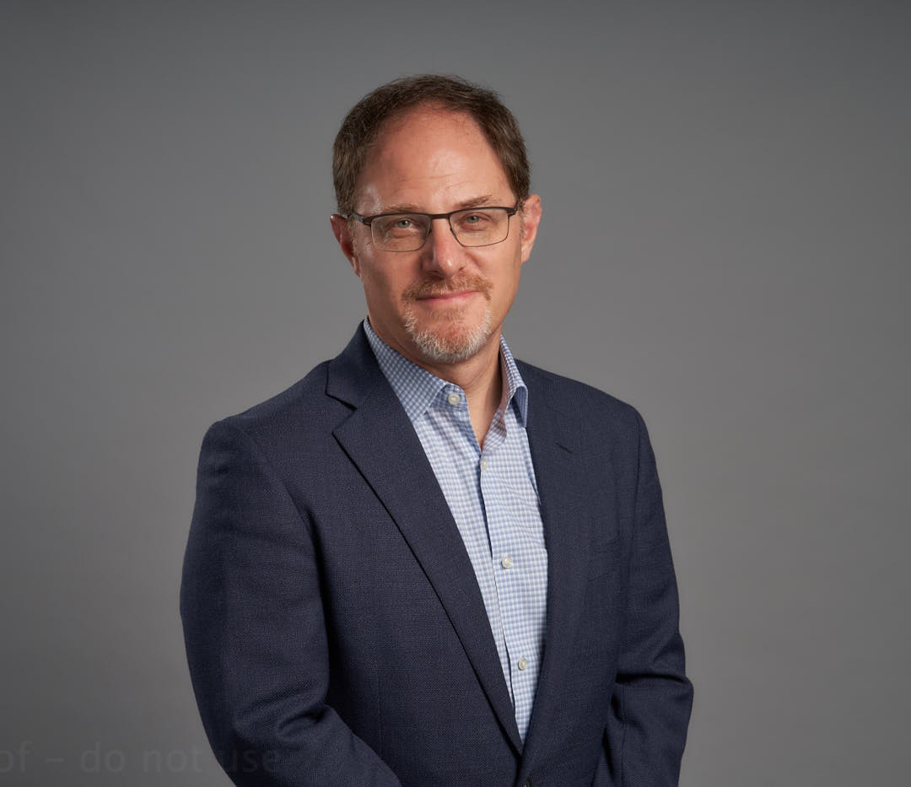

JEFFERY B. LEVI

Director

[Trusts & Estates](https://www.fennemorelaw.com/services/trusts-estates/)

[Oakland](https://www.fennemorelaw.com/contact-us/oakland/)

P: 510.834.6600 F: 510.834.1928

[jlevi@fennemorelaw.com](mailto:jlevi@fennemorelaw.com)

# JEFFERY B. LEVI

In addition to Jeff’s experience in estate planning, he has a background in corporate and transactional law, which gives him unique insights into advising individuals and families with business interests. Jeff works closely with clients to devise strategies and creative solutions to

meet their objectives. He is certified by the State Bar of California Board of Legal Specialization as a specialist in estate planning, trust, and probate law.

### Estate Planning

Jeff works with individuals and families to plan and structure their estates. He prepares revocable trusts, irrevocable generational trusts, wills, durable powers of attorney, and advance health care directives. With his corporate and transactional skills, Jeff frequently forms and prepares the organizational and operating documents for family businesses (such as family limited partnerships and limited liability companies) to meet clients’ estate planning and business

objectives.

### Business Law

Jeff’s experience includes forming, organizing, and counseling limited liability companies,

partnerships, and corporations. He has acted as outside counsel for entities on a variety of legal issues, such as buy-sell agreements, duties of directors, and family business succession. Jeff has handled major transactions, including acquisitions, financings, conversions, and dissolutions, and advises clients about their estate planning options when faced with liquidity events or other changes in their businesses. Jeff also has substantial experience with forming, counseling, and obtaining tax-exempt status for nonprofit organizations.

Trusts & Estates Estate Planning

# EDUCATION

J.D., University of San Francisco, School of Law, *cum laude*

B.A., Pomona College, California

# AREAS OF PRACTICE

## OTHER EXPERIENCE

Nonprofits and Trade Organizations Trusts & Estates

Estate Planning

# AWARDS AND HONORS

Super Lawyer, *Northern California Super Lawyers*®, 2014-2019, 2025 Rising Star, *Northern California Super Lawyers*®, 2009-2010

# ARTICLES AND PRESENTATIONS

Author, “Keeping Your Family Business Intact from One Generation to Another” *Oakland Business Review*, May 24, 2019

Author, “Tax Strategies For Family-Owned Businesses?” *Financial Advisor*, September 07, 2016

# PROFESSIONAL AND COMMUNITY ACTIVITIES

Member, Trust and Estates and Business Sections, California State Bar Past President, East Bay Trusts and Estates Lawyers

Member, East Bay Tax Club

Member, East Bay Estate Planning Council

# ADMISSIONS

California