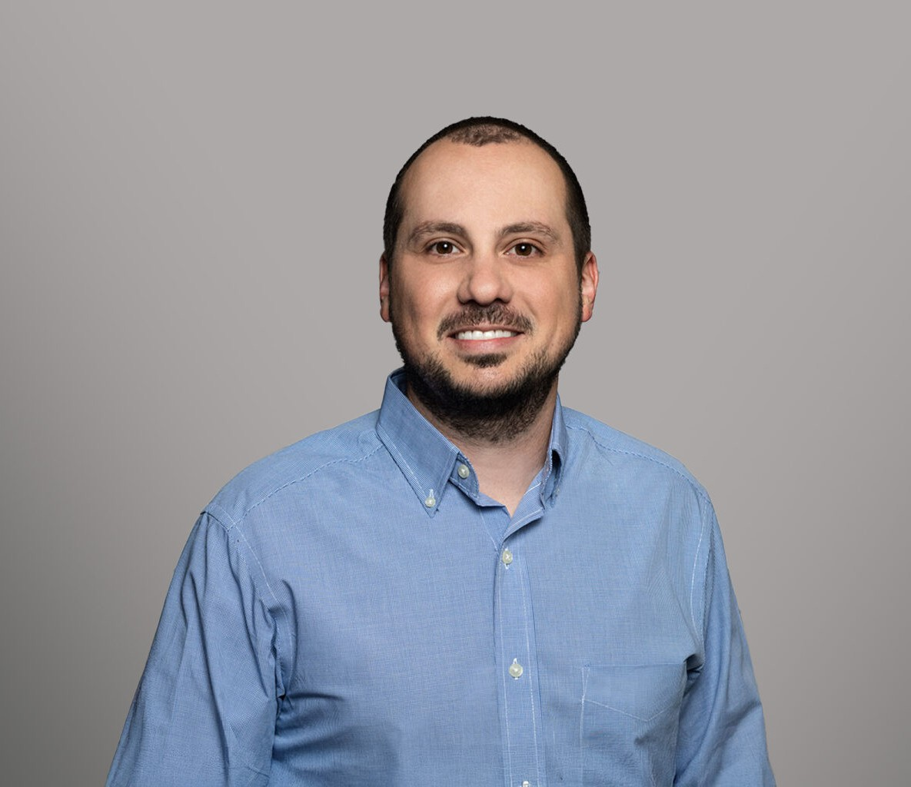

JOHN R. AARON

Patent Agent/Paralegal

[Intellectual Property](https://www.fennemorelaw.com/services/intellectual-property-and-ip-litigation/)

[Fresno](https://www.fennemorelaw.com/contact-us/fresno/)

P: 559.432.4500

F: 559.432.4590

[jaaron@fennemorelaw.com](mailto:jaaron@fennemorelaw.com)

# AARON, JOHN R.

John Aaron is a patent agent in our intellectual property group where his work involves the preparation and prosecution of patent applications, coordination with inventors and outside

counsel, preparation and filing of documents before the USPTO, and portfolio management. He earned his undergraduate degree from Fresno Pacific University, a B.S. in Pre-Health Sciences, and his graduate degree from the University of California, Davis, an M.S. in Atmospheric Science.

After receiving his graduate degree, John moved back to his hometown of Fresno with plans to start a career elsewhere. He took a temporary position in the accounting department at our firm, while he sought out other opportunities. However, not long after starting, he realized two things – that he wanted to plant his roots in Fresno and that he loved our firm. Shortly thereafter,

with the knowledge of John’s scientific background, an IP attorney at our firm approached John with an opportunity to join the firm’s IP practice as a patent agent. Seeing that this was a great opportunity to apply some of the knowledge and skills acquired throughout his scholastic career, to turn a temporary position into a potential career at the firm, and to serve clients in his community – all at the same time – John made the easy decision to become a registered

patent agent. John takes great satisfaction in representing his clients before the United States Patent and Trademark Office and being entrusted with the task of affirming the novelty and ingenuity of each client’s invention.

Away from the office, you’ll find John playing or watching golf, barbecuing, spending weekends at the coast, traveling and exploring craft breweries with his wife, spending time with family and friends, and doing projects around the house.

# EDUCATION

M.S., Atmospheric Science, University of California, Davis B.S., Pre-Health Sciences, Fresno Pacific University

# AREAS OF PRACTICE

Intellectual Property

# ADMISSIONS

*\*Not licensed to the practice of law*