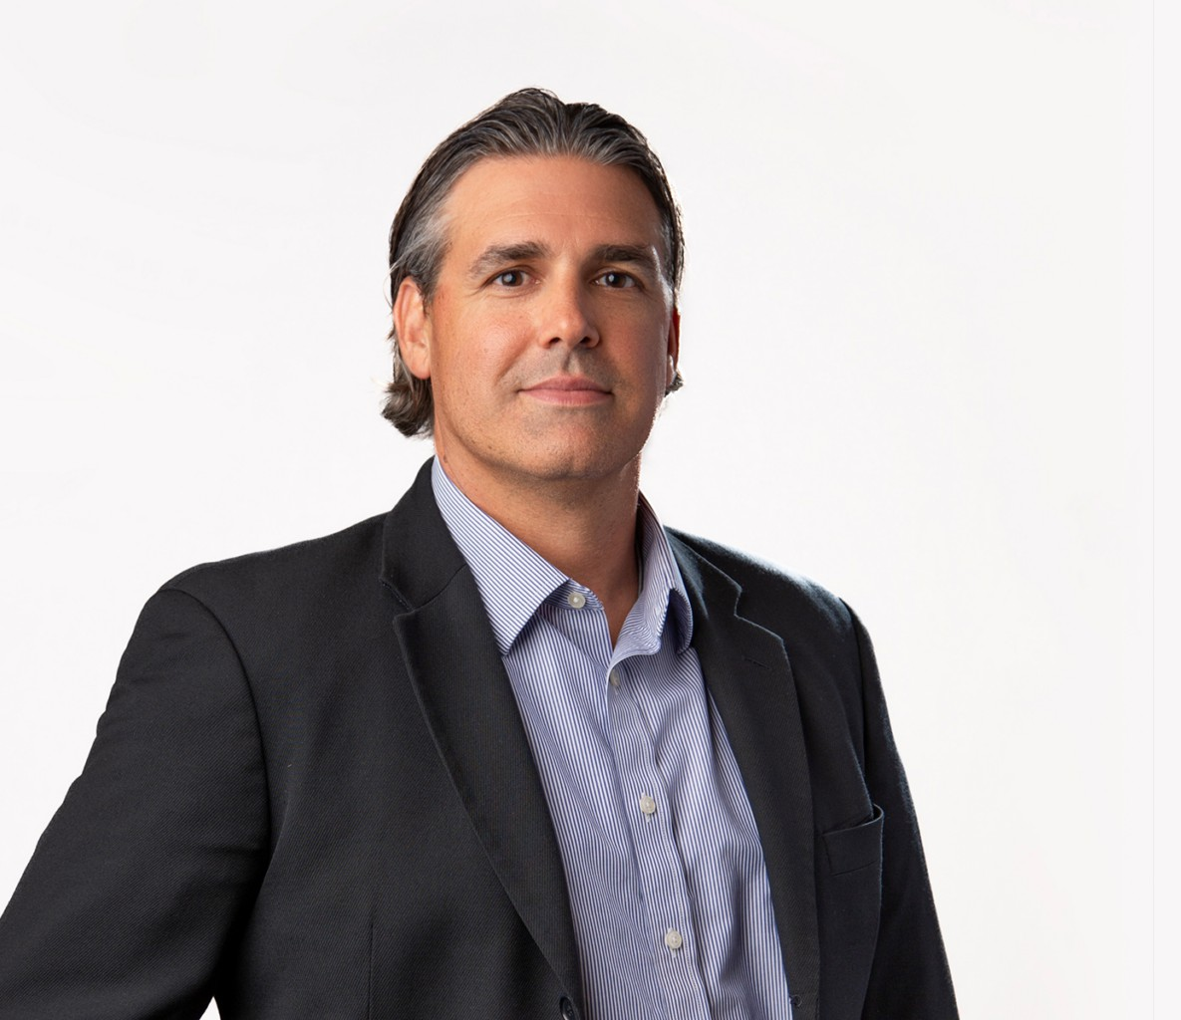

JOSEPH J. DOERR

Director

[Tax Law](https://www.fennemorelaw.com/services/tax/)

[Fresno](https://www.fennemorelaw.com/contact-us/fresno/)

P: 559.753.2803

F: 559.753.2803

[jdoerr@fennemorelaw.com](mailto:jdoerr@fennemorelaw.com)

# JOSEPH J. DOERR

Joseph J. Doerr is a director in our firm’s Fresno office where he is certified by the California Board of Legal Specialization as a specialist in taxation law. In his practice, Joe is known for providing insightful counsel to both individuals and businesses in tax planning and tax controversy resolution. His experience includes handling cases, appeals and audits with

domestic tax bodies like the IRS, FTB, EDD, and CDTFA, as well as offering advice on international tax matters.

Beyond taxation, he also guides new businesses through stages of inception, including entity structure and formation. He also counsels established businesses with restructuring, mergers and acquisitions, and capital needs. His understanding of trust administration and estate planning offers families comprehensive estate plans tailored to their needs, including generation skipping trusts and other complex irrevocable trusts.

# EDUCATION

Masters of Law, Taxation, New York University

J.D., University of California, Davis, School of Law

B.A., University of California, Santa Barbara, with Honors

# AREAS OF PRACTICE

Tax Law

Business & Finance Estate Planning Real Estate Agribusiness

Mergers & Acquisitions Trusts & Estates

General Counsel Services

# AWARDS AND HONORS

California Board of Legal Specialization as a specialist in taxation law Northern California Super Lawyer, 2019-2025

Northern California Rising Star in the field of Taxation, 2010, 2012-2018

# PROFESSIONAL AND COMMUNITY AFFILIATIONS

Member, State Bar of California Member, State Bar of Montana

Member, Tax Section, California Lawyers Association

Member and current Treasurer, Fresno County Bar Association (FCBA) Treasurer, Fresno County Bar Association (FCBA)

# ADMISSIONS

California