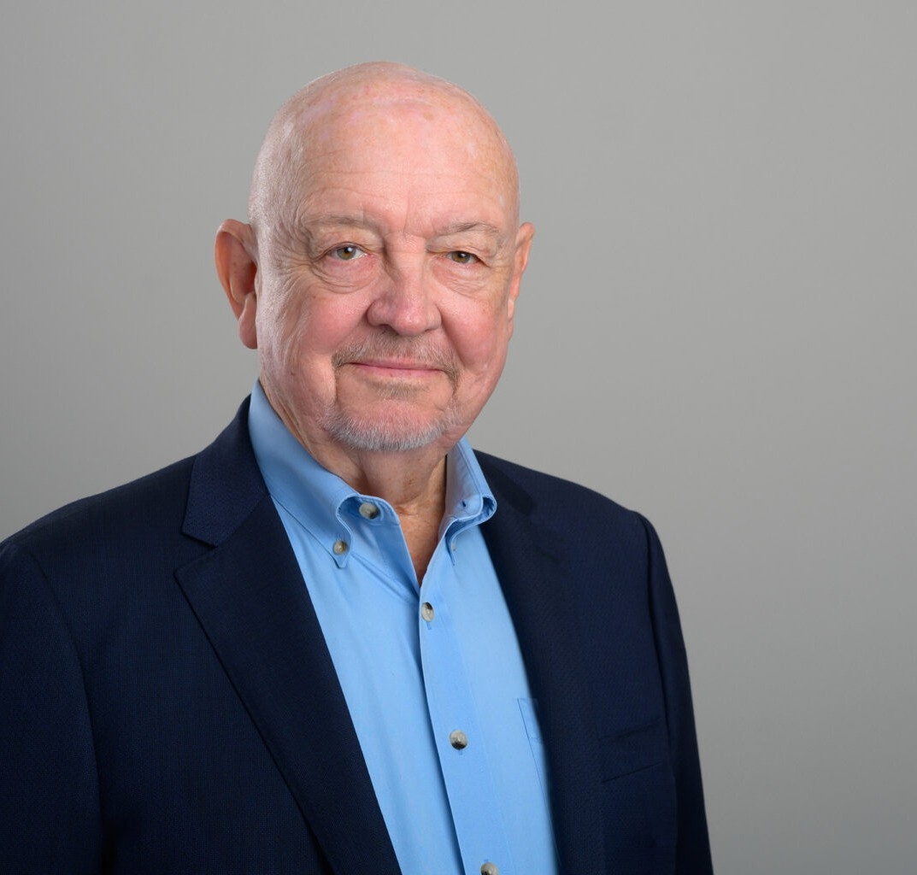

JOSEPH L. MARSHALL

Director

[Real Estate](https://www.fennemorelaw.com/services/real-estate/)

[San Diego](https://www.fennemorelaw.com/contact-us/san-diego/)

P: 619.595.3252

F: 619.231.4372

[joseph.marshall@fennemorelaw.com](mailto:joseph.marshall@fennemorelaw.com)

# JOSEPH L. MARSHALL

Joseph L. Marshall practices in real estate and business transactions, tax planning, and estate planning. He has extensive experience in all aspects of purchase and sale of real estate, financing large commercial properties, and commercial and retail leasing. He guides clients through real estate transactions and negotiates on behalf of owners, developers, landlords,

tenants, lenders, borrowers, partnerships, limited liability companies, and corporations. His practice includes handling commercial real estate ownership, mergers and acquisitions, and business formations. Joseph has an advanced LL.M degree in taxation from New York University, and advises in a wide variety of tax planning and dispute resolution matters with taxing

authorities.

Notably skilled in real estate finance, Joseph represents both secured lenders in real estate loans and aids borrowers in securing and closing real property loans, especially in construction

financing. His knowledge also extends to complex commercial lease transactions, particularly within the retail grocery sector.

# EDUCATION

Masters of Law, Taxation, New York University

J.D., University of California, Hastings College of Law B.A., University of California, San Diego

# AREAS OF PRACTICE

Real Estate Agribusiness Business & Finance

Family Office & Private Client Attorneys Food & Beverage

Mergers & Acquisitions Tax Law

Trusts & Estates

# AWARDS AND HONORS

AV® Preeminent™ Peer Review Rating by Martindale-Hubbell Top San Diego Lawyer, San Diego Magazine, 2015-2023, 2025 Rising Star by Super Lawyers, Real Estate

# PROFESSIONAL AND COMMUNITY ACTIVITIES

Member, Steering Committee, University of California Economics Roundtable

Member, California Lawyers Association Tax Procedures and Administration Committee Member, Taxation Section, American Bar Association

Member, International Council of Shopping Centers and Steering Committee, UCSD Economic Roundtable

Member, American Bar Association Member, San Diego Bar Association

Board of Directors, Grossmont Shopping Center

# ADMISSIONS

California