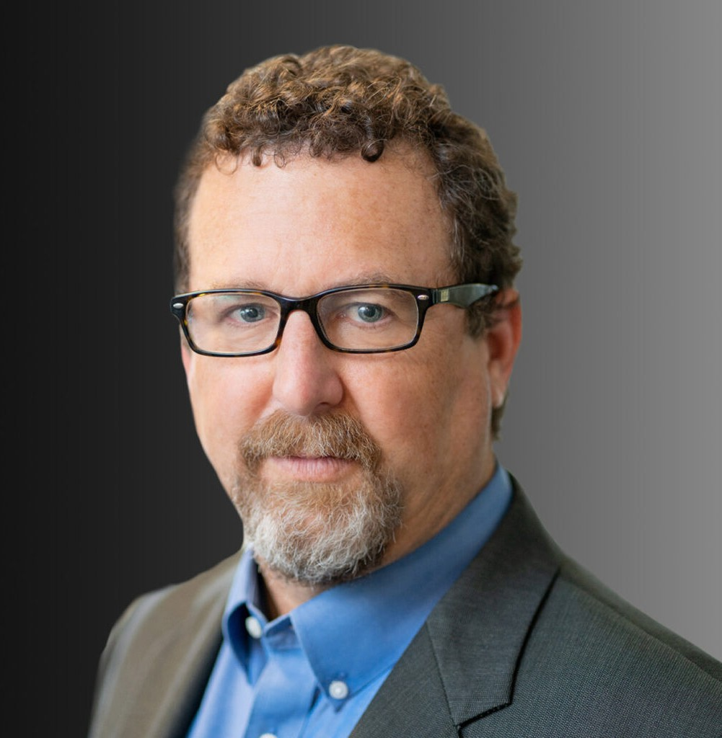

JOSHUA D. COHEN

Pronouns: he/him

Director

[Business Litigation](https://www.fennemorelaw.com/services/business-litigation/)

[Oakland](https://www.fennemorelaw.com/contact-us/oakland/)

P: 510.834.6600 F: 510.834.1928

[jcohen@fennemorelaw.com](mailto:jcohen@fennemorelaw.com)

“

We are men of action. Lies do not become us.

- Dread Pirate Roberts

**JOSHUA D. COHEN**

”

Josh works closely with his clients to efficiently and effectively resolve their problems. Josh has extensive trial experience, litigating a full spectrum of commercial disputes, ranging from real estate to technology, he is adept at addressing clients’ sophisticated litigation needs. He represents clients in litigation prevention, mediation, arbitration and trial in state and federal courts. He has a proven track record of success in high-stakes trials and arbitrations.

Josh’s business litigation experience includes handling disputes regarding partnerships, business torts, trade secrets, high-tech product defects, indemnification and warranty, trademark and

copyright infringement, licensing, cannabis-related IP issues, and employment matters regarding non-compete, non-solicitation and non-disclosure agreements.

Josh has represented major residential and commercial developers, as well as contractors and individuals in disputes regarding purchase and sale, brokers’ commissions, contractor licensing, non-disclosure/fraud/concealment actions and land use issues.

Josh helps cities, counties, special districts and other public entities, as well as private clients throughout the state, in public acquisition (eminent domain) and similar matters.

## EDUCATION

J.D., University of California, Davis School of Law B.A., University of California, Los Angeles

**AREAS OF PRACTICE**

# OTHER EXPERIENCE

Real Estate Litigation Business Litigation

Eminent Domain Intellectual Property Real Estate Cannabis Business

## REPRESENTATIVE CASES

Obtained $4 million plus verdict for client in partnership dispute.

Prosecuted developer who subdivided agricultural preserve into residential lots in violation of local and state law.

Defended cannabis business against unfair competition claim by competitor.

Obtained jury verdict and attorneys’ fee award for mail processing company for wrongful termination by customer.

Negotiated favorable settlement for company threatened with multimillion dollar disgorgement claim for alleged violation of state contractor’s licensing rules.

Defended international manufacturer and its U.S. subsidiaries against fraud and breach of merger agreement claims in California state and federal courts.

Full defense verdict in jury trial for East Bay engineering firm accused of trade secret misappropriation and unfair competition.

Prosecuted fraud/product defect action against computer chip manufacturer resulting in

$7.1 million eve of trial settlement.

Obtained substantial damages and attorneys’ fee award in involuntary dissolution action for partners that were being held hostage by managing member.

Defeated restraining order and preliminary injunctions for terminated employees accused of trade secret, breach of non-disclosure and non-compete agreements.

Obtained verdict and attorneys’ fees award in bench trial for specific performance for one of the country’s top five residential developers.

## AWARDS AND HONORS

*Northwest Super Lawyers®*, Top Rated Business Litigation Attorney, 2022-2025

## ARTICLES AND PRESENTATIONS

Co-Presenter, “Annual Legal Update,” International Right of Way Association, Bay Area Chapters 2, January 26, 2022, 2021, 2019

Speaker, “Can Appraisers Still Reply on Hearsay After the Sanchez and Stamps Decisions?” IRWA Chapter 42 Spring Conference, Friday, April 3, 2020

Presenter, “Saving Your Assets,” Wendel Rosen LLP, May 2019

Author, “USPTO Stripped of Power to Deny Disparaging or Vulgar Trademarks,” The Recorder, April 27, 2018

Author, “Gold Rush for Cannabis Trademarks,” Marijuana Venture, July 6, 2017

## PROFESSIONAL AND COMMUNITY ACTIVITIES

Member, Intellectual Property Section, Contra Costa County Bar Association

Board Member, Former Chair, Litigation Section, Contra Costa County Bar Association Member, International Right of Way Association

Member, Alameda County Bar Association

Board of Directors, California Shakespeare Theater Board of Directors, Council One

## ADMISSIONS

California

U.S. District Courts, Eastern District of California

U.S. District Courts, Northern District of California

U.S. Court of Appeals, Ninth Circuit