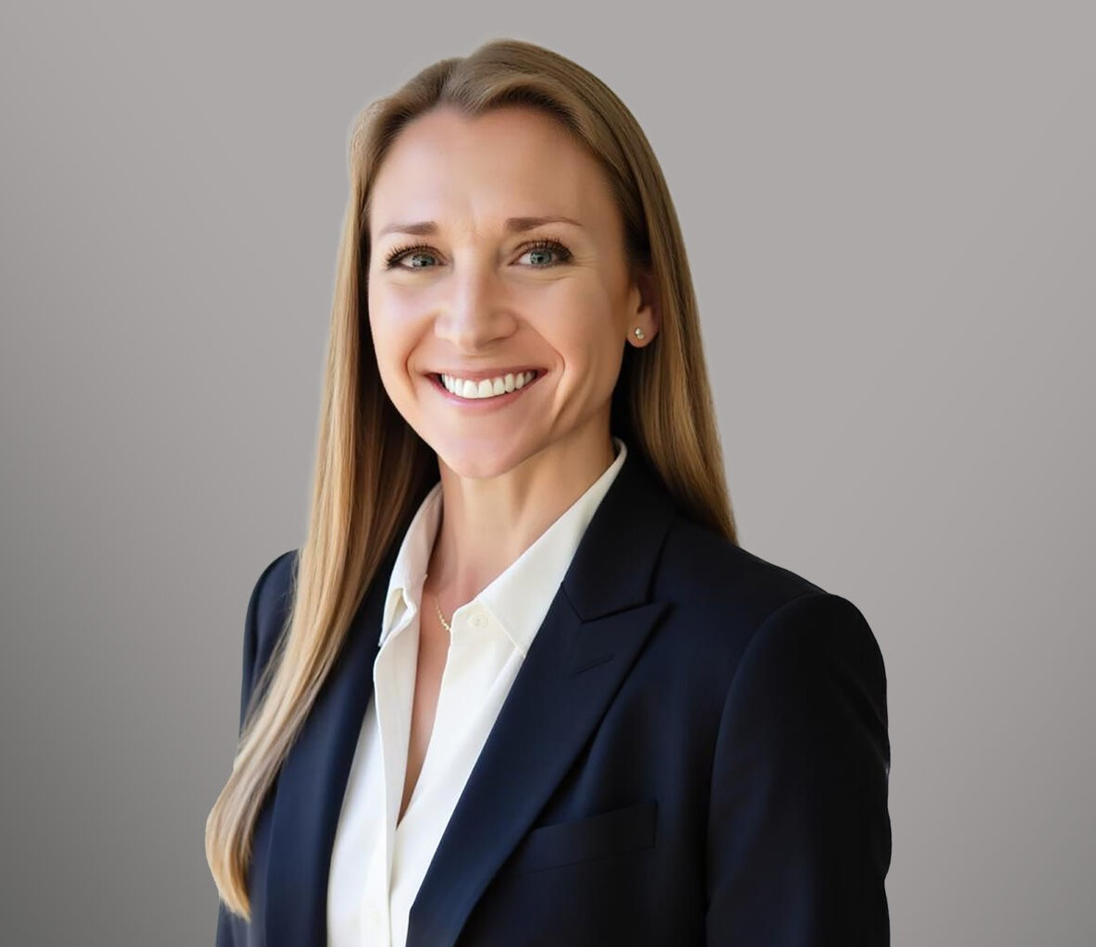

KATIE SHEFTIC

Associate

[Real Estate](https://www.fennemorelaw.com/services/real-estate/)

[Fennemore Forward](https://www.fennemorelaw.com/contact-us/fennemore-forward/)

P: 208.956.0133

[ksheftic@fennemorelaw.com](mailto:ksheftic@fennemorelaw.com)

# KATIE SHEFTIC

Katie Sheftic is a mining and natural resources attorney with a background in energy, law, and

policy. From transactional matters to litigation, Katie enjoys helping clients navigate the complex legal, tribal, and regulatory landscape of Idaho’s natural resources industry. She has assisted

domestic and international stakeholders with mineral title opinions and helped secure successful quiet title actions for mineral rights and hard rock mining claims.

Prior to joining Fennemore, Katie worked for a mining and natural resources firm in Alaska and was instrumental in launching the first mining law practice team at another Pacific Northwest firm. Before her legal career, she conducted policy research on global energy terrorism for a national think tank and led strategic projects for a quasi-public energy utility on critical infrastructure cybersecurity, enterprise risk management, and business continuity and resilience. Katie leverages her professional and legal background to help natural resources clients achieve business objectives while mitigating legal risks.

Katie is actively involved in the Idaho and natural resources legal communities. Between 2022- 2024, she served as the Chief Symposium Editor and Associate Editor of the Idaho Law Review, which awarded her the Outstanding Writing Award for her published Comment on interstate water law in 2023. In 2024, she organized the Idaho Law Review Water Law Symposium in Boise, Idaho, an event that drew national legal scholars, judges, former cabinet members and attorneys to engage on state and federal water issues. Katie is a current member of the Foundation for Natural Resources and Energy Law, and Idaho State Bar Water Law and

Environmental and Natural Resources Law Sections. As a career military spouse, Katie also enjoys assisting America’s Veterans on a pro bono basis.

Outside of her professional work, Katie enjoys spending time outdoors with her family and her German Shorthaired Pointer, Ellie Mae.

# EDUCATION

J.D., University of Idaho College of Law B.A., University of Vermont

# AREAS OF PRACTICE

Real Estate

Mining Law Natural Resources Advanced Energy

# AWARDS AND HONORS

The Foundation for Natural Resources & Energy Law Scholarship Winner, 2024

Oral Argument Semi-Finalist, University of Idaho College of Law Annual McNichols Competition, 2023

Idaho Law Review Annual Outstanding Writing Award, 2023

U.S. Army Commander’s Award for Civilian Service, 2017

# ARTICLES AND PRESENTATIONS

Author, *Leveraging the ‘Law of the River’: The Legal History Upstream from the Colorado River Crisis & its Lessons for the Coeur d’Alene-Spokane River Basin,* Idaho Law Review, 60 Idaho L. Rev. 427, Nov. 1, 2024

Acknowledged Research Assistant, Cohen’s Handbook of Federal Indian Law, 2024

# PROFESSIONAL AND COMMUNITY ACTIVITIES

The Foundation for Natural Resources and Energy Law (FNREL) American Exploration and Mining Association (AEMA)

Women in Mining (National & Idaho Chapter Member) Idaho Veteran’s Law Society

# ADMISSIONS

Idaho State Courts

U.S. District and Bankruptcy Court for the District of Idaho