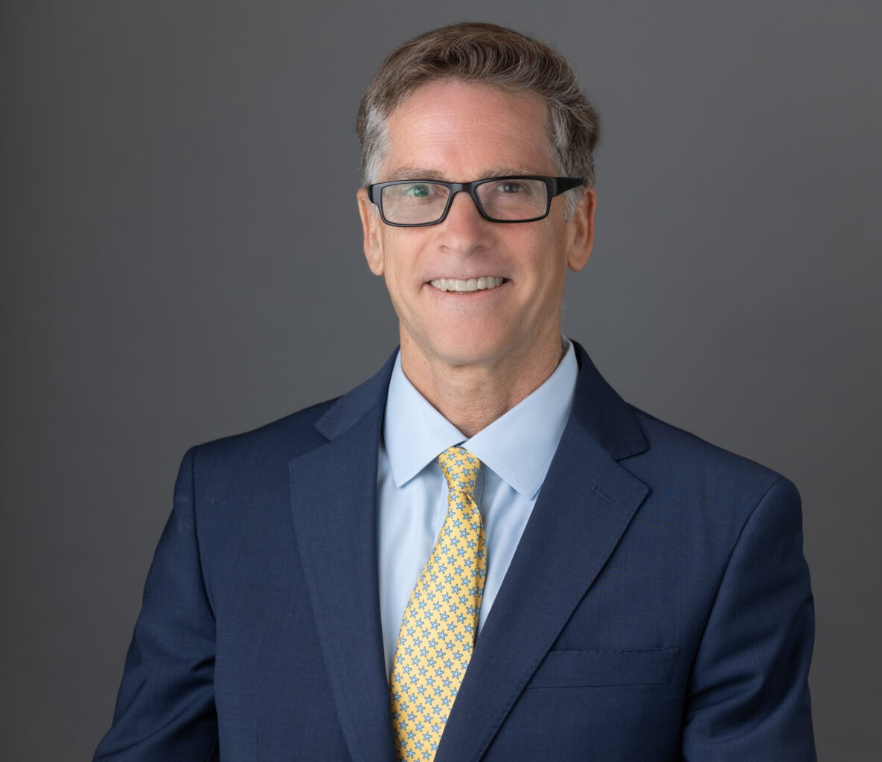

KURT A. FRANKLIN

Director

[Business Litigation](https://www.fennemorelaw.com/services/business-litigation/)

[Walnut Creek](https://www.fennemorelaw.com/contact-us/walnut-creek/)

P: 510.622.7519

F: 510.834.1928

[kfranklin@fennemorelaw.com](mailto:kfranklin@fennemorelaw.com)

**KURT A. F**“**RANKLIN**

I like being a lawyer.

”

Kurt Franklin is a director in our Walnut Creek office who works in our Business Litigation and

Employment & Labor practice groups. Kurt focuses on overseeing complex, multi-party, class

action, and civil rights and impact-litigation defense cases, regularly serving as lead counsel. In the private sector, he has represented franchisee groups and entire business communities in

complex multi-party lawsuits. And in the public sector he has appeared before the California Supreme Court to represent more than 100 California cities and local government entities in an amicus effort.

Kurt also regularly advises California employers in wage-and-hour, trade secret, discrimination, harassment, retaliation, wrongful termination, whistleblower, traditional labor law, arbitration, collective bargaining, employee privacy, due process and government ethics. He has deep experience with public employee bargaining, public employee due process, the California

Public Records Act, the Public Safety Officers Procedural Bill of Rights Act, the NLRA, RLA, and section 13(c) of the Federal Transit Act.

Growing up in Santa Ana in Orange County, CA, Kurt attended public schools and his family taught him how to talk with and respect people from myriad backgrounds. As a seasoned

litigator, he credits this background with giving him the ability to deftly negotiate and bring down tensions in a room. Kurt enjoys problem-solving, and learning about different industries – and during his career he’s taken on interesting issues for government clients, and private sectors including zoos, manufacturing, construction, and flood cases, and all points in between. He’s

pragmatic and finds that providing good counsel, instead of just selling clients is what leads to long-term relationships. Kurt will aggressively fight for his clients’ rights, but he also has the ability to take the emotion out of an equation and mediate when that’s the best business decision.

An avid surfer – who used to catch a wave 100 days-a-year with his family of surfers – as an empty nester, these days you’re more likely to catch Kurt fly fishing or golfing. The common

denominator with all three activities: the intense focus necessary helps Kurt relax, and places his brain in a different place

# EDUCATION

J.D. University of San Francisco School of Law

B.A. University of California, Los Angeles

# AREAS OF PRACTICE

Business Litigation

Employment & Labor

# REPRESENTATIVE MATTERS

### Representative Disability-Access Class Action and Impact Cases

**Case Name: *Riker v Beach Blanket Babylon***

### Case No. 3:11-cv-03755-EDL

**Court: United States District Court for the Northern District of California Judge: The Honorable Elizabeth D. Laporte**

This was an impact case where plaintiff asserted theater patrons that use wheelchairs have inadequate access to Club Fugazi theater. With coordination of multiple defendants, matter efficiently resolved between counsel after a mandatory mediation with panel mediator.

**Case Name: *Vallabhapurapu v Burger King Corporation***

### Case No. 3:11-cv-00667-WHA

**Court: United States District Court for the Northern District of California Judge: The Honorable William Alsup**

This was a second ADA class action filed against Burger King Corporation alleging disability discrimination under the ADA and related state laws. We represented more than 150 non-party franchisees and guarantors, totaling more than 90 restaurants and successfully kept them out of the case in chief. We also successfully defended the franchisor’s claims for indemnity by way of a favorable early resolution.

**Case Name: *Newport v Burger King Corporation***

### Case No. 10-cv-04511-WHA

**Court: United States District Court for the Northern District of California Judge: The Honorable William Alsup**

Working with more than 150 clients, we initiated a declaratory relief action against a national franchisor over the interpretation of a franchisee’s contractual duty to indemnify the franchisor for ADA allegations. This matter resolved successfully without the franchisees directly contributing money for indemnification under the agreements.

## Case Name: *Davis v Avish Partnership (Super 8 Downtown Los Angeles), et al*

### Case No. 09-00580 RGK

**Court: United States District Court for the Central District of California Judge: The Honorable R. Gary Klausner**

This was a discrimination case, wherein plaintiff asserted defendant denied him a hotel room for unlawful reasons – race (African American) and disability discrimination (walking and service

dog). Forced to try the case on a lean budget, we obtained a unanimous jury verdict in our client’s favor. Further, the Court granted our motion for attorney’s fees and costs.

## Case Name: *Mills College Department of Justice Investigation and Compliance Review*

### Case No. DJ# 202-11-192

Counseled university through DOJ compliance review.

**Case Name: *Castaneda v. Burger King Corporation***

### Case No. 08-CV-04262-WHA

**Court: United States District Court for the Northern District of California Judge: The Honorable William Alsup**

This was a class action filed against Burger King Corporation alleging disability discrimination under the ADA and related state laws. We represented more than 40 non-party franchisees, totaling more than 80 restaurants and successfully kept them out of the litigation.

## Case Name: *Delil v. Golden Gate Bridge, Highway and Transportation District*

### Case No. C 08 01105 MEL

**Court: United States District Court for the Northern District of California Judge: The Honorable Marie Elena James**

This was an impact case where the plaintiff sought changes to Bay Area ferry service between Marin and San Francisco – asserting ferries and related facilities were inaccessible to persons that use wheelchairs. This was resolved with equitable relief staged over several years to integrate with scheduled vessel inspection and refurbishment.

## Case Name: *Hyatt v Northern California Presbyterian Homes*

### Case No. No. C08-03265 PJH

**Court: United States District Court for the Northern District of California Judge: The Honorable Phyllis J. Hamilton**

This was an impact case brought by Disability Rights California under the FHA, the ADA and state disability access laws. Plaintiff sought to expand the rights of seniors using access laws, which would have both fundamentally altered the nature of defendant’s business and put seniors at serious risk for injury. With a dispositive motion pending, this case was successfully resolved before Magistrate Maria Elena James.

## Case Name: *Greater Napa Fair Housing Center v. Harvest Redwood Retirement Residence, LLC*

### Case No.: C0-07-3653 PJH

**Court: United States District Court for the Northern District of California Judge: The Honorable Phyllis Hamilton**

This was an impact case filed in the summer of 2007 by Disability Rights California and housing

advocates. At its core, this was a disability discrimination matter brought against a senior housing community that operates an independent living facility. Plaintiffs alleged that Defendants (1) discriminated against disabled residents by charging a fee for meal trays that were delivered to their rooms, (2) discriminated against disabled residents by threatening to evict residents who could not care for themselves, and who did not hire private caregivers, and (3) used illegal terms in their marketing, such as “active” and “independent.” Plaintiffs filed a motion for preliminary

injunction, which the Court denied because Plaintiffs were “not likely to prevail on the merits.”

Defendants had articulated legitimate business reasons for their actions, namely efforts to protect residents from inadequate private caregivers or otherwise insufficient care.

We had this matter in an early settlement conference before a magistrate judge by February 2008, and favorably resolved by May 2008.

## Case Name: *Campos v. Golden Gate Bridge Highway and Transportation District*

### Case No.: 304391

**Court: City and County of San Francisco Superior Court Judge: The Honorable David Garcia**

On behalf of putative class, Plaintiff brought ADA Title II, Unruh Act and California Disabled Persons Act claims seeking equitable relief and damages. The court never approved class certification and the matter resolved for a modest amount.

## Case Name: *Robert Hecker and Christopher Lee Jenkins v. California Department of Corrections* and Rehabilitation, et al.

**Case No.: 05-CV-02441 LKK GGH**

**Court: United States District Court for the Eastern District of California**

**Judge: The Honorable Lawrence K. Karlton/Magistrate Judge John Moulds**

This case was a class action alleging that Defendants have discriminated against prison inmates who are mentally disabled, regarded as mentally disabled, or have a record of mental disabilities in violation of the Americans With Disabilities Act. Defendants brought a 12(b)(6) motion after Plaintiffs filed a second amended complaint. Defendants argued this action was precluded by Court actions approving mental health care programs in a prior class

action, *Coleman v. California Department of Corrections, et al.,* which alleged that Defendants failed to provide constitutionally adequate mental health care to a class of prison inmates in violation of the 8th Amendment. At oral argument on the 12(b)(6) motion, Defendants requested the Court to stay the matter. This request was granted, with the Plaintiffs filing a motion to lift the stay in December 2007. The court denied Plaintiffs’ motion. This firm was lead litigation counsel in association with the California Attorney General. Eight years later, class counsel recently renewed a motion to lift the stay in this matter.

## Case Name: *Mitchell J. Klemaske, on behalf of himself and others similarly situated v. California* Department of Corrections and Rehabilitation, et al.

**Case No.: 2:04-cv-01750-FCD-KJM**

**Court: United States District Court for the Eastern District of California**

**Judge: The Honorable Lawrence K. Karlton/Magistrate Judge John Moulds**

This case was a class action alleging that Defendants have discriminated against prison inmates who are mentally disabled, regarded as mentally disabled, or have a record of mental disabilities with respect to certain programs, practices, and procedures in violation of the Americans With Disabilities Act. This case settled on a non-class basis with affirmative relief and a modest settlement for the named Plaintiff. This firm was lead litigation counsel in association with the California Attorney General.

## Case Name: *San Francisco Community College District v. Swinerton (Cherry v. SFCCD)*

### Case No.: CO4- 4981 WHA

**Court: United States District Court for the Northern District of California Judge: The Honorable William Alsup**

A class action lawsuit against defendant college district alleging discrimination in violation of ADA Title II regarding physical access for persons with mobility disabilities. The college district stipulated to judgment and equitable relief in the amount of several million dollars, and then crossed claimed against our client – a general contractor. Keeping attorneys’ fees down, in less

than six months, we resolved the matter for a modest sum and the court approved our good faith settlement motion.

## Case Name: *Molski v. Arciero Wine Group; Molski v Castoro Cellars; Molski v Chateau Margene;* Molski v Eberle Winery; Molski v Jankris Winery; Molski v Linne Calodo Cellars; Molski v Penman Springs (Paso Robles Winery Litigation)

### Case Nos.: Multiple

**Court: United States District Court for the Central District of California Judges: Multiple**

Coordinated multiple actions and brought motion to relate claims in cases brought by plaintiff Jarek Molski in the Paso Robles Winery Litigation. Judge of the earliest-filed-case denied motion to relate. Firm later resolved claims on behalf of many individual wineries and worked with co- counsel following denied motion to relate.

## Case Name: *Castro Street Business ADA Litigation (Anniversary Flowers)*

### Case No.: C 03-3298 VRW

**Court: United States District Court for the Northern District of California Judge: The Honorable Vaughn Walker**

Coordinated and related 17 separate ADA Title III lawsuits against individual businesses, and Civil RICO counterclaims against plaintiffs. Plaintiffs dismissed all actions as to all businesses with prejudice and received no equitable relief or damages.

**Case Name: *Smith v The Oakland Raiders et al.***

### Case No.: 3:01-cv-03166-MJJ

**Court: United States District Court for the Northern District of California Judge: The Honorable Martin J. Jenkins**

This was an impact case seeking improved access to NFL football games by a person advocating on behalf of wheelchair users. Coordinated defense and resolution on behalf of Stadium Management Group.

## Case Name: *Rudder v Los Angeles County Metropolitan Transportation Authority (Metrolink), and* Southern California Regional Rail Authority (LA Metro)

### Case No. CV 12-0840 JFW

**Court: United States District Court for the Central District of California Judge: The Honorable John F. Walter**

This was an impact case asserting passengers that use wheelchair have inadequate access to Union Station. Matter efficiently resolved during a JAMS mediation.

**Case Name: *Tamara v El Camino Hospital, et al.***

### Case No. C12-01032 RMW

**Court: United States District Court for the Northern District of California Judge: The Honorable Ronald M. Whyte**

This was an impact case affecting the policies of a hospital related to service animals, as well as hospital access features. Mr. Franklin served as special mediation counsel, resolving this matter during a JAMS.

## Case Name: *Calderon v Los Angeles County Metropolitan Transportation Authority, Veolia* Transportation Services, Inc., et al.

### Case No. C13-01381 MWF

**Court: United States District Court for the Central District of California Judge: The Honorable Michael W. Fitzgerald**

This was an impact case challenging complaint policies and procedures for bus service. Matter resolved efficiently during a JAMS mediation.

# ARTICLES AND PRESENTATIONS

Author, “[Artificial Intelligence Risk for Employers – The Tin Man Prompts Class Action Lawsuits](https://www.fennemorelaw.com/artificial-intelligence-risk-for-employers-the-tin-man-prompts-class-action-lawsuits-lions-and-tigers-and-bears-oh-my/) [(Lions and Tigers and Bears, Oh My!)](https://www.fennemorelaw.com/artificial-intelligence-risk-for-employers-the-tin-man-prompts-class-action-lawsuits-lions-and-tigers-and-bears-oh-my/),” Fennemore Blog, June 27, 2025

Author, “[California’s Recent and Pending AI Laws Affecting Employers: Will the Federal](https://www.fennemorelaw.com/californias-recent-and-pending-ai-laws-affecting-employers-will-the-federal-government-preempt-californias-laws/) [Government Preempt California’s Laws?](https://www.fennemorelaw.com/californias-recent-and-pending-ai-laws-affecting-employers-will-the-federal-government-preempt-californias-laws/),” Fennemore Blog, June 27, 2025

Author, “[A New Storm for Employers May Be Forming in the California Sunshine: Preliminary](https://www.fennemorelaw.com/a-new-storm-for-employers-may-be-forming-in-the-california-sunshine-preliminary-certification-of-collective-action-against-human-resource-ai-software-provider/) [Certification of Collective Action Against Human Resource AI Software Provider](https://www.fennemorelaw.com/a-new-storm-for-employers-may-be-forming-in-the-california-sunshine-preliminary-certification-of-collective-action-against-human-resource-ai-software-provider/),” Fennemore Blog, June 27, 2025

Author, “[Being Prepared for ICE Workplace Enforcement Actions](https://www.fennemorelaw.com/being-prepared-for-ice-workplace-enforcement-actions/),” Fennemore Blog, June 27, 2025

Author, “New California Law Gives U.S. Employers and Employees More Power to Challenge Any Non- Compete Clause, LinkedIn, October 13, 2023

Featuring, “In recent developments in an ongoing legal battle, Spencer v. Lunada Bay Boys,” Daily Journal, July 1, 2023

Featuring, “Is the reign of the Lunada Bay surf thugs at an end?” Los Angeles Times, March 23, 2023

“Court Revives California Public Beach Harassment Case,” *Law360* (March 2023)

“Appeals Court Ruling in Lunada Bay Boys Case Could Make Cities Liable for Surf Localism,” *Los Angeles Daily News* (March 2023)

“SF’s Chinatown Businesses Hit with Lawsuits by Prolific ADA Plaintiffs, Officials Vow Help,” *NBC Bay Area News* (July 2021)

“Surfer gang harassment allegations dismissed by Palos Verdes officials, records show,” *Los Angeles Times* (May 2016)

“Allegations flowing in against the surfer gang of Lunada Bay,” *Los Angeles Times* (April 2016)

“More surfers harassed by Bay Boys want to join lawsuit, attorney says,” *Daily Breeze* (April 2016)

“Attorneys React To DOL Misclassification Guidance,” *Law360* (July 2015)

[“Reviewing an ADA Case Involving a Ship, Ninth Circuit Puts Burden on Plaintiff to Show](https://www.hansonbridgett.com/Publications/articles/2020-10-19-reviewing-ada-case-from-ninth-circuit-removing-barriers) [Removing Barrier is Readily Achievable,” co-author,](https://www.hansonbridgett.com/Publications/articles/2020-10-19-reviewing-ada-case-from-ninth-circuit-removing-barriers) [*Labor & Employment Alert*](https://www.hansonbridgett.com/Publications/articles/2020-10-19-reviewing-ada-case-from-ninth-circuit-removing-barriers)[(October 2020)](https://www.hansonbridgett.com/Publications/articles/2020-10-19-reviewing-ada-case-from-ninth-circuit-removing-barriers)

[“Website Accessibility Lawsuits Continue to Trend Up,” co-author,](https://www.hansonbridgett.com/Publications/articles/2020-01-website-accessibility-lawsuits-continue-to-trend-up) [*Labor & Employment*](https://www.hansonbridgett.com/Publications/articles/2020-01-website-accessibility-lawsuits-continue-to-trend-up)[*Alert*](https://www.hansonbridgett.com/Publications/articles/2020-01-website-accessibility-lawsuits-continue-to-trend-up)[(January 2020)](https://www.hansonbridgett.com/Publications/articles/2020-01-website-accessibility-lawsuits-continue-to-trend-up)

[“New Law Should Limit Disability-Access Litigation in California,” co-author,](https://www.hansonbridgett.com/Publications/articles/2016-05-labor-ada-violations) [*Labor &*](https://www.hansonbridgett.com/Publications/articles/2016-05-labor-ada-violations)[*Employment Law Alert*](https://www.hansonbridgett.com/Publications/articles/2016-05-labor-ada-violations)[(May 2016)](https://www.hansonbridgett.com/Publications/articles/2016-05-labor-ada-violations)

[“The Defend Trade Secrets Act Opens Federal Courts To Claims Of Misappropriation Of Trade](https://www.hansonbridgett.com/Publications/articles/2016-05-labor-trade-secrets-act) [Secrets,” co-author,](https://www.hansonbridgett.com/Publications/articles/2016-05-labor-trade-secrets-act) [*Labor & Employment Law Alert*](https://www.hansonbridgett.com/Publications/articles/2016-05-labor-trade-secrets-act)[(May 2016)](https://www.hansonbridgett.com/Publications/articles/2016-05-labor-trade-secrets-act)

[“Is Your Online Business Accessible To Persons With Disabilities?” co-author,](https://www.hansonbridgett.com/Publications/articles/2016-05-technology-disability-access) [*Technology Law*](https://www.hansonbridgett.com/Publications/articles/2016-05-technology-disability-access)[*Alert*](https://www.hansonbridgett.com/Publications/articles/2016-05-technology-disability-access)[(April 2016)](https://www.hansonbridgett.com/Publications/articles/2016-05-technology-disability-access)

[“What the Final New Airbnb Legislation Means for You, Your Tenants and Your Liabilities,” co-](http://www.hansonbridgett.com/Publications/articles/2014-10-landuse-term-rentals.aspx) [author,](http://www.hansonbridgett.com/Publications/articles/2014-10-landuse-term-rentals.aspx) [*Land Use Law Alert*](http://www.hansonbridgett.com/Publications/articles/2014-10-landuse-term-rentals.aspx)[(October 2014)](http://www.hansonbridgett.com/Publications/articles/2014-10-landuse-term-rentals.aspx)

[“Governor Signs New Paid Sick Leave Law: Healthy Workplaces, Healthy Families Act of 2014](http://www.hansonbridgett.com/Publications/articles/2014-09-labor-healthy-family-act.aspx) [[AB 1522],” co-author,](http://www.hansonbridgett.com/Publications/articles/2014-09-labor-healthy-family-act.aspx) [*Labor and Employment Law Alert*](http://www.hansonbridgett.com/Publications/articles/2014-09-labor-healthy-family-act.aspx)[(September 2014)](http://www.hansonbridgett.com/Publications/articles/2014-09-labor-healthy-family-act.aspx)

“The NLRB General Counsel’s Decision To Name McDonald’s As A Joint Employer Threatens To Change The Franchise Model,” co-author, *Labor and Employment Law Alert* (July 2014)

[“Long Term Rules for Short Term Rentals,” co-author,](https://www.hansonbridgett.com/sites/default/files/sitecore/Files/Publications/sf%200614%20gladstonefranklin.pdf) [*SF Apartment Magazine*](https://www.hansonbridgett.com/sites/default/files/sitecore/Files/Publications/sf%200614%20gladstonefranklin.pdf)[(June 2014)](https://www.hansonbridgett.com/sites/default/files/sitecore/Files/Publications/sf%200614%20gladstonefranklin.pdf)

“Reducing the Risk of an ADA Lawsuit,” co-author, *Journal of the California Dental Association* (September 2013)

[“Attack on Quick Service Restaurants – Escalating Campaign for Increased Minimum Wage](http://hansonbridgett.com/Events/2013-08-labor-fast-food-strikes-social) [and the Pending Fast Food Strike,” co-author,](http://hansonbridgett.com/Events/2013-08-labor-fast-food-strikes-social) [*Labor & Employment Law Alert*](http://hansonbridgett.com/Events/2013-08-labor-fast-food-strikes-social)[(August 2013)](http://hansonbridgett.com/Events/2013-08-labor-fast-food-strikes-social)

[“As of June 1, 2013, Compliance Required for New Disabled Access Local Rules for Non-](http://www.hansonbridgett.com/Publications/articles/2013-08-new-ada-compliance.aspx) [Residential Properties, Under San Francisco Administrative Code Section 38,”](http://www.hansonbridgett.com/Publications/articles/2013-08-new-ada-compliance.aspx) [*Hanson Bridgett*](http://www.hansonbridgett.com/Publications/articles/2013-08-new-ada-compliance.aspx)[*Land Use Newsletter*](http://www.hansonbridgett.com/Publications/articles/2013-08-new-ada-compliance.aspx)[(August 2013)](http://www.hansonbridgett.com/Publications/articles/2013-08-new-ada-compliance.aspx)

“Don’t Become the Next Wage/Hour Target,” *California Employer Daily* (November 2010) “Do Aggressive Decisions Save Money?” *California Employer Daily* (November 2010)

“California Dreaming: 2008 ADA Amendments Make Federal Law More Like the Republic of California, Where Virtually Every Employee Can Claim a Disability,” *Labor & Employment Law Update* (Winter 2008)“Unconscious Bias, Civil Rights Movements, and the Law,” MCLE Marathon (January 2021)

“ADA Compliance and Accessibility Update,” presenter, MCLE Marathon (January 2020)

“Elimination of Bias – ADA Compliance – Accessibility Issues,” presenter, Land Use Fall 2018 Study Section Conference (November 2018)

“Sexual Harassment Preventing Training,” California Special Districts Association (July 2018)

“ADA Compliance and Elimination of Bias in the Legal Profession,” County Counsel’s Association of California Probate and Mental Health Conference (October 2017)

“ADA Compliance & Elimination of Bias in the Legal Profession,” County Counsel’s Association of California Land Use Spring 2016 Conference (May 2016)

“Independent Contractor or Employee: Overview and Update,” co-speaker, Hanson Bridgett Labor & Employment Seminar (January 2016)

“Meal Breaks and CA Sick Leave,” co-presenter, Golden Gate Restaurant Association Webinar (June 2015)

“The Press is Downstairs and They Have Cameras,” co-presenter, County Counsels’ Association of California Annual Meeting (September 2014)

“Franchisor Liability Class Action Employment Claims – Consider Educating Franchisees on Risk, Mitigation, and Defense Strategy,” GWFA Summer Meeting (June 2014)

“Social Media and Ethical Issues for Public Agency Attorneys,” co-speaker, County Counsel Association of California – Land Use Spring Conference (May 2014)

“Elimination of Bias in the Legal Profession,” co-speaker, County Counsel Association of California – Land Use Spring Conference (May 2014)

“ADA Compliance for Government Access Issues: Compliance, Risks and Strategies,” County Counsel’s Association of California (November 2013)

“Defending ADA Title III Lawsuits; Selected Laws and Strategies,” Alameda County Bar Association (August 2013)

“Layoffs, RIFs, Severances and Releases: Making Your Releases Stick,” Advanced California Employer Seminar (2007)

# PROFESSIONAL AND COMMUNITY ACTIVITIES

Member, The Bar Association of San Francisco, Labor and Employment Section Member, The American Bar Association

Member, The Association of Business Trial Lawyers

Member, Editorial Advisory Board for the California Wage and Hour Advisor, 2007

# ADMISSIONS

California

U.S. Court of Appeals for the Ninth Circuit

U.S. Court of Appeals for the District of Columbia Circuit

U.S. District Court for the Northern District of California

U.S. District Court for the Central District of California

U.S. District Court for the Eastern District of California

U.S. District Court for the Southern District of California