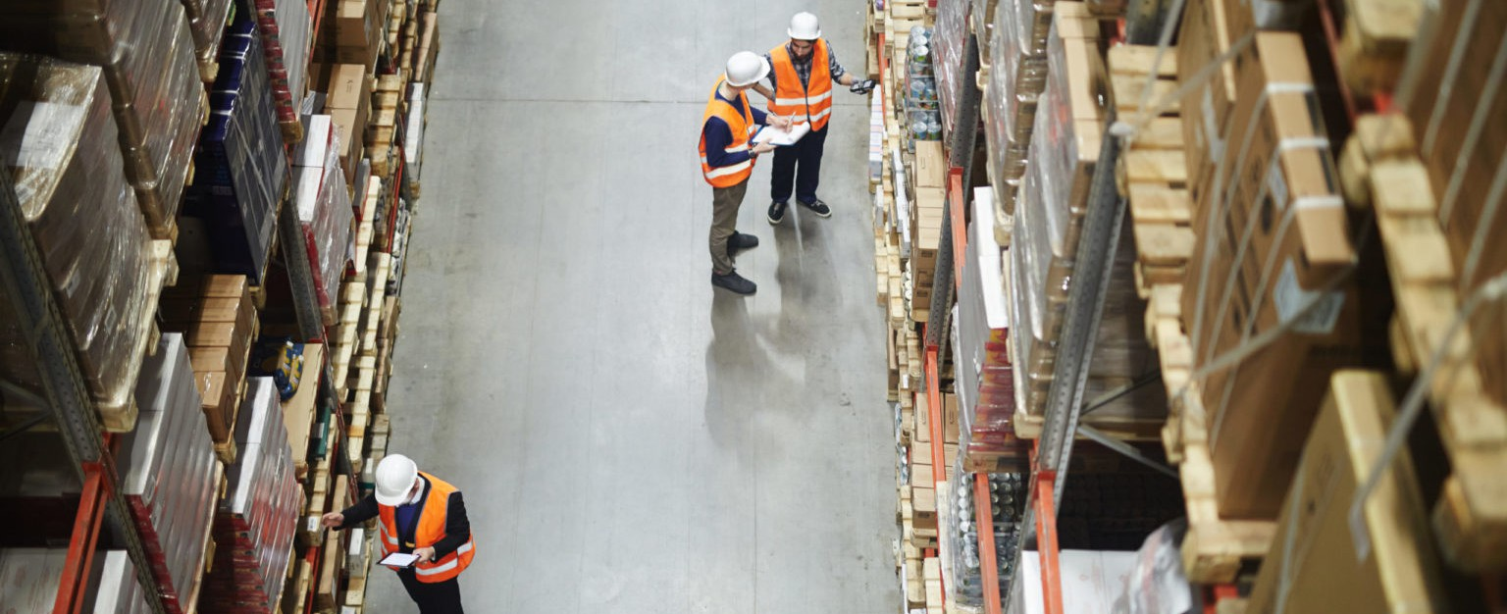

# Logistics

Helping Our Clients Realize Their Vision For Responsible Development In The American West Since 1885.

Logistics is a constantly evolving industry that spans several categories from material handling, trucking, employment and land use. Logistics is a broad term that encompasses the developers of the logistics buildings, contractors and operators and each face a myriad of issues starting with obtaining land use approvals, construction and continuing throughout the operations of a logistics facility.

Fennemore’s attorneys have wide experience with land use and regulatory permitting (i.e. endangered species, cultural resources and water (stormwater and water rights) through to employment and business compliance (including tariffs and trucking). We are able to assist and guide clients through all aspects of Logistics and can coordinate with all departments of local, regional, state and federal governments to address any unique matters in the states where we provide representation, including Arizona, California, Colorado and Nevada.

### LEADERSHIP

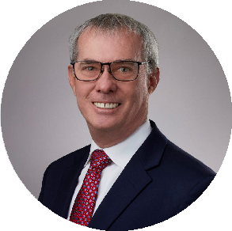[LOGISTICS](https://www.fennemorelaw.com/services/logistics/) [LAND USE](https://www.fennemorelaw.com/services/land-use/)

[**Brent McManigal**](https://www.fennemorelaw.com/people/attorneys/brent-mcmanigal/)

Director

[**San Bernardino**](https://www.fennemorelaw.com/contact-us/#san-bernardino)

PH 909.723.1807

FX 909.890.9877

[bmcmanigal@fennem](mailto:bmcmanigal@fennemorelaw.com) [orelaw.com](mailto:bmcmanigal@fennemorelaw.com)

## RESOLVING CHALLENGES

Logistics continues to evolve and become more complex, our attorneys help clients find creative solutions throughout a project. We advise private and public sector clients in all aspects of development and permitting, including litigation whether that litigation results from the land use entitlements, operational issues or regulatory compliance. Fennemore’s team of attorneys offer a broad background of experience and often unique skills based on years of experience.

Our team will support you throughout your business, from inception to conclusion all aspects of your logistics business we are able to assist. Whether it be land acquisition, land development, compliance, or business operations (mergers and acquisitions) Fennemore can meet your

needs. With a firm history spanning more than 140 years, our attorneys have the experience, agency connections, and legal knowledge to handle any matter effectively and efficiently.

## CONTACT US

Please do not hesitate to contact us about your needs and how we can assist your business. Our attorneys have decades of experience representing clients seeking to develop property for a logistics use or operate a logistics use, and are available for you.