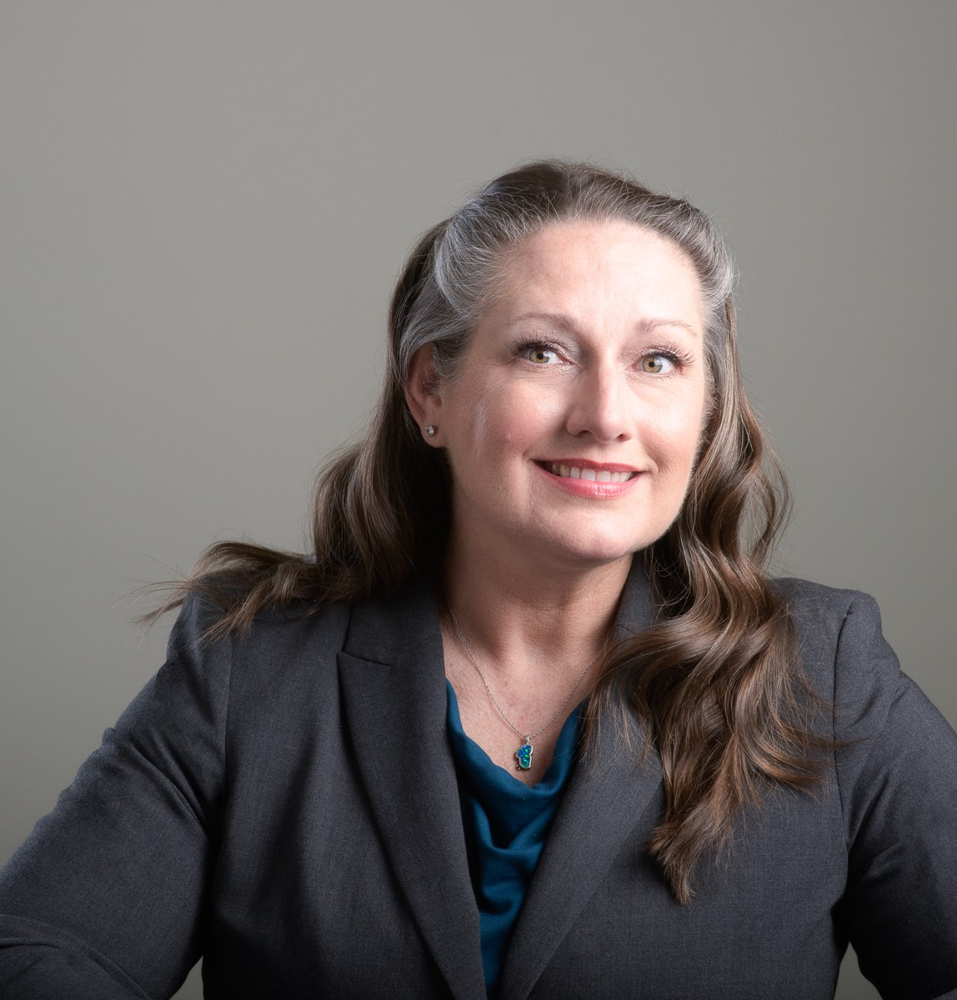

MICHELINE NADEAU FAIRBANK

Of Counsel

[Natural Resources](https://www.fennemorelaw.com/services/natural-resources-energy-and-environmental/)

[Reno](https://www.fennemorelaw.com/contact-us/reno/)

P: 775.788.2210

F: 775.788.1177

[mfairbank@fennemorelaw.com](mailto:mfairbank@fennemorelaw.com)

“

Continuous improvement is better than delayed perfection

Mark Twain

**MICHELINE NADEAU FAIRBANK**

”

Micheline Fairbank is an engaged and results driven Of Counsel attorney with broad experience involving the management and resolution of controversial and complex matters who practices in our Business Litigation and Natural Resources practice groups from our Reno, NV office. With many years of experience handling a broad spectrum of civil matters, including extensive trial and appellate experience and a practice focused on water and natural resource law, Micheline most recently served as a Deputy Administrator for the Nevada Division of Water Resources. In this capacity, Micheline worked with the Nevada State Engineer in administering Title 48 of the Nevada Revised Statutes in the management of water rights and the Silver State’s water resources.

Micheline also represented the Nevada Division of Environmental Protection in handling a variety of permitting and compliance matters involving hazardous waste disposal and

management, the Comprehensive Environmental Response, Compensation and Liability Act

(CERCLA), mine reclamation, the Clean Water Act (CWA), the Safe Drinking Water Act (SDWA) and related state environmental laws.

Micheline also has experience handling legislative matters and has extensive practice experience before the Nevada State District Courts, Federal District Courts in Nevada and California, the Ninth Circuit Court of Appeals, the National Labor Relations Board, the Equal Opportunity and Employment Commission, and state administrative agencies.

Born and raised in Northern Nevada, Micheline is known for finding unique solutions to challenging problems. She has the rare ability to work outside of the box – or inside the constraints of the box depending on the matter – and she takes great pride in discovering

resolutions in a timely, economic and efficient manner. Conscientious and efficient, finding success that is meritorious for her clients is Micheline’s ultimate goal.

Outside of work, Micheline is married to an avid runner and reformed ultra-marathoner, so she supports this insanity by being active in local running organizations, including operating the Tunnel Creek Aid Station at the Tahoe Rim Trail Endurance Runs. Along with her family, she also enjoys exploring the backcountry, camping, hunting and fishing, and gardening.

# EDUCATION

B.A., Western Colorado University, cu*m laude*

J.D., Willamette University College of Law

# AREAS OF PRACTICE

Natural Resources Business Litigation

# REPRESENTATIVE CASES

*Coachella Valley Water District v. Agua Caliente Band of Cahuilla Indians*, United States Supreme Court Case Nos. 17-40, -42.

*United States v. United States Board of Water Commissioners*, 893 F3d 578 (9th Cir. 2018)

# PROFESSIONAL AND COMMUNITY ACTIVITIES

Western States Water Council Executive Committee, 2019-2023 Western States Water Council, Legal Committee, 2019-2023

Western States Water Council, Non-Tribal Federal Water Needs Subcommittee, 2018-Present Western Regional Partnership, Water Security Committee, 2019-2023

Nevada Supreme Court Commission to Study the Adjudication of Water Law Cases, 2021-2023 Board of Directors, Walker Basin Conservancy, 2023-present

Conference of Western Attorneys General, Western Attorney General Legal Action Committee, July 2014-April 2018

# ARTICLES AND PRESENTATIONS

Presenter, “Stormwater Runoff Hot Topics and Case Law Updates” Live Online Seminar, June 3, 2025

Interview, “[Thursday Thoughts with Micheline Nadeau Fairbank: Harnessing Nevada’s Lithium](https://www.fennemorelaw.com/thursday-thoughts-with-micheline-nadeau-fairbank-harnessing-nevadas-lithium-potential/) [Potential](https://www.fennemorelaw.com/thursday-thoughts-with-micheline-nadeau-fairbank-harnessing-nevadas-lithium-potential/),” Fennemore Blog, May 2, 2024

Featuring, “People: Micheline Fairbank joins the Fennemore Craig Business Litigation and Natural Resources practice groups,” Northern Nevada Business Weekly, May 29, 2023

[Interview, “I always love how there is something new to learn every time and, in every case,](https://www.fennemorelaw.com/i-always-love-how-there-is-something-new-to-learn-every-time-and-in-every-case-and-situation/) [and situation,” Fennemore Blog, May 11, 2023](https://www.fennemorelaw.com/i-always-love-how-there-is-something-new-to-learn-every-time-and-in-every-case-and-situation/)

State Groundwater Management and Federal Reserved Water Rights: What’s Next? ABA Section of Environment, Energy, and Natural Resources Water Resources Committee Newsletter, March 2018

# ADMISSIONS

California Colorado Nevada

United States District Court, District of Nevada

United States District Court, Northern District of California United States District Court, Eastern District of California United States District Court, Central District of California United States District Court, Southern District of California 9th Circuit Court of Appeals

United States Supreme Court