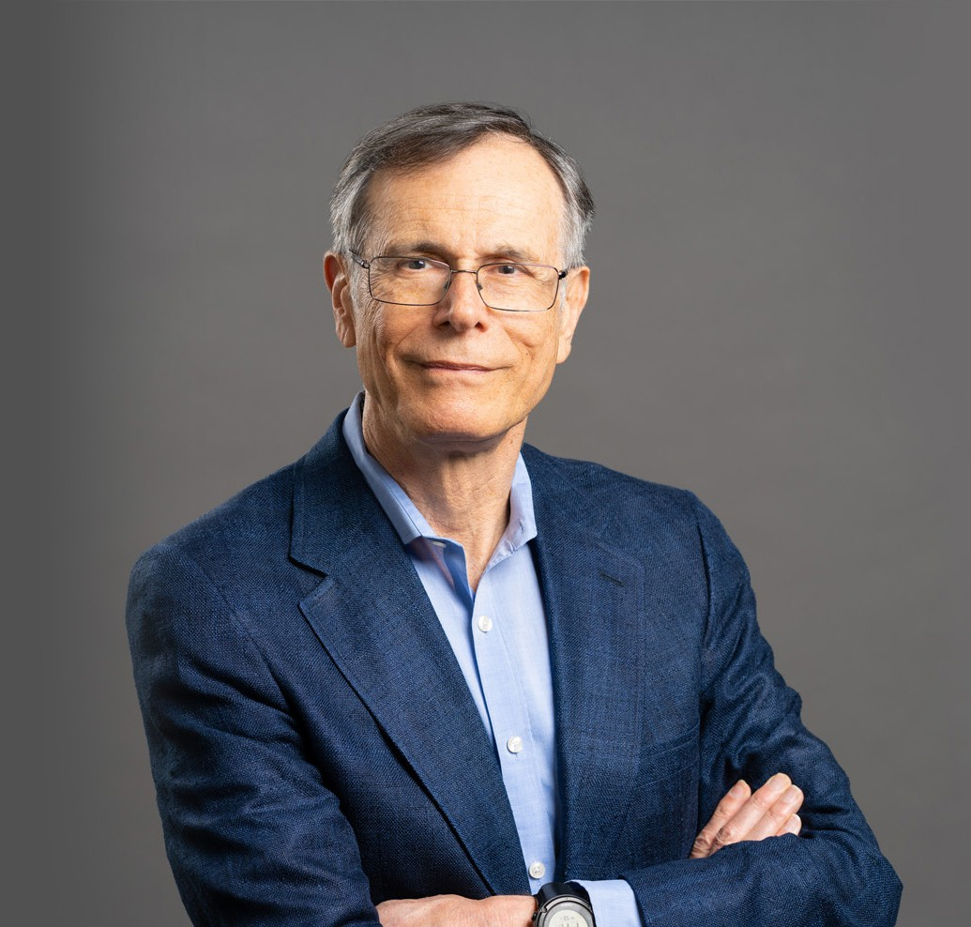

RICHARD A. LYONS

Director

[Business & Finance](https://www.fennemorelaw.com/services/business-and-finance/)

[Oakland](https://www.fennemorelaw.com/contact-us/oakland/)

P: 510.834.6600 F: 510.834.1928

[rlyons@fennemorelaw.com](mailto:rlyons@fennemorelaw.com)

## RICHARD A. LYONS

Richard is highly experienced in corporate, securities, and intellectual property (IP) law. He co- founded the firm’s intellectual property and green business practice groups and has deep

insight in a broad range of business and legal matters. Richard is passionate about helping visionary companies meet their objectives.

### Corporate

Versed in all aspects of the “business of business,” Richard guides clients in legal matters related to operations, organization, financing, and mergers and acquisitions. He assists clients in entity formation, corporate governance, shareholder agreements, equity and debt financing, distribution and vendor agreements, covenants not to compete, and employment agreements, and has represented companies and investors in venture capital rounds and private equity

transactions.

### Securities

Richard has represented both companies and professional investors in countless exempt private securities transactions, including founders, accredited investors, venture capitalists, private

equity, family offices, and strategic investors. He is experienced with disclosure and registration requirements under state Blue Sky and federal securities laws. He has advised clients on private placement memoranda, stock purchase agreements, structuring investor preferential returns, representations and warranties, and related ancillary agreements.

### Intellectual Property

Richard is experienced with trademarks, trade secrets, copyright and patent licensing, and advises clients concerning the selection and clearing of trademarks, the protection of

trademarks, and infringement issues. He has represented retail brands and businesses involved in digital entertainment and production services. With a background in computer programming, Richard has substantial legal experience advising software companies and, developers of enterprise products, including cloud-based software-as-a-service (SaaS).

### Food and Beverage

For more than two decades Richard has guided food and beverage companies, including natural and organic businesses and investors, in matters related to growing, manufacturing and production, co-packing and contract manufacturing, distribution, retail and online retail, food

service, consumer brands, FDA labeling requirements, and third party certifications, such as Organic, Non-GMO and Fair Trade. He has also worked on product recalls and product recall insurance coverage issues.

## EDUCATION

J.D., University of California, Berkeley, School of Law B.A., University of California, Irvine

**AREAS OF PRACTICE**

# OTHER EXPERIENCE

Natural & Organic Products Business & Finance

Food & Beverage Advanced Energy Intellectual Property

## REPRESENTATIVE CASES

Represented investor in sports equipment manufacturing company in sale to Dutch public company for $150+ million.

Represented seller of software as a service to major U.S. public cable company.

Represented investor in Canadian natural food company in $100+ million sale to public U.S. company.

Represented venture capital fund as lead or co-lead investor in 15 financings in the natural foods and products industry.

Represented real estate entrepreneurs in connection with offerings by 12 LLC’s raising approximately $50 million from investors.

Represented consumer products company in $5 million Series A offering. Represented organic food company in $5+ million Series A offering.

Represented organic food company in $3+ million Common Stock offering. Represented natural online retailer in convertible debt offerings.

Represented buyer in leveraged buy-out of ingredient supply company.

Represented CGI-based creative services company in more than 30 transactions with major and independent film studios, advertising agencies and game companies.

Represented major land owner in Altamont Pass in connection with $100+ million repowering wind projects.

Represented municipal utility in contracts with power suppliers and users of substation facilities.

Represented fair trade organic food company in $5 million Series B offering.

Represented organic and fair trade food manufacturer in acquisition of North American trademark rights and worldwide trademark registration matters.

Represented largest West Coast distributor of natural food in merger that created the largest

U.S. distributor of natural food

## PROFESSIONAL AND COMMUNITY ACTIVITIES

Past President, Alameda Chamber of Commerce Director, Alameda Chamber of Commerce Director, Trans Pacific National Bank

Director, Inner City Advisors

Co-Chair, Silicon Island Technology Consortium (SITCON) Director and Corporate Secretary, California Jazz Conservatory Member, Corporations Section, California State Bar Association

Member, Intellectual Property Section, California State Bar Association Member, Alameda County Bar Association

Member, Wakefield Jazz Sextet

## ADMISSIONS

California