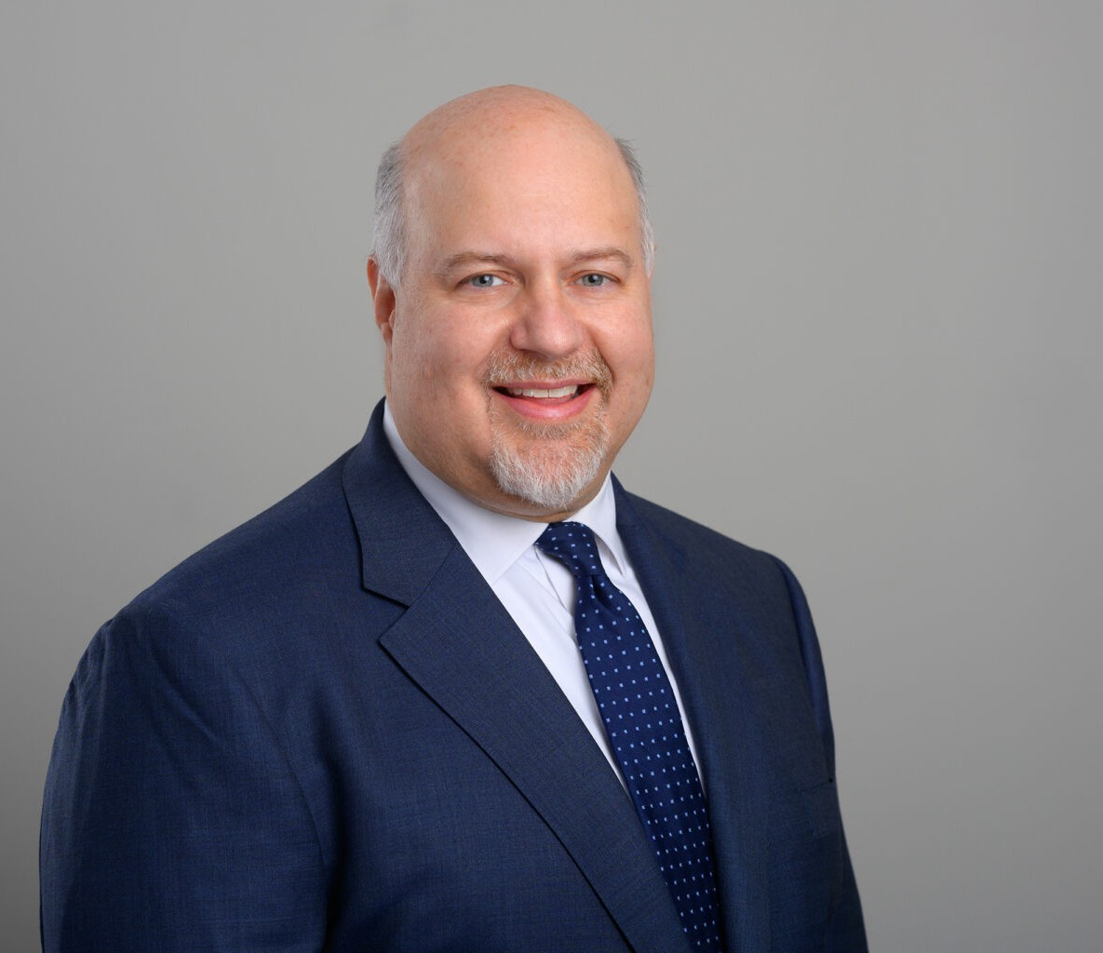

TIMOTHY C. EARL

Director

[Business Litigation](https://www.fennemorelaw.com/services/business-litigation/)

[San Diego](https://www.fennemorelaw.com/contact-us/san-diego/)

P: 619.595.3279

F: 619.231.4372

[tearl@fennemorelaw.com](mailto:tearl@fennemorelaw.com)

# TIMOTHY C. EARL

Timothy C. Earl, an insurance coverage, construction and business litigation attorney, is a skilled litigation attorney with a focus on comprehensive insurance coverage and construction law. His practice spans, insurance coverage, construction litigation and business litigation, handling

complex cases including policy interpretation and bad faith litigation.

In insurance coverage litigation, Timothy represents policyholders and insurance companies in a variety of insurance coverage disputes primarily involving property damage or bodily injury arising out of construction defect and asbestos claims. He represents policyholders in declaratory relief and bad faith actions against insurers, and has represented insurers in subrogation and contribution actions against other insurers.

In construction litigation, Timothy represents a wide array of clients, such as developers, architects, and contractors in both residential and commercial projects. He’s skilled at managing indemnity claims, construction defect cases, mechanic’s lien disputes and bid protests. His knowledge also extends to representing sureties on bond claims.

Additionally, Timothy’s business litigation experience includes representing companies in disputes related to real estate, unfair competition, and various tort claims. His ability to provide strategic, efficient legal solutions makes him a valuable asset in the construction and insurance legal

sectors.

# EDUCATION

J.D., University of San Diego School of Law B.A., University of California, Davis

# AREAS OF PRACTICE

Business Litigation Construction Law Insurance Coverage

# AWARDS AND HONORS

AV® Preeminent™ Peer Review Rating by Martindale‐Hubbell

Top Rated Litigator by the Legal Leaders of ALM, 2021-2023

Best Lawyers in America® in the field of Litigation – Construction Super Lawyer – Insurance Coverage, 2019-2023

Top San Diego Lawyer, San Diego Magazine, 2013-2023, 2025 Top 100 Leaders in Law by San Diego Business Journal

Top Lawyer of Southern California by LA Times, 2014-2024

Top San Diego Attorney in Insurance Coverage by San Diego Daily Transcript Top 1% of The American Registry, “Best of the Best”

# ARTICLES AND PRESENTATION

Co-Chair & Presenter, “Understanding Deductibles and Self-Insured Retentions,” The Seminar Group’s Insurance in Construction Industry Seminar, January 2023

Co-Chair & Presenter, “WRAP Insurance Live Webcast,” The Seminar Group, January 2021

Author, “Does Business Interruption Insurance Cover COVID-19 Related Business Shutdowns in California, Firm Newsletter, 2020

Presenter, “Construction Law: Wrapping Your Head Around Wrap Policies,” AGC San Diego, November 2017

Presenter, “Insurance Archaeology – Raiders of the Lost Policies,” San Diego County Bar Association, May 2016

Presenter, “California Law for Design Professionals,” Lorman Education Services, September 2002

# PROFESSIONAL AND COMMUNITY ACTIVITIES

Member, Construction Lawyers Society of America Member, Trial Law Institute

Member, Diversity Law Institute Member, American Bar Association

Member, San Diego County Bar Association Member, Building Industry Association of San Diego

Member, Claims and Litigation Management Alliance

# ADMISSIONS

California

U.S. District Court for Central, Northern, Eastern and Southern Districts of California Washington

U.S. District Court for the Western District of Washington