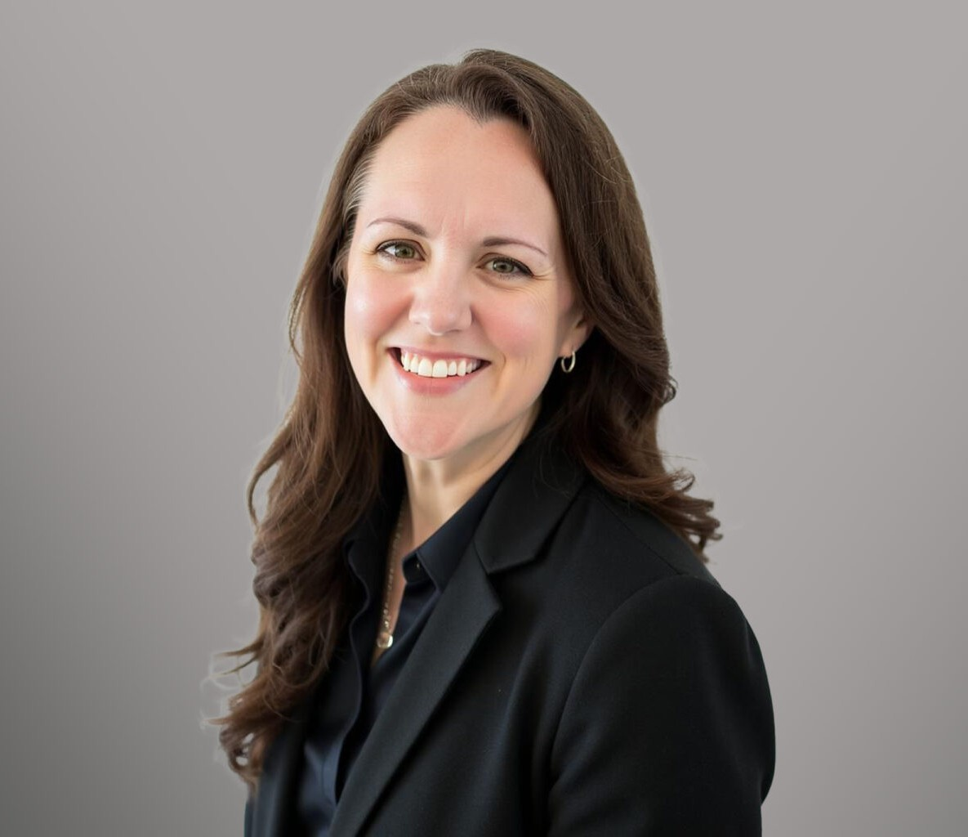

BREENA ROOS

Of Counsel

[Business Litigation](https://www.fennemorelaw.com/services/business-litigation/)

[Seattle](https://www.fennemorelaw.com/contact-us/seattle/)

P: 206.822.6809 F: 206.749.0600

[broos@fennemorelaw.com](mailto:broos@fennemorelaw.com)

## BREENA ROOS

Breena Roos is an Of Counsel attorney in Fennemore’s [Business Litigation](https://www.fennemorelaw.com/services/business-litigation/) practice group. With more than 20 years of experience representing clients in both federal and state courts, Breena has handled disputes involving consumer protection, intellectual property, contracts,

government investigations, and class actions. She approaches complex legal challenges with a practical, business-minded perspective, aiming to deliver efficient and effective solutions tailored to her clients’ goals.

Breena brings deep public-sector experience to her practice, having served at the Federal Trade Commission, where she investigated and prosecuted companies for unfair or deceptive business practices and promoted public awareness through consumer education initiatives.

Breena also worked as a Managing Assistant Attorney General at the Washington State Attorney General’s Office, where she litigated high-impact consumer protection cases and advanced the state’s enforcement priorities. Prior to government service, Breena practiced at Perkins Coie in Seattle.

Breena earned her law degree at Boston University School of Law. She also holds a Masters of Business Administration from the University of Cambridge, where she worked with a local nonprofit organization on their fundraising operations and developed a framework for an international non-governmental organization to evaluate funding sources aimed at reducing poverty in rural Thailand and Cambodia.

Breena is an active member of her community. She volunteers with the Girl Scouts of Western Washington and serves on the Board of Directors for the Renton Rowing Center. Outside of her professional work, Breena enjoys spending time outdoors and with her daughter.

## EDUCATION

M.B.A., University of Cambridge, Judge Business School J.D., Boston University School of Law, *cum laude*

B.A., University of Washington

**AREAS OF PRACTICE**

# OTHER EXPERIENCE

Class Actions

Consumer Protection Business Litigation

Intellectual Property Privacy & Data Security

## REPRESENTATIVE MATTERS

Obtained $7.2 million in consumer redress in administrative litigation of FTC Act claims against a two-sided platform connecting home service providers and homeowners.

Investigated a Fortune 100 company regarding potential violations of FTC Act and Fair Credit Reporting Act relating to data collection and sharing practices.

Achieved $4.5 million consent judgment in consumer protection and pyramid scheme lawsuit against a multi-level marketing company.

Obtained consent judgment and $9.9 million in consumer restitution in resolution of consumer protection litigation against medical device manufacturers.

Secured judgment and injunction following bench trial in representation of class of indigent misdemeanor defendants seeking enforcement of their constitutional right to counsel.

Achieved unanimous defense verdict in federal court lawsuit alleging privacy, contract, and consumer protection claims against technology company.

Defended biotechnology company in criminal and civil False Claims Act and Food, Drug and Cosmetic Act investigation arising from clinical research and marketing activities.

Defeated class certification in putative class action alleging consumer protection, contract, and Stored Communications Act claims against technology company.

Achieved partial summary judgment and settlement in constitutional challenge to felony public defense system in Grant County, Washington.

## AWARDS AND HONORS

Civil Libertarian Award, American Civil Liberties Union of Washington, 2014

Champion for Justice Award, Washington Association of Criminal Defense Lawyers, 2014 President’s Award, Washington Defender Association, 2014

Washington Law & Politics, Rising Stars of Washington Law, 2010, 2012, 2013 Outstanding Young Lawyer Award, WSBA Young Lawyers Division, 2007

Pro Bono Award, Perkins Coie LLP, 2005, 2013

## ARTICLES AND PRESENTATIONS

Contributor, American Bar Association, *State Consumer Protection Law,* ABA Antitrust Law Section, 2022

Author, Note, The Quest for Equality: Comprehensive Insurance Coverage of Prescription Contraceptives,” 82 B.U.L. REV. 1289, 2002

## PROFESSIONAL AND COMMUNITY ACTIVITIES

Girl Scouts of Western Washington, Volunteer, 2019–Present Renton Rowing Center, Board of Directors, 2024–Present Metrocenter YMCA, Board of Managers, 2011–2016

## ADMISSIONS

Washington

United States Court of Appeals, Ninth Circuit

United States District Court, Western District of Washington United States District Court, Eastern District of Washington