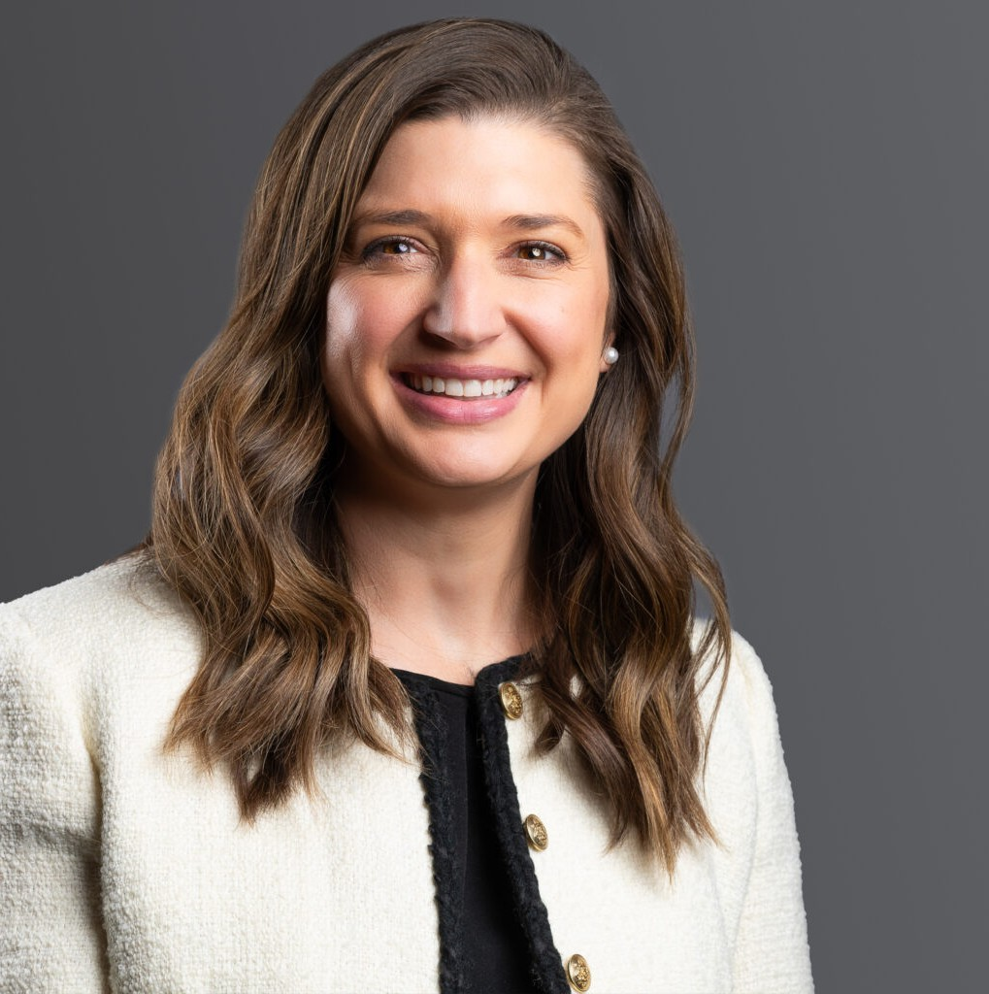

CALEENA S. BRAIG

Director & Director of Legal Talent Acquisition

[Business Litigation](https://www.fennemorelaw.com/services/business-litigation/)

[Denver](https://www.fennemorelaw.com/contact-us/denver-2/)

P: 303.813.3808

F: 303.291.3201

[cbraig@fennemorelaw.com](mailto:cbraig@fennemorelaw.com)

# CALEENA S. BRAIG

As a member of the Business Litigation team, Caleena represents clients in various civil litigation matters, including commercial, business, and employment claims. Her experience in contractual disputes allows her clients to keep the value of the contract intact while obtaining favorable

outcomes. Caleena has experience in strict liability claims, property damage, and wrongful termination claims, in addition to construction defect, professional liability, and FELA claims.

She also has experience litigating jury trials and arbitrations and has managed all aspects of litigation in state and federal court in cases across the country. This includes conducting and defending lay, corporate, and expert witness depositions, preparing witnesses for trials, managing all aspects of discovery, drafting pleadings and motions, and attending hearings.

Before joining Fennemore, Caleena worked for a regional litigation firm. While there, her accomplishments included defending a Fortune 500 company through all stages of litigation nationwide. She also obtained summary judgments in defense of personal injury lawsuits.

Additionally, she worked with a litigation defense firm in Dallas, Texas, litigating numerous jury trials and, prior to that, a national toxic tort law firm representing Fortune 500 companies in product liability, premises liability, and environmental litigation.

Outside of the office, Caleena enjoys spending time with her family, enjoying new restaurants, traveling and learning, and reading. She also enjoys watching sports with her husband and staying active outside with her daughters.

# EDUCATION

J.D., Baylor University B.S., University of Texas

# AREAS OF PRACTICE

Business Litigation

Employment & Labor

# AWARDS AND HONORS

*Best Lawyers® Ones to Watch*, 2022 – 2024

*Colorado Super Lawyers®* Rising Star*®*, 2022 – 2025

*Colorado Super Lawyers®* Rising Star*®*, 2019 Texas Super Lawyers Rising Star, 2018

# ARTICLES AND PRESENTATIONS

Author, “Advice for Women in Male-Dominated Fields,” Firm Blog, March 2022

Quoted, “Supreme Court Ruling Likely Spells the End for Vaccine-or-Test Federal Mandates at Large Businesses, But Numerous Caveats Apply”

Corporate Compliance Insights, January 2022

Author, “OSHA’S Emergency Temporary Standard is Postponed Pending Review,” Firm Blog, January 2022

Author, “Preparing To Meet OSHA’s Est Rulings Pending Court Ruling On Constitutionality,” HR Legal & Compliance, December 2021

Author, “What does OSHA’s EST ruling mean for builders?” Colorado Builder, November 2021

Author, “Preparing to Meet OSHA’s EST Rulings Pending Court Ruling on Constitutionality,” Law Week Colorado, November 2021

Author, “While Courts Consider OSHA’s Vaccine-or-Test Mandate ETS, Businesses Are Caught in Limbo,” Corporate Compliance Insights, November 2021

Co-author, “Silver Linings Provide Optimistic Future for Litigation Post-Pandemic,” ColoradoBiz, September 2021

Author, “Keep an Eye Out, Employers: The Colorado Legislature Proposed Changes to Colorado Anti-Discrimination Statute,” Law Week Colorado, May 2021

Author, “8 Things You Need to Know About Employee Vaccinations,” Colorado Builder, March 2021

Co-author, “How the Pandemic Will Impact Litigation Beyond 2021,” ColoradoBiz, December 2020

Author, “Identifying the Legal Boundaries of Employer’s GPS Use,” Texas Lawyer, December 2015

Quoted, “Wellness Programs Due for Privacy Scrutiny, Experts Say, ”HealthcareDive, October 2015

Quoted, “Employers take note: Americans with Disabilities Act payouts soaring in Texas,” Dallas Business Journal, December 2014

Speaker, “Dealing with a Snap Chatterbox: Social Media Use in Litigation,” Texas Association of Defense Counsel Annual Meeting, September 2017

Speaker, “The World of Veterinary Malpractice Claims,” Zurich Insurance, June 2017 Panelist, “Medical Malpractice isn’t Dead,” Dallas Bar Association CLE, 2016

Speaker, “Defending a Claim for Malpractice and Board Actions: Defense, Damages, and Success,” Zurich Insurance, September 2015

# PROFESSIONAL AND COMMUNITY AFFILIATIONS

Member, Colorado Bar Association Junior League of Denver

Board Member, Mile High 360 Member, Texas Bar Association Member, American Bar Association

# ADMISSIONS

Colorado Montana Texas

U.S. District Court – Eastern District of Texas

U.S District Court – District of Colorado

U.S. District Court – Northern District of Texas

U.S. District Court – Southern District of Texas

U.S. District Court – Western District of Texas