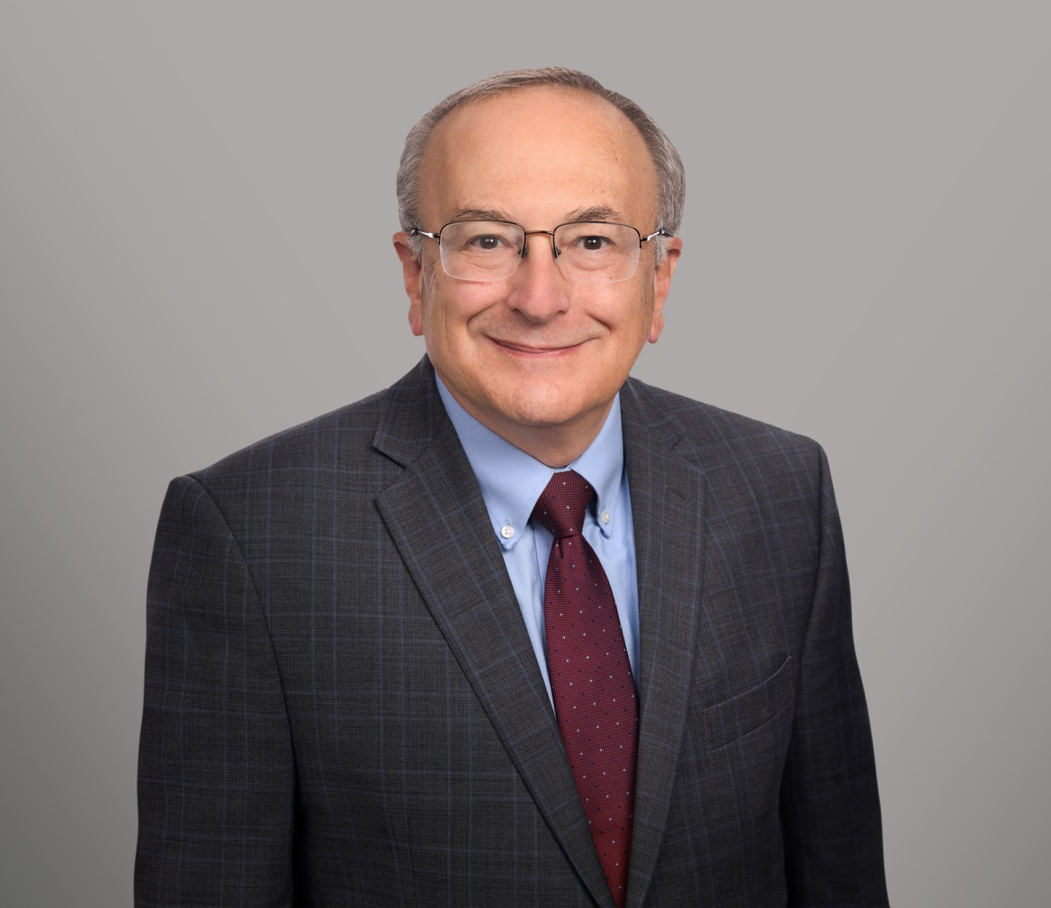

CAMERON HESS

Director

[Business & Finance](https://www.fennemorelaw.com/services/business-and-finance/)

[Sacramento](https://www.fennemorelaw.com/contact-us/sacramento/)

P: 916.273.1810

F: 916.920.5286

[chess@fennemorelaw.com](mailto:chess@fennemorelaw.com)

# CAMERON HESS

Cameron L. Hess brings unique dual experience in taxation and business law to the firm’s transaction department. As a Certified Public Accountant with a former tenure at KPMG, Cameron combines his accounting acumen with over 30 years of legal experience. His practice is marked by a comprehensive approach to real estate, business transactions, estate planning, nonprofit, and tax controversy at federal, state, and local levels.

Noted by his ability to navigate complex IRS negotiations and tax litigation, Cameron offers clients representation in tax disputes, leveraging his understanding of both legal and financial aspects. His diverse practice serves several industries and closely held businesses, including real estate, manufacturing, and services, providing integrative planning that addresses the intricate interplay of business operations and tax implications.

# EDUCATION

J.D., University of Southern California School of Law

M.S. University of Southern California B.S., University of California, Berkeley

# AREAS OF PRACTICE

Business & Finance Mergers & Acquisitions Real Estate

Tax Law

Trusts & Estates Estate Planning

# AWARDS AND HONORS

AV Preeminent 5.0 Peer Review Rated by Martindale-Hubbell

# ARTICLES AND PRESENTATION

Author, “[Navigating unitary taxation in California for businesses and non-residents](https://www.bizjournals.com/sacramento/news/2024/08/01/unitary-taxation-california-businesses-nonresident.html),” Sacramento Business Journal, August 1, 2024

Presenter, Corporate Transparency Act Presentation, Firm Presentation, February 15, 2024 Co-Author, Corporate Transparency Act, Firm Newsletter, January 19, 2024

Presenter, Real Estate Virtual Conference, CalCPA, January 19, 2024

Interview, How To Factor In Taxes When Considering Special Needs Trusts / (ABLE) Accounts, Financial Advisor, July 13, 2021

# PROFESSIONAL AND COMMUNITY ACTIVITIES

Contributing Writer, Spidell’s California Tax Letter Member, Tax Section, American Bar Association Member, Tax Section, State Bar of California Member, Business Section, State Bar of California

Member, Tax Section, Sacramento County Bar Association Member, Business Section, Sacramento County Bar Association Chair, CalCPA Estate Planning Committee

Chair, CalCPA Chapter Real Estate Committee (RED Group) Member, Beta Alpha Pi

Member, Tax Law Journal (USC) Member, Phi Alpha Delta

Instructor, McGeorge Law School (Partnership Taxation)

# ADMISSIONS

California

U.S. Court of Appeals, 9th Circuit

U.S. District Court, Eastern District of California

U.S. District Court, Central District of California

U.S. Tax Court

Certified Public Accountant