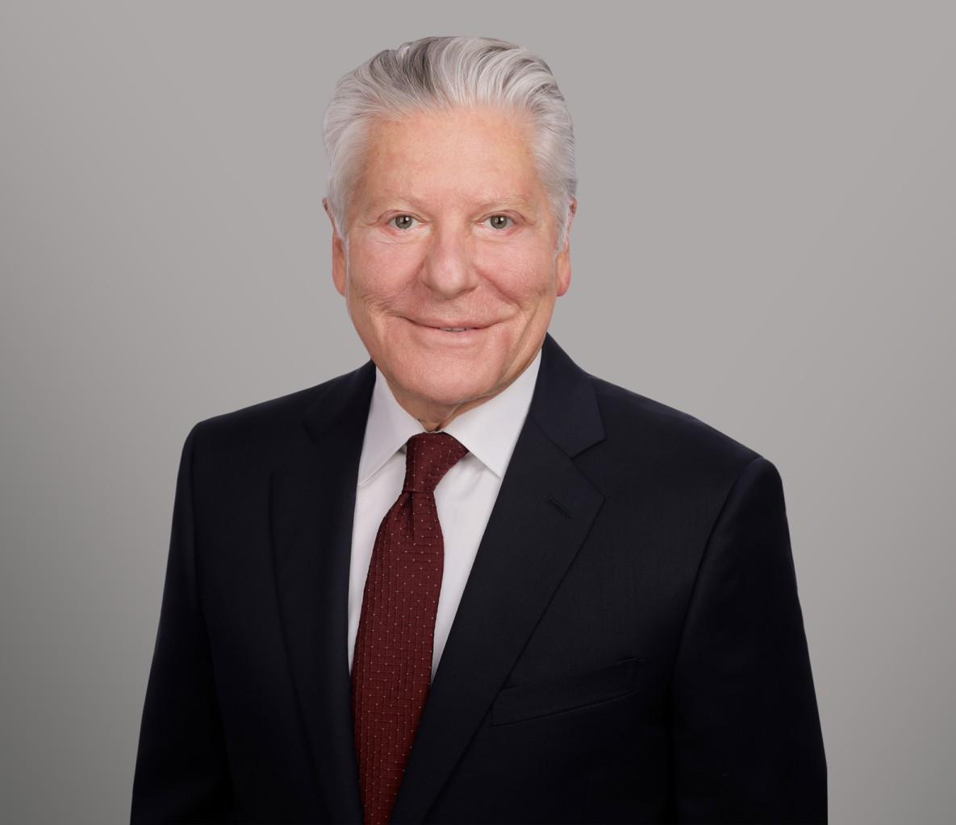

CARL P. BLAINE

Director

[Business Litigation](https://www.fennemorelaw.com/services/business-litigation/)

[Sacramento](https://www.fennemorelaw.com/contact-us/sacramento/)

P: 916.920.5286 F: 916.920.5286

[cblaine@fennemorelaw.com](mailto:cblaine@fennemorelaw.com)

## CARL P. BLAINE

Carl Blaine is a partner with 35 years of experience in federal and state litigation. His areas of expertise include business, partnership, corporate, real estate, fiduciary, probate and trust, elder and dependent adult abuse, and tax litigation. He is also skilled in complex litigation, including class actions related to agricultural products, commercial, and consumer matters. Carl’s track record in successfully bringing numerous jury and court trials to verdict showcases his expertise.

Before joining the firm, Carl served as a law clerk to Presiding Justice George A. Brown of the California Court of Appeal and as Deputy District Attorney in San Luis Obispo County. His extensive background provides a solid foundation for his successful practice areas in litigation.

## EDUCATION

Harvard Law School Negotiation Institute (Certificate of Completion, Mediating Disputes) J.D., University of the Pacific, McGeorge School of Law

B.A., University of California, Santa Barbara (High Honors)

**AREAS OF PRACTICE**

# OTHER EXPERIENCE

Elder Abuse Business Litigation Construction Law Estate Litigation Trusts & Estates Estate Planning

## AWARDS AND HONORS

Traynor Honor Society

AV Preeminent 5.0 Peer Review Rated by Martindale-Hubbell

## ARTICLES AND PRESENTATIONS

Co-Author, “[What the FTC’s new noncompete rule means for California businesses](https://www.bizjournals.com/sacramento/news/2024/08/08/ftc-noncompete-rule-california-businesses.html),” Sacramento Business Journal, August 8, 2024

## PROFESSIONAL AND COMMUNITY ACTIVITIES

Articles Editor, *Law Review Pacific Law Journal*

President, McGeorge School of Law Alumni Association Member, Sacramento County Bar Association

Member, State Bar of California

Founding Board Member of the Sacramento Zoological Society Served on Advisory Board of the U.C. Davis Children’s Hospital

## ADMISSIONS

California

U.S. District Court, Eastern, Northern and Central Districts of California

U.S. Tax Court

U.S. Court of Appeals, 9th Circuit

U.S. Bankruptcy Court, Eastern and Central Districts of California