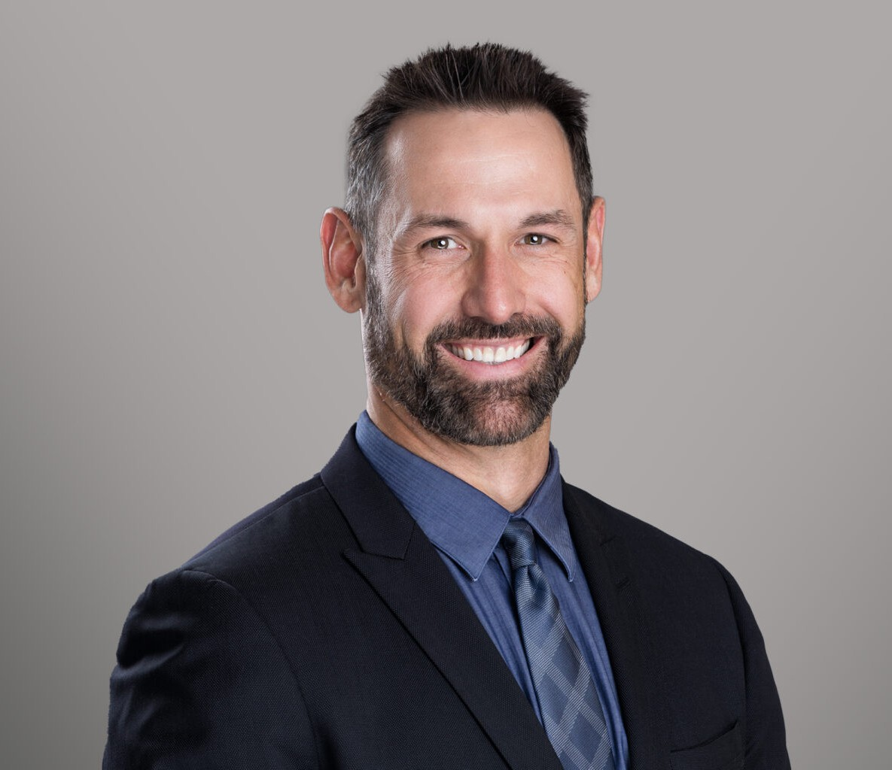

CRAIG WEAVER

Director

[Business & Finance](https://www.fennemorelaw.com/services/business-and-finance/)

[Reno](https://www.fennemorelaw.com/contact-us/reno/)

P: 775.788.2200 F: 775.786.1177

[cweaver@fennemorelaw.com](mailto:cweaver@fennemorelaw.com)

“

No one cares how much you know, until they know how much you care.

Theodore Roosevelt

**CRAIG WEAVER**

”

Craig Weaver is a Director at Fennemore based in Reno-Tahoe who assists business owners in establishing, growing, protecting, and selling their businesses.

Practicing law in Reno, Truckee, Lake Tahoe, Northern Nevada, and the Lost Sierra, Craig is an experienced litigator and transactional attorney. Craig now spends less time in the courtroom but draws heavily on that experience when advising entrepreneurs who are just getting started

as to the proper entity structure to best meet their needs, maximize efficiency, liability protection, and tax savings, whether that be an LLC, corporation, or limited liability partnership, and also when working with established business owners on mergers, acquisitions, equity incentive plans, real estate matters, corporate financing, secured transactions, capital raises, corporate

restructuring, and general corporate governance and compliance matters.

Craig is well known for his attention to detail, responsiveness, and methodical approach to the practice of law, which allows him to obtain the best result for each of his clients while always being mindful of each client’s individual needs. Craig is able to quickly recognize and define the issues his clients face and then work with them to develop strategies on how to best deal with each individual issue. As a former Certified Family Law Specialist, certified by the State Bar of California Board of Legal Specialization, Craig gained considerable experience litigating the nuances of phantom stock programs, profit sharing agreements, and restrictive stock units in the family law arena, as well as issues concerning the valuation of family-owned businesses and fractional ownership interests in businesses and real property holdings. Craig now works with individuals and business owners to help them structure or restructure these types of programs and ownership interests to avoid common pitfalls.

As a litigator, Craig has established a successful track record, including helping to facilitate favorable settlements for his clients. He has successfully argued cases and motions before the Superior Courts of Placer, Nevada, El Dorado, Sacramento, Plumas, Sierra, Alpine, Tuolumne, San

Francisco, Sonoma, Alameda, Yolo, San Joaquin, Stanislaus, Riverside, Orange, San Diego, and Los Angeles counties in the State of California, in the Eastern District of California, as well as in District Court in Washoe County, Nevada, and Kootenai County, Idaho, and Justice Court in Carson City and Incline Village, Nevada.

From 2023 through 2025, Craig has been named a “Super Lawyer” in Northern California by Thomson Reuters after having been named a “Rising Star” from 2017-2021. In 2019, Craig was admitted as a Fellow of the National Association of Distinguished Counsel. In 2017-2018, he was recognized as one of the 10 Best Family Law Attorneys in Northern California for Client Satisfaction by the American Institute of Legal Counsel, and in 2018, Craig was selected as one of the Top 10 Family Law Attorneys in California by the American Jurist Institute. In 2017, Craig was recognized as being one of the top 40 attorneys under the age of 40 in Northern California by The National Advocates, and in 2015 he was named as one of the Top Family Law Lawyers in Sacramento by Sacramento Magazine, received the Avvo Client’s Choice Award, and was nominated as a National Lawyer of Distinction in Family Law. A year earlier in 2014, Craig received an Honor Advocate award from the American Academy of Matrimonial Lawyers of Northern California for his performance at the Northern California Trial Practicum in San

Francisco.

Craig received his Juris Doctorate (J.D.) degree from the University of Idaho in 2009. He also received a Bachelor of Science (B.S.) degree in Business with an emphasis in Marketing and a minor in Public Relations from the same institution. Craig graduated magna cum laude near the top of his class and served as the president and executive director of various organizations while pursuing his undergraduate degree. In addition, in 2004, Craig was named the Outstanding Business Student of the Year by the prestigious Beta Gamma Sigma honor society, the business

equivalent to Phi Beta Kappa for liberal arts and science graduates, and is a recipient of the University of Idaho Alumni Award for Excellence.

Prior to joining Fennemore, Craig was a partner MOBO Law, LLP based in Lake Tahoe. Before going to law school, Craig served as the director of marketing for an international travel company based out of El Dorado Hills, California, and gained international experience working as a program director in the Bahamas, Mexico, and Canada for WorldPass Travel Group, LLC and International Student Tours, Inc. During law school, Craig gained substantial experience as a legal intern at Paine Hamblen, LLP, based out of Coeur d’Alene, Idaho, and Beck & Poorman,

LLC, based out of Hayden, Idaho, both highly respected firms in North Idaho and Eastern

Washington. As a third-year law student, Craig gained notoriety by successfully arguing a case before the Ninth Circuit Court of Appeals in San Francisco while serving as a member of the University of Idaho Legal Aid Clinic. Upon completion of his law degree, Craig returned to Northern California and founded American Dream Management, LLC, a California limited liability company providing management services to common-interest development community associations. Soon thereafter, in 2009, Craig began practicing law as a solo practitioner before joining Cordell & Cordell, P.C., one of the nation’s largest domestic relations litigation law firms, where he served as the lead attorney for the Sacramento office. In 2014, he joined Bartholomew & Wasznicky, LLP to better serve his clients as part of the most experienced family law firm in Northern California. In 2016, he moved to MOBO Law, LLP to expand his practice base and increase his presence in Truckee, Reno, Lake Tahoe, Northern Nevada, and the Lost Sierra. In

2025, Craig joined Fennemore to better serve his existing clientele and continue expanding his practice reach further into the Mountain West.

In his time away from the office, Craig enjoys mountain biking and spending time with his family. He is also an avid alpine and backcountry skier, competitive triathlete, and endurance runner,

having completed Ironman Lake Tahoe, Ironman Canada, Ironman Coeur d’Alene, XTERRA Lake Tahoe, XTERRA Tahoe City, and the Big Sur Marathon, among other races.

# EDUCATION

J.D., University of Idaho College of Law Dean’s List

B.S., University of Idaho, *magna cum laude*

Dean’s List

# AREAS OF PRACTICE

Business & Finance Construction Law

Emerging Businesses & Technologies Food & Beverage

Mergers & Acquisitions

# AWARDS AND HONORS

Super Lawyer, Thomson Reuters, 2023 – 2025

Rising Star, Thomson Reuters Super Lawyers, 2017 – 2021

National Association of Distinguished Counsel (The Nation’s Top 1%), Fellow, 2019 Top 10 Family Law Attorneys in California, American Jurist Institute, 2018

10 Best Family Law Attorneys in Northern California for Client Satisfaction, American Institute of Legal Counsel, 2017 – 2018

Top Lawyer Award, Avvo, 2018

Superb Attorney Rating, Avvo, 2018

Nominated as an Elite Advocate, American Institute of Legal Advocates, 2018

Nominated as a National Lawyer of Distinction in Family Law, Lawyers of Distinction, 2015 – 2019

Top 10 Attorneys in California, Attorney and Practice Magazine, 2017 Top 40 Under 40 (Northern California), The National Advocates, 2016 Excellent Attorney Rating, Avvo, 2016

Client’s Choice Award, Avvo, 2015

Top Family Law Lawyers in Sacramento, Sacramento Magazine, 2015 Very Good Rating, Avvo, 2015

Honor Advocate Award, American Academy of Matrimonial Lawyers Northern California Trial Advocacy Practicum, 2014

Intra-School Negotiation Competition – 1st Place, University of Idaho College of Law, 2008

2-Time CALI Excellence for the Future Award Recipient for being the highest scoring student in Constitutional Law and Wills, Estates, & Trusts during law school, 2007

University of Idaho College of Law Dean’s List, 2007 – 2009

Outstanding Business Student of the Year Award, Beta Gamma Sigma Honor Society, 2004 University of Idaho Alumni Award for Excellence Recipient, 2004

2-Time Kappa Sigma Member of the Year, Gamma Theta Chapter, 2003 – 2004

# ARTICLES AND PRESENTATIONS

UNLV Small Business Development Center Construction Workshop Presenter, Reno and Las Vegas, NV, 2024 – 2025

Contractors Association of Truckee Tahoe (CATT), Contracting Seminar Presenter, Truckee, CA, and Zephyr Cove, NV, 2020 – 2025

# PROFESSIONAL AND COMMUNITY ACTIVITIES

Board Member, Sierra Buttes Trail Stewardship Board Member, Clean Up the Lake

Local Government Affairs Committee Chairperson, Contractors Association of Truckee Tahoe (CATT)

Advisory Council Member, Friends of the Truckee Library Volunteer Ski Patrol, Sky Tavern

Member, Association of Ski Defense Attorneys (ASDA)

# ADMISSIONS

California Nevada

Idaho

Montana

Supreme Court of the United States of America

U.S. Court of Appeals 9th Circuit

U.S. District Court Eastern District of California

U.S. District Court Northern District of California

U.S. District Court District of Nevada

U.S. District Court District of Idaho