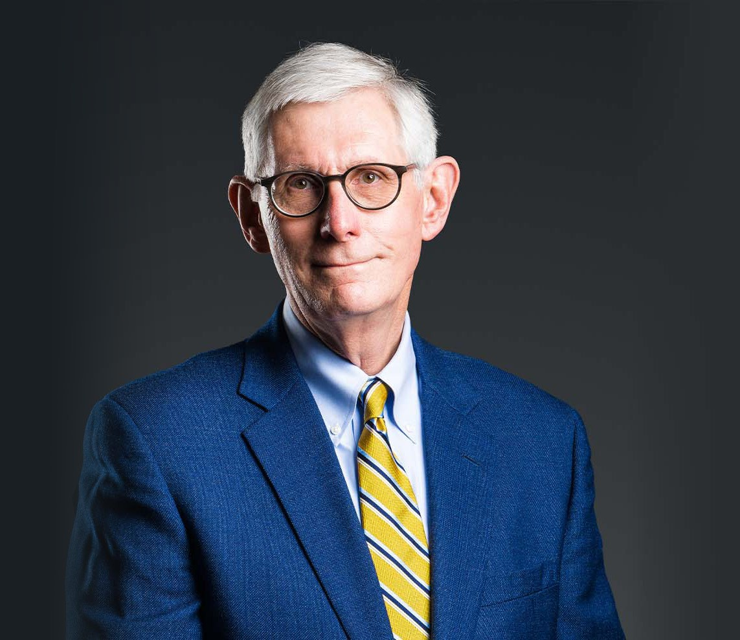

DAN R. REASER

Director

[Business & Finance](https://www.fennemorelaw.com/services/business-and-finance/)

[Reno](https://www.fennemorelaw.com/contact-us/reno/)

P: 775.788.2226 F: 775.788.2227

[dreaser@fennemorelaw.com](mailto:dreaser@fennemorelaw.com)

“

To give anything less than your best, is to sacrifice the gift.

-Steve Prefontaine

**DAN R. REASER**

”

For more than forty years, Dan has guided businesses navigating state and local licensing and regulatory responsibilities. His focus is on helping companies start, sustain and grow their organizations in the commercial gaming, financial services and public utility sectors. Dan leads a team that supports regulated firms with transactions, operational compliance, and licensing, permitting and other proceedings before administrative agencies or other government bodies.

His experience extends to government procurement disputes, judicial review of government action, eminent domain and government relations strategy. He also undertakes unique assignments for local governments in projects that leverage his expertise. Dan is General

Counsel to the firm’s client, Greater Nevada Credit Union, a state chartered financial institution founded in 1949 with over 1.7 billion in assets and more than 88,000 members.

Dan currently is the Chair of the Nevada Taxicab Authority Board, a five member citizen panel appointed by Nevada’s Governor, with oversight of the licensed taxicab industry in Clark

County, Nevada. He previously was the Chair of both the Nevada Private Investigators Licensing Board and the Nevada Standing Committee on Judicial Ethics and Elections Practices. Dan served in the Office of the Attorney General for Nevada as Chief Deputy for the Gaming

Division, where he represented the Nevada Gaming Commission and the Nevada Gaming Board. He was Chief Counsel to the Nevada Department of Transportation. During his tenure as a deputy attorney general, Dan was counsel to the Nevada Commissions on Economic

Development, Tourism and Environmental Protection, and the State Departments of Agriculture, Corrections, Minerals and Wildlife.

When time permits, you can find Dan with family in the beloved Sierra Nevada. A red Old Town Loon 111 kayak, a Trek Rockhopper mountain bike and a very comfortable pair of Vasque hiking boots are always at the ready.

## EDUCATION

J.D., California Western School of Law

B.A., California State University, Fullerton

**AREAS OF PRACTICE**

# OTHER EXPERIENCE

Government Procurement Business & Finance

Government Relations & Regulatory Gaming & Hospitality

Natural Resources

## REPRESENTATIVE MATTERS

Representations in 2024 director and key executive licensing and suitability determinations by Nevada Gaming Commission for Tracy Harris, Marcus Glover, Ameet Patel and Arik Knowles of Bally’s Corporation.

Regulatory support of Association of Gaming Equipment Manufactures in Nevada Gaming Control Board public workshops and working group sessions to improve gaming technology methods and efficiencies culminating in adoption of Gaming Technology Approval Guidelines (Notice No. 2024-53 dated May 28, 2024).

Engagement by Bally’s Corporation in 2023 registration and approvals by Nevada Gaming Commission for corporate holding company reorganization.

2023 engagement by Robert Parker, Inc. for transactional and Nevada Gaming Commission regulatory approvals in acquisition of multi-property gaming establishment operations at interstate travel facilities from Travel Centers of America, Inc.

Provide Nevada transactional and regulatory counsel to private equity firm in connection with 2023 mezzanine loan of $400 million to Nevada nonrestricted gaming licensee.

2023 representation of closely-held Nevada gaming holding company in transactional and regulatory compliance aspects of sale of five location casino and restricted operation

portfolio to Truckee Gaming, LLC.

Representation in 2022 of Great Basin Water Company in consolidated general rate case resolved by multi-party settlement before the Public Utilities Commission of Nevada.

Provide Nevada transactional and regulatory counsel to private equity firm in connection with $55 million loan transaction to Nevada nonrestricted gaming licensee in 2022.

Secure licensing in 2022 of San Pasqual Trust Company as Nevada retail trust company by Nevada Division of Financial Institutions.

2022 engagement by Bally’s Corporation in licensing, registration and approvals before the Nevada Gaming Commission to acquire Tropicana Las Vegas.

Representation of Bally’s Corporation in 2021 licensing, registration and approvals by Nevada Gaming Commission to acquire MontBleu Resort Lake Tahoe.

2021 Approvals for Everi Games, Inc. from Nevada Gaming Commission for multi-jurisdictional wide area progressive system.

2020 defense of approval and award of contract by Nevada Department of Transportation for Ennis-Flint, Inc.

2020 engagements by two insurance companies in obtaining health maintenance organization certificates of authority from the Nevada Division of Insurance.

Legislative engagement for Association of Gaming Equipment Manufacturers on 2019 passage of Assembly Bill 221 to expand gaming technology sector work force development.

Representation in 2019 of Wynn Las Vegas, LLC for Nevada Gaming Commission licensing of Marilyn Spiegel as the President for Las Vegas properties.

2019 legislative representation of McLane Company, Inc. on Senate Bill 81 excise tax amendments.

Engagement in 2019 by international payment processor firm in connection with multi- jurisdictional gaming regulatory compliance and licensing for associated equipment technology development for use in the casino point of sale operations.

Nevada special corporate and gaming counsel to underwriters in the initial public offering by social gaming technology company in 2019.

2018 engagement as counsel for Tronox, LLC in sale of Electrolytic Division to EMD Acquisition LLC.

2018 representation of MHM Solutions, Inc. in successful cancellation of contract award for temporary medical services by Nevada State Purchasing Division based on violation of state procurement laws.

Nevada special gaming counsel on 2018 working capital loan by international investment

bank to holding company of publicly traded multi-jurisdictional gaming resort hotel company.

2017 officer and director licensing and public share redemption transaction approval by

Nevada Gaming Commission for Tracinda Corporation as controlling shareholder the Estate of Kirk Kirkorian and largest private holder of equity stock in MGM Resorts International.

2017 approval for Calpine Energy Solutions, LLC of merger with ECP ControlCo, LLP and related license transfer.

Separate engagements during 2017 for a multi-property resort hotel firm, a gaming technology company, and a skill-based mobile games platform operator on multi- jurisdictional gaming regulatory matters relating to various social gaming and sports wagering platforms.

2016 preliminary finding of suitability for Station Casino’s Project Redfield Reno.

2016 negotiation for City of Boulder City of Post-2017 Hoover Power electric service contract and related agreements with United States Bureau of Reclamation and Western Power

Administration.

2015 passage for the Association of Gaming Equipment Manufacturers of Senate Bill 9 and related adoption of Nevada Gaming Commission regulations authorizing development and play in Nevada of electronic skill-based games.

2014 licensing and approvals for acquisition by Global Cash Access Holdings, Inc. of Multimedia Games Holding Company, Inc.

2013 adoption for International Game Technology and Bally Technologies, Inc. of Nevada Gaming Commission Regulations authorizing multi-state progressive prizes for linked slot

machines.

2012 and 2011 licensing and approvals for acquisition by private equity consortium of Aliante Casino & Hotel from Stations Casino, LLC.

2011 approval of utility environmental protection act permits for Armagosa Valley Solar I, LLC to construct 500 megawatt solar generation plant.

2011 and 2010 approvals for credit facilities and notes offerings by International Game Technology.

2011 and 2009 legislative engagements for the Association of Gaming Equipment Manufacturers on Assembly Bill 294 and Senate Bill 83 providing for the regulation of gaming device independent contractors.

2010 approval of award and contract by Regional Transportation Commission of Washoe County for First Transit.

2009 approval of award and contract by Nevada Public Employees Retirement System for Diversified Dental Services, Inc.

2007, 2003 and 1999 legislative engagements for AT&T, Inc. and SBC Communications, Inc. on Assembly Bill 518, Assembly Bill 526, Senate Bill 400 and Senate Bill 440 adopting the state video services franchise act and proving plan and program for telecommunications market regulatory reform.

2007 approvals of merger of First Republic Bank with Merrill Lynch Bank & Trust. 2006 approval of demutualization of Employers’ Insurance Group.

*International Game Technology, et al. v. Second Judicial District Court, et al.,* 122 Nev. 132, 127 P.3d 1088 (2006).

*Attorney General v. NOS Communications,* 120 Nev. 65, 84 P.3d 1052 (2004). 2003 licenses and approvals for formation of Schwab Bank, N.A.

2003 approval for SBC Communications, Inc. to offer long-distance service under Section 271 of the Telecommunications Act.

*Sengel v. International Game Technology*, 116 Nev. 565, 2 P.3d 258 (2000).

1999 initial registration and licensing of Sierra Design Group as manufacturer and distributor of gaming equipment.

1999 approval for SBC Communications, Inc. to acquire Ameritech Corporation.

1998 and 1997 initial registration and licensing of Starwood Hotels & Resorts Worldwide, Inc. and acquisition of ITT Sheraton Corporation and Caesars World, Inc.

1997 legislative engagement for First Republic Bank on Assembly Bill 360 providing for banking and thrift company regulatory reform.

1996 approval for SBC Communications, Inc. to acquire Pacific Telesis Corporation. 1996 approvals of acquisition of First Interstate Bank by Wells Fargo, N.A.

1995 initial registration and licensing of WMS Industries Inc. as manufacturer and distributor of gaming equipment.

*Kraft v. Jacka*, 872 F.2d 862 (9th Cir. 1989).

*Hotel Employees v. State Gaming Control Bd.,* 103 Nev. 588, 747 P.2d 878 (1987).

## AWARDS AND HONORS

*Best Lawyers in America®,* Administrative/Regulatory Law, Energy Law, Gaming Law, 2005- 2025

2025 Top Rank Attorney List, Nevada Business Magazine *Chambers USA,* Leading Lawyers for Business, 2005-2024 *Mountain States Super Lawyers®,* Gaming, 2007-2024

*Best Lawyers in America®,* Lawyer of the Year, Energy Law, 2022

*Best Lawyers in America®,* Lawyer of the Year, Gaming Law, 2015, 2019 “Legal Elite,” *Nevada Business Magazine*, 2017

AV® Preeminent™ Peer Review Rated (the highest rating available), by Martindale-Hubbell

## ARTICLES AND PRESENTATIONS

Author, “[Thursday Thoughts with Dan Reaser: Will the Supreme Court Alter Decades of Judicial](https://www.fennemorelaw.com/thursday-thoughts-with-dan-reaser-will-the-supreme-court-alter-decades-of-judicial-deference-to-regulators/) [Deference to Regulators?](https://www.fennemorelaw.com/thursday-thoughts-with-dan-reaser-will-the-supreme-court-alter-decades-of-judicial-deference-to-regulators/),” Fennemore Blog, May 16, 2024

Panelist, “Ensuring Industry Sustainability through Robust Responsible Gaming Measures,” International Association of Gaming Advisors, 2024 Gaming Summit, May 30, 2024

[Author, “Cybersecurity Changes by the Gaming Commission,” Fennemore Client Alert,](https://mailchi.mp/9782da1c28fb/fennmore-general-elections-federal-and-state-update-dont-let-it-surprise-you-15828457?e=6383ff8993) [December 30, 2022](https://mailchi.mp/9782da1c28fb/fennmore-general-elections-federal-and-state-update-dont-let-it-surprise-you-15828457?e=6383ff8993)

Quoted, “Lawsuit filed against Nevada mail-in voting law,” KTVN 2 News, August 5, 2020

[Co-author, “Nevada Creates Tax Amnesty Program Providing Relief From Penalties and](https://www.fennemorelaw.com/insights/newsletters/2020/nevada-creates-tax-amnesty-program-providing-relief-from-penalties-and-interest) [Interest,” Fennemore Client Alert, July 24, 2020](https://www.fennemorelaw.com/insights/newsletters/2020/nevada-creates-tax-amnesty-program-providing-relief-from-penalties-and-interest)

Quoted, “Digital and cashless gaming technology viewed as bringing casinos into the 21st century”, *The Nevada Independent*, June 22, 2020

[Co-author, “Nevada Businesses Should Not Delay Renewing Their Licenses and Permits,”](https://www.fennemorelaw.com/insights/newsletters/2020/nevada-businesses-should-not-delay-renewing-their-state-license-permits) [Fennemore Client Alert, April 23, 2020](https://www.fennemorelaw.com/insights/newsletters/2020/nevada-businesses-should-not-delay-renewing-their-state-license-permits)

Quoted, “Betting on Nevada: Gaming Industry Outlook,” *Nevada Business Magazine,*

February 1, 2020

[Author, “OPINION: Plea for further restrictions on ex parte communications with the Nevada](https://www.cdcgamingreports.com/opinion-plea-for-further-restrictions-on-ex-parte-communications-with-the-nevada-gaming-commission-is-misguided/) [Gaming Commission is misguided,”](https://www.cdcgamingreports.com/opinion-plea-for-further-restrictions-on-ex-parte-communications-with-the-nevada-gaming-commission-is-misguided/) [*CDC Gaming Reports, Inc.,*](https://www.cdcgamingreports.com/opinion-plea-for-further-restrictions-on-ex-parte-communications-with-the-nevada-gaming-commission-is-misguided/)[January 24, 2020](https://www.cdcgamingreports.com/opinion-plea-for-further-restrictions-on-ex-parte-communications-with-the-nevada-gaming-commission-is-misguided/)

Quoted, “Nevada Gaming Attorneys Caution Lawmakers on Sports Betting: ‘You Really Have to Give It Some Serious Thought’,” *The Nevada Independent,* January 14, 2020

Presenter, “Best Practices for the Future of Sports Betting,” NCLGS Winter Meeting, January 2020

[Author, “A Missed Chance: Nevada’s Rejection of Adaptive Play for Skill-Based Games,”](https://www.liebertpub.com/doi/10.1089/glr2.2018.2252)

[*Gaming Law Review,*](https://www.liebertpub.com/doi/10.1089/glr2.2018.2252)[June 2018](https://www.liebertpub.com/doi/10.1089/glr2.2018.2252)

Speaker, “Regulatory Challenges: Problems and Solutions,” IMGL Spring Conference, March 9, 2018

Quoted, “PropSwap: A Company Looking to Hedge Your Bet,” ESPN, November 8, 2017 [Co-author, “Nevada Energy Choice,” Fennemore Client Alert, October 12, 2017](https://www.fennemorelaw.com/insights/newsletters/2017/nevada-energy-choice-alert) [Author, “The Next Evolution in Gaming Law,”](https://digital.superlawyers.com/superlawyers/mxslrs16?pg=6&pg6) [*Super Lawyers,*](https://digital.superlawyers.com/superlawyers/mxslrs16?pg=6&pg6)[2016](https://digital.superlawyers.com/superlawyers/mxslrs16?pg=6&pg6)

Author, “Nevada Lobbying, PACs and Campaign Finance,” *SCG Legal,* 2015

Author, “Gaming Law Jurisdictional Comparison: Nevada,” *Thompson Reuters European Lawyer Reference Series,* 2014

Author, “A Tie That Binds: Nevada Embraces Multi-Jurisdictional Progressive Prize Systems,” *10 Casino Lawyer 1,* Spring 2014

Author, “Regulation of Gaming Device Software Development: Nevada’s Paradigm Shift on Independent Contractors,” *2 UNLV Gaming Law Journal 1,* 2011

Panelist, “Post-2017 Hoover Power Contracting: Building a Framework for Challenges of Delivering Hydropower for the Next Fifty Years,” State Bar of Nevada Section on Energy, Utilities and Communications Law Section Annual Conference, April 29, 2016

Panelist, “Regulatory Developments on Skill Based and Hybrid Games,” International Masters of Gaming Law, Spring Meeting, April 22, 2016

## PROFESSIONAL AND COMMUNITY ACTIVITIES

Member, Clark County Bar Association Member, Washoe County Bar Association Member, American Bar Association

Member, International Masters of Gaming Law Member, International Association of Gaming Advisors

Nevada State Bar Sections on Gaming Law, and Energy, Utilities & Communication Law Chair, Nevada Taxicab Authority Board

Nevada State Bar Northern Fee Dispute Committee

Visiting Instructor, Judicial Studies Program on Gaming and the Law, National Judicial College Audit Committee, Greater Nevada Credit Union (2012-2020)

Audit Committee, Washoe County School District (2006-2016) Nevada State Bar Northern Disciplinary Board (2002-2014)

Nevada Standing Committee on Judicial Ethics & Election Practices (2003-2011) Nevada Private Investigators Licensing Board (1984-1985)

## ADMISSIONS

California Nevada

U.S. District Court, District of Nevada

U.S. Court of Appeals, Ninth Circuit

U.S. Supreme Court