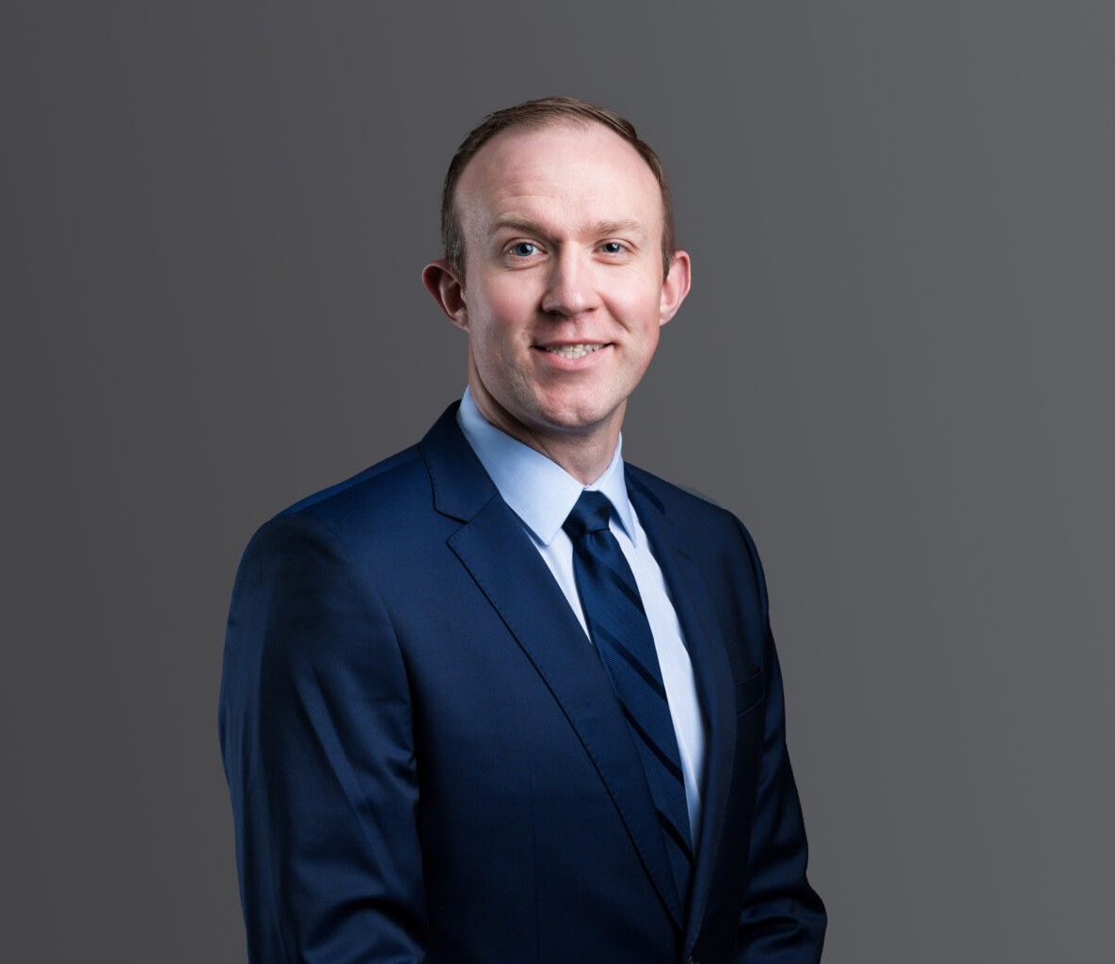

DAVID SIECK

Associate

[Employment & Labor](https://www.fennemorelaw.com/services/employment-and-labor-relations/)

[Phoenix](https://www.fennemorelaw.com/contact-us/phoenix/)

P: 602.916.5334 F: 602.916.5999

[dsieck@fennemorelaw.com](mailto:dsieck@fennemorelaw.com)

“

We choose to go to the Moon this decade and do the other things, not because they are easy, but because they are hard.

John F. Kennedy

”

# DAVID SIECK

David Sieck is an Associate attorney in our firm’s Employment & Labor practice group who works out of the Phoenix office. His practice focuses on providing legal services to numerous joint

labor-management trust funds’ employee benefit plans and their fiduciaries, including consultation, collection, and litigation services.

Prior to joining Fennemore, David represented a number of pension (including 401(k) plans), health and welfare plans, and apprenticeship plans. He works in-depth with the provisions of the Employee Retirement Income Security Act of 1974, as amended (ERISA), the Internal Revenue

Code, the Taft-Hartley Act, relevant state statutes, and the related administrative regulations.

David advises plan sponsors and fiduciaries on all aspects of plan governance and

administration, including governmental compliance, and has experience in both federal and state courts.

Born and raised in Spokane, Washington, David considers himself a counselor at law. He’s comfortable in a room with the labor trustees of the union on one side, and management trustees on the other – and he has the ability to understand, relate to and speak to both sides in a meaningful way that solves problems and finds solutions. This passion for insurance,

employment and labor law, and all things ERISA and Taft-Hartley-related serve David well, and he enjoys the mix of transactional and litigation work needed by his clients – with an eye towards constantly improving and learning more.

Outside of work, you’d better be a warrior if you want to keep up with David. He’s a Triathlete who has completed several full-iron distance Triathlons and numerous half-iron distance races,

and he has his sights set on the world’s most famous triathlon: the Ironman World Championship. David enjoys adventuring and traveling with his wife and spending time with his Alaskan Malamute and two cats.

# EDUCATION

J.D., Gonzaga University School of Law B.A., Washington State University

# AREAS OF PRACTICE

Employment & Labor ERISA

# AWARDS AND HONORS

*Super Lawyers® Rising Stars,* 2020-2024

# ARTICLES AND PRESENTATIONS

Co-Author, “‘[One Big Beautiful Bill’ – what employers need to know](https://azbigmedia.com/business/one-big-beautiful-bill-what-employers-need-to-know/),” AZ Big Media, July 26, 2025

Co-Author, “[Supreme Court Makes It Easier For Plaintiffs To Sue Plan Fiduciaries](https://www.fennemorelaw.com/supreme-court-makes-it-easier-for-plaintiffs-to-sue-plan-fiduciaries/),” Fennemore Blog, April 21, 2025

[Co-Author, Justices Likely To Stay In ERISA’s Bounds On Pleadings, Law360, February 12, 2025](https://www.fennemorelaw.com/justices-likely-to-stay-in-erisas-bounds-on-pleadings/)

Co-Author, [Buying Or Selling A Business? Don’t Forget To Look Out For These Employee Benefits](https://www.fennemorelaw.com/buying-or-selling-a-business-dont-forget-to-look-out-for-these-employee-benefits-issues/) [Issues!](https://www.fennemorelaw.com/buying-or-selling-a-business-dont-forget-to-look-out-for-these-employee-benefits-issues/), Fennemore Blog, June 26, 2024

Author, “[California civil penalties await Arizona employers enforcing noncompete clauses](https://www.bizjournals.com/phoenix/news/2024/04/01/california-civil-penalties-arizona-noncompete.html) [across state lines](https://www.bizjournals.com/phoenix/news/2024/04/01/california-civil-penalties-arizona-noncompete.html),” Phoenix Business Journal, April 1, 2024

[Co-Author “New 401(k) Plan Rules Impose Mandatory Eligibility Requirements for Part-Time](https://mailchi.mp/fennemorelaw/roth-catch-up-contributions-15828694?e=521c02bb5c) [Employees in 2024,” Fennemore Client Alert, October 5, 2023](https://mailchi.mp/fennemorelaw/roth-catch-up-contributions-15828694?e=521c02bb5c)

[Co-Author “Roth Catch-Up Contributions Under SECURE 2.0: The IRS Delays New Requirements](https://mailchi.mp/fennemorelaw/roth-catch-up-contributions) [to 2026,” Fennemore Client Alert, September 6, 2023](https://mailchi.mp/fennemorelaw/roth-catch-up-contributions)

[Co-Author “Health Plans Must Attest They Have No “Gag Clause” By End of 2023: It’s Time To](https://mailchi.mp/fennemorelaw/erisa-gag-clause?e=%5bUNIQID) [Check Your Service Provider Agreement,” Fennemore Client Alert, August 24, 2023](https://mailchi.mp/fennemorelaw/erisa-gag-clause?e=%5bUNIQID)

# PROFESSIONAL AND COMMUNITY ACTIVITIES

Board Member and Volunteer for Play for Gracie Foundation, Spokane, WA, 2014-2019

# ADMISSIONS

Arizona Washington

U.S. District Court, District of Arizona

U.S. District Court, Eastern District of Washington

U.S. District Court, Western District of Washington

U.S. Bankruptcy Court, Eastern District of Washington

U.S. Bankruptcy Court, Western District of Washington