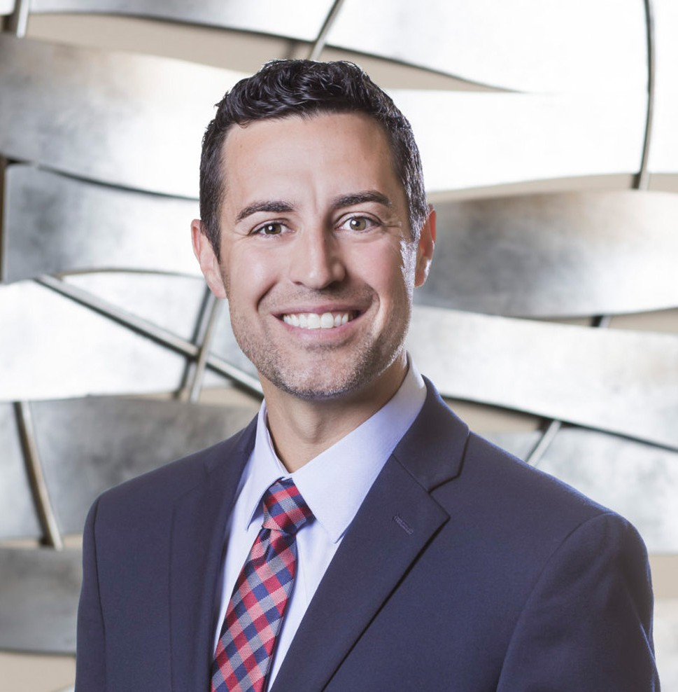

DEREK HOFFMAN

Director

[Natural Resources](https://www.fennemorelaw.com/services/natural-resources-energy-and-environmental/)

[San Bernardino](https://www.fennemorelaw.com/contact-us/san-bernardino/)

P: 909.890.4499

F: 909.890.4499

[Fresno](https://www.fennemorelaw.com/contact-us/fresno/)

P: 559.446.3224

F: 559.432.4590

[dhoffman@fennemorelaw.com](mailto:dhoffman@fennemorelaw.com)

“

Whatever the mind of man can conceive and believe, it can achieve.

- Napoleon Hill

**DEREK HOFFMAN**

”

Derek Hoffman is a seasoned water resources attorney and a director in our Natural Resources practice group. He has represented clients in some of the largest and most complex groundwater basin adjudications in California, including the Antelope Valley, Mojave Basin Area, and the Indian Wells Valley. His practice includes guiding clients through the implementation of California’s Sustainable Groundwater Management Act (SGMA), and other state and federal natural resources laws. He assists clients in developing and implementing effective strategies to

obtain, maintain, protect and transfer water rights and supplies. He also practices in the areas of business and real estate.

He enjoys the complex and ever-changing nature of water law, including its deep-rooted role in California’s history and its future. He finds creative and pragmatic solutions for his clients’ water supply needs, which often comprises an essential component to their business operations.

Derek is also an active member of the California water law community. He speaks and writes frequently on water-related topics. He is an Editorial Board Member and author for the California Water Law & Policy Reporter. He is a member of the Groundwater Resources Association of California and serves as Secretary-Treasurer for the CalWaterPAC.

Outside of the office, Derek and his wife are blessed with four children, and their lives are a whirlwind of attending and coaching youth sports teams, piano recitals and everything in between. Derek also enjoys the many year-round outdoor activities that California uniquely

offers, including snowboarding, wakeboarding, wake-surfing, mountain biking and hiking. He also plays soccer once a week in an adult league.

# EDUCATION

J.D., University of the Pacific, McGeorge School of Law

M.S. The Johns Hopkins University, Carey Business School

B.S., Accounting, Brigham Young University, Marriott School of Business

# AREAS OF PRACTICE

OTHER EXPERIENCE

Water Law Natural Resources Agribusiness

# ARTICLES AND PRESENTATIONS

Co-Author, “First District Court Finds Combined Wastewater and Stormwater System is a

‘Sewer’ For Purposes of Proposition 218,” July 2025, California Water Law And Policy Reporter, <https://argentco.com/> (subscription required)

Co-Author, “First District Court Affirms Trial Court’s Rejection of Challenge to City Community Services District Charges Made Without Voter Approval,” California Land Use & Policy Reporter, June 2025

Co-Author, “First District Court Affirms Trial Court’s Rejection of Challenge to City Community Services District Charges Made Without Voter Approval,” California Water Law & Policy Reporter, June 2025

Co-Author, “DWR Approves 15 Groundwater Sustainability Plans – Legal Implications,” California Water Law & Policy Reporter, April 1, 2025

Co-Author, “DWR Approves 15 Groundwater Sustainability Plans – Legal Implications,” Western Water Law & Policy Reporter, April 2025

Co-Author, “U.S. Bureau of Reclamation Issues Final Decision Regarding Long-term Operation of the Central Valley Project and State Water Project,” California Land Use Law & Policy Reporter, March 2025

Co-Author, “Reaffirming Taxpayer Protections: Fourth District Court Finds Water District’s Rate Structure Ran Afoul of the California Constitution,” California Water Law And Policy Reporter, March 2025

Co-Author, “Reaffirming Taxpayer Protections: Fourth District Court Finds Water District’s Rate Structure Ran Afoul of the California Constitution,” California Land Use Law And Policy Reporter, March 2025

Co-Author, “Reaffirming Taxpayer Protections: Fourth District Court Finds Water District’s Rate Structure Ran Afoul of the California Constitution,” Western Water Law And Policy Reporter, March 2025

Co-Author, “California Expands Efforts to Capture Excess Flood Flows for Groundwater Recharge Via Governor Newsom’s Executive Order N-16-25,” California Water Law And Policy Reporter, March 2025

Co-Author, “U.S. Bureau of Reclamation Issues Final Decision Regarding Long-term Operation of the Central Valley Project and State Water Project,” Western Law & Policy Reporter,

February 2025

Co-Author, “Superior Court Orders Sonoma County To Cease Issuing Well Permits Except for Emergency Permits,” California Water Law And Policy Reporter, February 2025

Co-Author, “U.S. Bureau of Reclamation Issues Final Decision Regarding Long-term Operation of the Central Valley Project and State Water Project,” California Water Law & Policy Reporter, February 1, 2025

Co-Author, “State Water Project Allocations Started at 5 Percent, Then Jump to 15 Percent After Late November Atmospheric Rivers Marking A Wetter Year Than Initially Forecasted” January 2025, California Water Law And Policy Reporter, <https://argentco.com/> (subscription required)

Speaker, “California Water Law & Policy Conference, Indian Wells Valley: A Case Study of Complex Groundwater Management and Adjudication Issues in the SGMA Era,” 2021

Speaker, “California Water Law & Policy Conference, The Price of Water? Water and the Nasdaq”, 2019

Speaker, California Water Law & Policy Conference, 2018 Speaker, California Water Law & Policy Conference, 2017 Speaker, California Water Law & Policy Conference, 2016 Speaker, “Water Rights in California,” National Business Institute

# PROFESSIONAL AND COMMUNITY ACTIVITIES

California Water Law & Policy Reporter

Groundwater Resources Association of California, Inland Empire Branch CalMutuals

CalWaterPAC

Groundwater Resources Association of California California Association of Realtors, Legal Affairs Forum Riverside County Bar Association

San Bernardino County Bar Association Reuben Clark Law Society

# ADMISSIONS

California