

Building relationships with families for over 137 years.

Serving ultra-high net worth individuals, families, and their business concerns.

**Family Office and Private Client Attorneys**

## LEADERSHIP

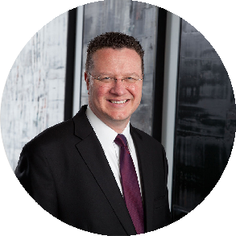[FAMILY OFFICE &](https://www.fennemorelaw.com/services/family-office-private-client-attorneys/) [PRIVATE CLIENT](https://www.fennemorelaw.com/services/family-office-private-client-attorneys/) [ATTORNEYS](https://www.fennemorelaw.com/services/family-office-private-client-attorneys/)

[TRUSTS & ESTATES](https://www.fennemorelaw.com/services/trusts-estates/)

[**Jim Lee**](https://www.fennemorelaw.com/people/attorneys/t-james-lee/)

Director

[**Phoenix**](https://www.fennemorelaw.com/contact-us/#phoenix)

PH 602.916.5422

FX 602.916.5622

[jlee@fennemorelaw.c](mailto:jlee@fennemorelaw.com) [om](mailto:jlee@fennemorelaw.com)

# YOUR CONCIERGE LAWYER

**ARIZONA CALIFORNIA COLORADO NEVADA**

[Steve Good](https://www.fennemorelaw.com/people/attorneys/e-j/good-stephen-a) [Richard Aaron](https://www.fennemorelaw.com/people/attorneys/a-d/aaron-richard-m) [Thomas J. Aldous](https://www.fennemorelaw.com/people/attorneys/a-d/aldous-thomas) [Craig Etem](https://www.fennemorelaw.com/people/attorneys/e-j/etem-craig) [Jim Lee](https://www.fennemorelaw.com/people/attorneys/k-n/lee-t-james) [Monica Dell’Osso](https://www.fennemorelaw.com/people/attorneys/monica-dellosso/) [Thomas Fell](https://www.fennemorelaw.com/people/attorneys/e-j/fell-thomas-h)

[J. Barry Shelley](https://www.fennemorelaw.com/people/attorneys/o-s/shelley-j-barry) [Virginia Palmer](https://www.fennemorelaw.com/people/attorneys/virginia-palmer/) [Stephanie Tribe](https://www.fennemorelaw.com/people/attorneys/t-z/tribe-stephanie-f) [Lanier Thomas](https://www.fennemorelaw.com/people/attorneys/t-z/thomas-wm-lanier)

# PRIVATE CLIENT SERVICES

Family office general counsel Private wealth planning

Sophisticated business and tax structuring Private equity and angel investment support

Specialty areas, such as agribusiness, aviation trusts, emerging technologies, household

employment, international tax and concerns, mansion and luxury home ownership, privacy law, real estate development, and technology manufacturing

# ARIZONA

### [STEVE GOOD](https://www.fennemorelaw.com/people/attorneys/e-j/good-stephen-a)

Director | Business & Finance

#### P 602.916.5395

E [sgood@fennemorelaw.com](mailto:sgood@fennemorelaw.com)

### [T. JAMES (“JIM”) LEE](https://www.fennemorelaw.com/people/attorneys/k-n/lee-t-james)

[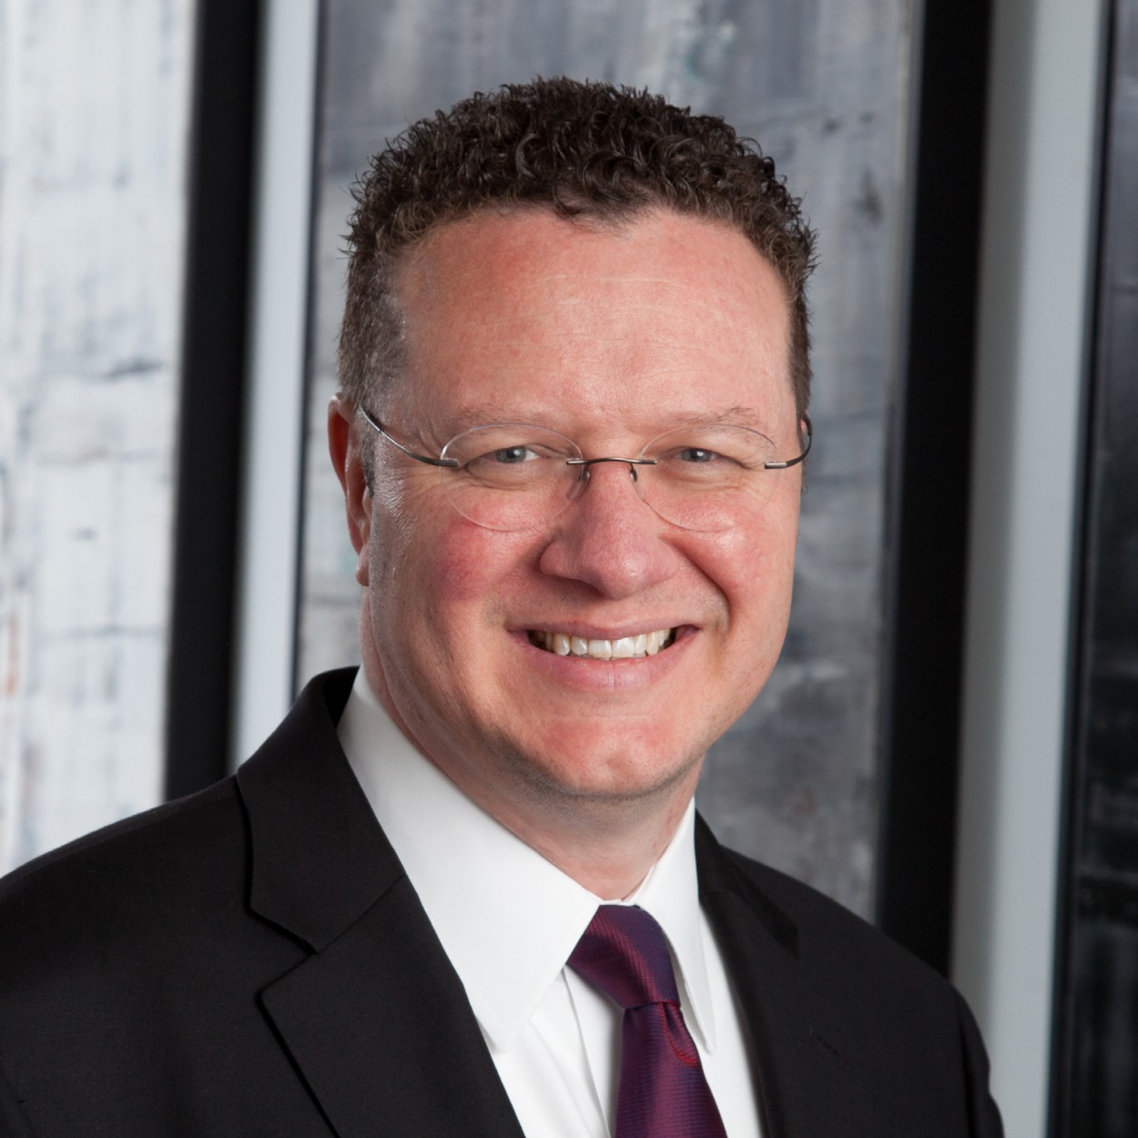](https://www.fennemorelaw.com/people/attorneys/k-n/lee-t-james)Director | Trusts & Estates

#### P 602.916.5422

E [jlee@fennemorelaw.com](mailto:jlee@fennemorelaw.com)

### [J. BARRY SHELLEY](https://www.fennemorelaw.com/people/attorneys/o-s/shelley-j-barry)

[](https://www.fennemorelaw.com/people/attorneys/o-s/shelley-j-barry)Director | Business & Finance

#### P 602.916.5390

E [bshelley@fennemorelaw.com](mailto:bshelley@fennemorelaw.com)

### [STEPHANIE TRIBE](https://www.fennemorelaw.com/people/attorneys/t-z/tribe-stephanie-f)

[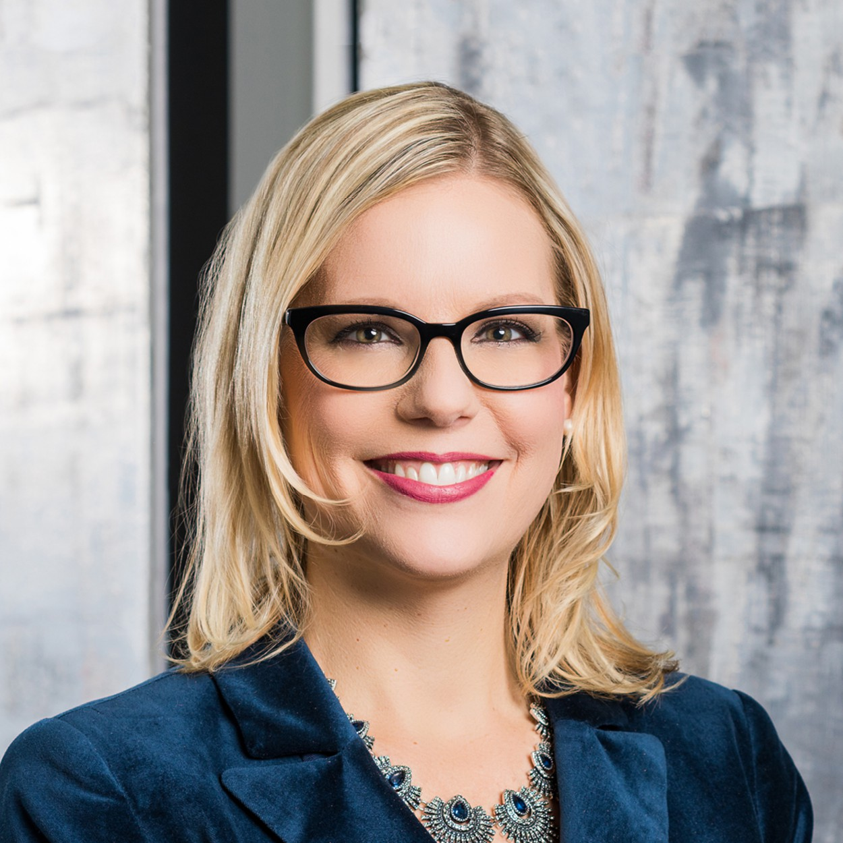](https://www.fennemorelaw.com/people/attorneys/t-z/tribe-stephanie-f)Director | Trusts & Estates

#### P 602.916.5325

E [stribe@fennemorelaw.com](mailto:stribe@fennemorelaw.com)

# CALIFORNIA

### [RICHARD M. AARON](https://www.fennemorelaw.com/people/attorneys/a-d/aaron-richard-m)

Director | Trusts & Estates

#### P 559.432.4500

E [raaron@fennemorelaw.com](mailto:raaron@fennemorelaw.com)

### [LANIER THOMAS](https://www.fennemorelaw.com/people/attorneys/t-z/thomas-wm-lanier)

Director | Trusts & Estates

#### P 559.432.4500

E [lthomas@fennemorelaw.com](mailto:lthomas@fennemorelaw.com)

# COLORADO

### [THOMAS ALDOUS](https://www.fennemorelaw.com/people/attorneys/a-d/aldous-thomas)

Of Counsel | Trusts & Estates

#### P 602.916.5468

E [taldous@fennemorelaw.com](mailto:taldous@fennemorelaw.com)

### [MICHAEL ROBERTSON](https://www.fennemorelaw.com/people/attorneys/michael-p-robertson/)

Director | Business Litigation

#### P 303.764.3723

E [mrobertson@fennemorelaw.com](mailto:taldous@fennemorelaw.com)

# NEVADA

### [CRAIG](https://www.fennemorelaw.com/people/attorneys/craig-etem/) ETEM

Director | Business & Finance

#### P 775.788.2224

E [cetem@fennemorelaw.com](mailto:cetem@fennemorelaw.com)

### [THOMAS H. FELL](https://www.fennemorelaw.com/people/attorneys/e-j/fell-thomas-h)

Director | Financial Restructuring

#### P 702.791.8224

E [tfell@fennemorelaw.com](mailto:tfell@fennemorelaw.com)