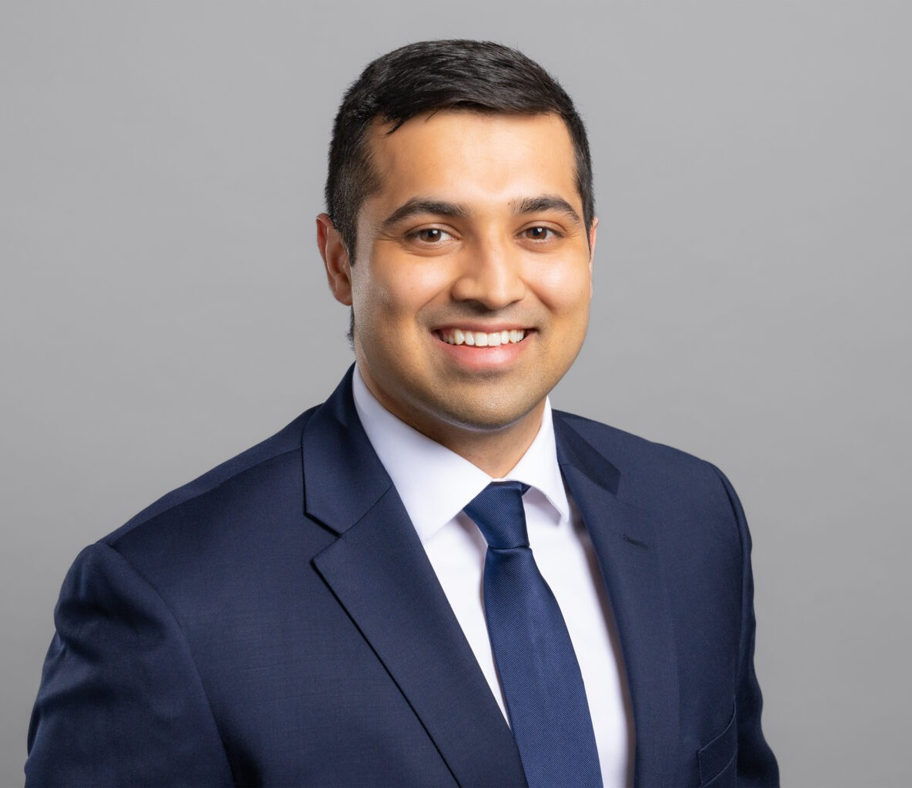

JASKARAN S. GILL

Associate

[Business Litigation](https://www.fennemorelaw.com/services/business-litigation/)

[Fresno](https://www.fennemorelaw.com/contact-us/fresno/)

P: 559.446.3271

F: 559.432.4590

[jgill@fennemorelaw.com](mailto:jgill@fennemorelaw.com)

# JASKARAN S. GILL

Jaskaran Gill is an associate attorney in our Business Litigation practice group who works out of our Fresno office. His practice focuses primarily on civil litigation, where he has represented clients through every stage of litigation, including trial. Jas has extensive experience in court, conducting and defending depositions, resolving matters through alternate dispute resolution, and representing clients in both bench and jury trials.

With a neuroscience background, Jas initially worked as an EMT, but his passion for rational, critical and analytic thinking eventually led him to the legal profession. In his practice, he really enjoys solving problems and resolving cases favorably for his clients. He enjoys helping clients navigate tough situations and takes pride in seeing a case through to a favorable outcome.

In addition to his legal practice, Jas is a professor at San Joaquin College of Law, where he teaches Advanced Legal Research and Writing, helping to shape the next generation of legal minds.

A proud Golden State Warriors fan, Jas enjoys staying active by playing basketball and spending time outdoors. Outside of the office and the courtroom, he cherishes time with his wife—who recently passed the California bar—and their young daughter, whose curiosity and energy inspire him daily.

Business Litigation

# EDUCATION

J.D., *Valedictorian*, San Joaquin College of Law Executive Editor, *San Joaquin Agricultural Law Review*

B.S., University of California, Los Angeles

# AREAS OF PRACTICE

Business Litigation

# AWARDS AND HONORS

Rising Star, *Northern California Super Lawyers*®, 2024-2025

Witkin Awards for Academic Excellence, Issued by Witkin Legal Institute, May 2017

# PROFESSIONAL AND COMMUNITY ACTIVITIES

Adjunct Law Professor, San Joaquin College of Law, August 2022 – Present Member, Fresno County Bar Association

Professor for an Advanced Research and Writing Course

# ARTICLES AND PRESENTATIONS

Groundwater Managed: California Takes Its First Step Towards Groundwater Sustainability, *San Joaquin Agricultural Law Review*, Volume 25 · Oct 1, 2016

# ADMISSIONS

California