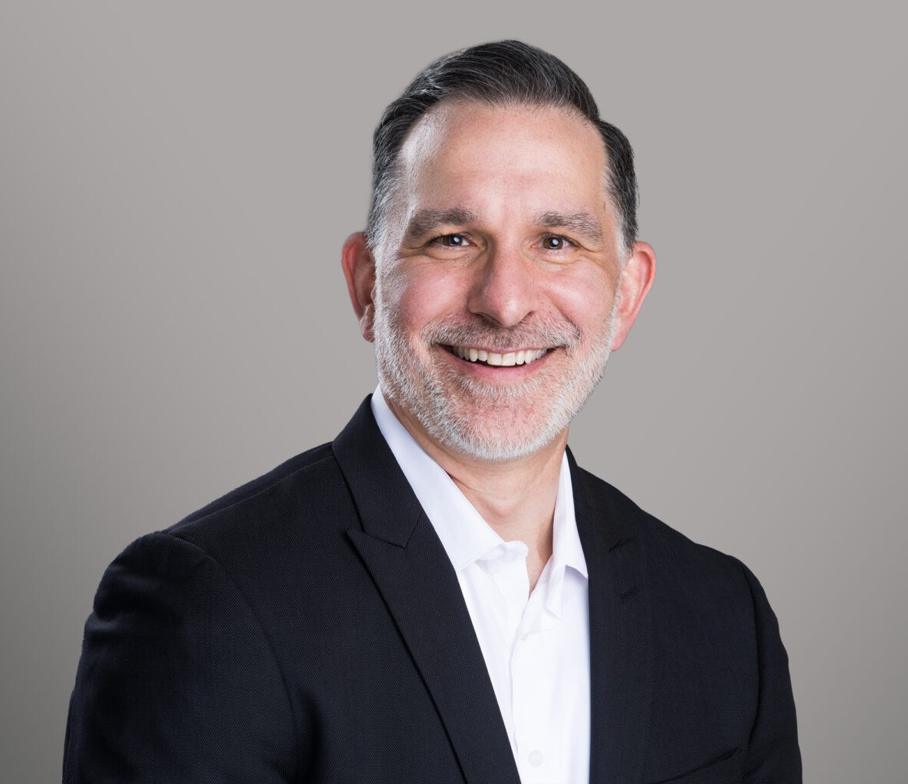

JASON PALMER

Director

[Business & Finance](https://www.fennemorelaw.com/services/business-and-finance/)

[Fennemore Forward](https://www.fennemorelaw.com/contact-us/fennemore-forward/)

P: 530.214.8700 F: 775.786.1177

[jpalmer@fennemorelaw.com](mailto:jpalmer@fennemorelaw.com)

# JASON PALMER

Jason Palmer is a business law attorney in Fennemore’s Business & Finance practice group. Jason advises clients on a broad range of legal matters spanning mergers and acquisitions, construction law, business law, and real estate.

His work includes structuring and negotiating complex business transactions, including the purchase and sale of companies, guiding clients through entity formation and corporate governance, and advising on day-to-day operational and compliance issues. In the construction industry, he counsels developers, contractors, and design professionals on contract drafting, risk management, and dispute resolution. In real estate, Jason assists with acquisitions,

leasing, development, and land use matters. His diverse background allows him to deliver practical, strategic counsel across all stages of a business or real estate project.

Prior to joining Fennemore, Jason was a partner and chief operating officer of a law firm with offices in California and Nevada, where he focused on business law, construction law, real

estate, and estate planning matters.

Palmer has also worked in operations and management for several Fortune 500 companies such as Shell, Wal-Mart, Starbucks, and Cardinal Health. He was also a Professor at Cal Northern School of Law and a private tutor for the California Bar Exam.

Palmer earned his Juris Doctorate from Cal Northern School of Law. He has always had a passion for helping people, and he knew at a young age that he wanted to attend law school. He is licensed to practice in California, Tennessee, and the federal court system. After graduation, Palmer began his law career in Red Bluff, California, practicing family law and various other civil matters.

When he is not in the office, Palmer enjoys running, hiking, traveling, cooking and live music.

# EDUCATION

J.D., Cal Northern School of Law B.A., University of Tennessee

# AREAS OF PRACTICE

Business & Finance

Construction Law Mergers & Acquisitions Real Estate

# PROFESSIONAL AND COMMUNITY ACTIVITIES

Professor, Cal Northern School of Law, 2009 – 2024 Private Tutor for the California Bar Exam, 2009 – 2024

# ADMISSIONS

California Tennessee

District Court Eastern District of California