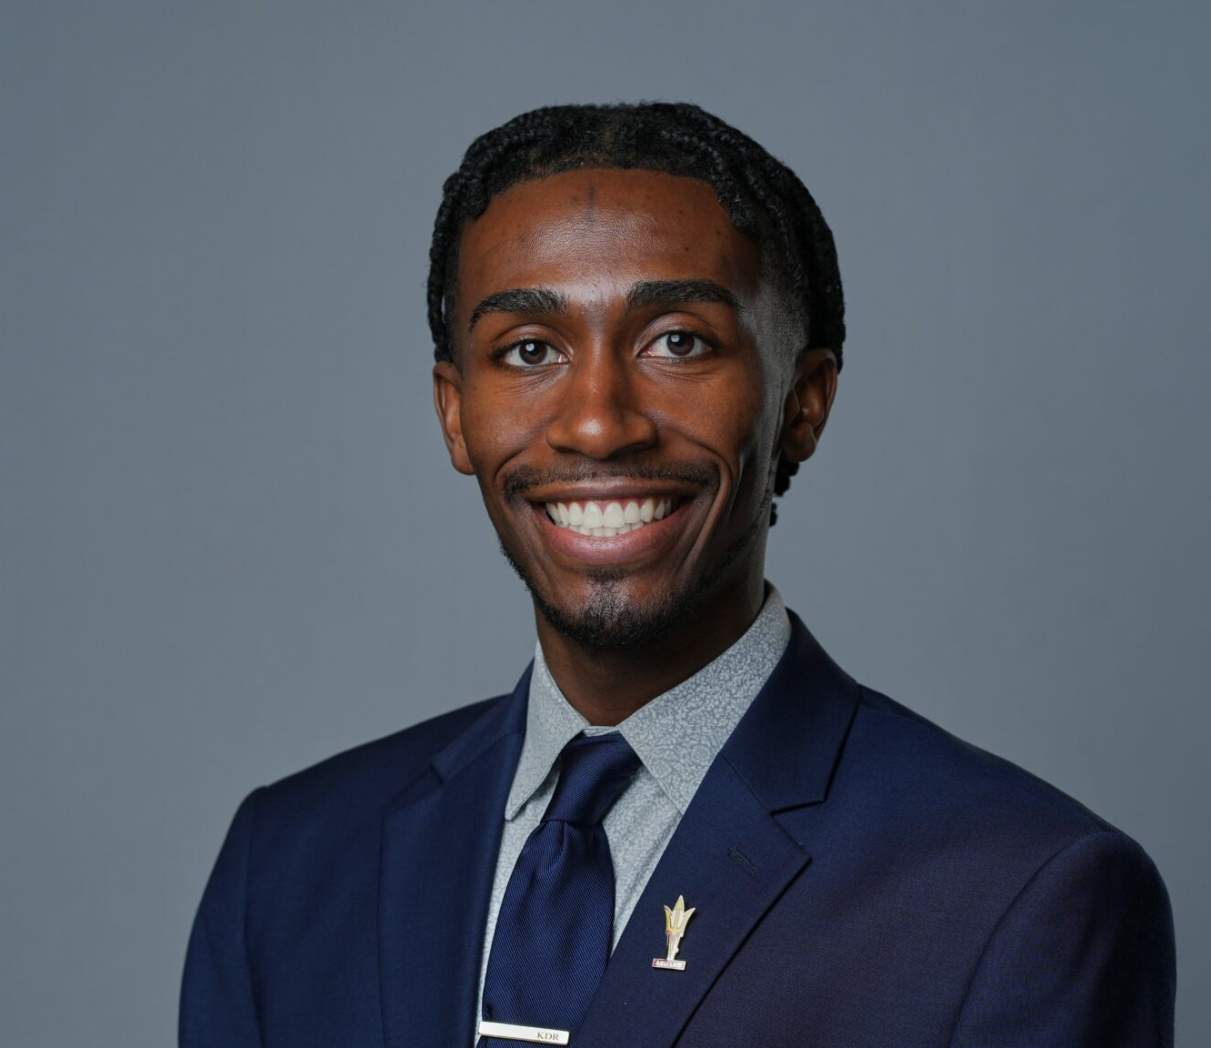

K.J. RUSSELL

Associate

[Business & Finance](https://www.fennemorelaw.com/services/business-and-finance/)

[Phoenix](https://www.fennemorelaw.com/contact-us/phoenix/)

P: 602.916.5326 F: 602.916.5999

[krussell@fennemorelaw.com](mailto:krussell@fennemorelaw.com)

# K.J. RUSSELL

K.J. Russell is an associate attorney in Fennemore’s [Business & Finance](https://www.fennemorelaw.com/services/business-and-finance/) practice group. He focuses on advising clients on a range of business matters, including the preparation of commercial agreements, corporate formation and structuring, transactional work, and mergers and acquisitions. His practice spans multiple industries, including technology, real estate, as well as sports and entertainment. K.J also counsels clients in the evolving space of collegiate athletics name, image, and likeness (NIL). His work involves advising collectives, athletes, and agencies on eligibility compliance and the negotiation of branding, sponsorship, and marketing

agreements.

Prior to joining Fennemore, K.J. served as a legal extern to the Klutch Sports Group, assisting in drafting and reviewing client agreements, endorsement deals, and sponsorship contracts. He conducted legal research on sports-related contracts, name image and likeness (NIL)

regulations, and compliance issues. Also, while in law school, K.J. held robust legal externships with Granderson Des Rochers, the Arizona Coyotes, and the Arizona Department of Gaming. Early on in his career, he also worked in sales and marketing for Paragon Marketing Group, the Atlanta Hawks, the Milwaukee Bucks, Fiserv Forum, Ohio University Ticket Operations, and Southern Ohio Copperheads Baseball Team. He is a certified Athlete Agent.

Outside of work, K.J. enjoys staying active by playing sports such as basketball and tennis. He enjoys playing videogames, especially sport games such as NBA 2K, Madden, or FIFA. When not on the game, K.J. enjoys traveling, and his favorite thing to do while traveling is to try a hole-in- the-wall donut shop and local ice cream parlor wherever he goes.

# EDUCATION

J.D., Arizona State University, Sandra Day O’Conner College of Law

MSLB, Master of Sports Law and Business, Arizona State University, Sandra Day O’Conner College of Law

B.S.M, Ohio University, College of Business B.A., Ohio University, College of Business

# AREAS OF PRACTICE

Business & Finance

Intellectual Property

# AWARDS AND HONORS

Arizona State University College of Law, Outstanding Graduate Award Arizona State University College of Law, Dean’s Award

Sports and Entertainment Law Journal Zealous Leader Award Fennemore Craig, ASU Law Diversity Scholarship/Fellowship

Fiesta Bowl McLendon Award

Excellence in Leadership and Scholarship Award Outstanding Senior Leader Award

# PROFESSIONAL AND COMMUNITY AFFILIATIONS

Community Relations Chair, Black Sports Professionals Member, Forbes BLK

Member, Black Entertainment and Sports Lawyer Association Member, Maricopa County Bar Association

Member, Arizona Black Bar Association Member, Sports Lawyer Association

Managing Editor, Sports and Entertainment Law Journal Membership Chair, Sports Law & Business Society

Alumni Relations Chair, John P. Morris Black Law Student Association

# ARTICLES AND PRESENTATIONS

Co-Author, “[NCAA settlement, Arizona’s SB 1615 reshaping student-athlete compensation —](https://www.yourvalley.net/tempe-independent/stories/ncaa-settlement-arizonas-sb-1615-reshaping-student-athlete-compensation-heres-how%2C596882) [here’s how](https://www.yourvalley.net/tempe-independent/stories/ncaa-settlement-arizonas-sb-1615-reshaping-student-athlete-compensation-heres-how%2C596882),” Wrangler News Independent, July 3, 2025

Co-Author, “[A new chapter in college athletics](https://azcapitoltimes.com/news/2025/07/02/a-new-chapter-in-college-athletics/),” Arizona Capitol Times, July 2, 2025

Co-Author, “[Finally, Arizona schools will pay student athletes. But it could cost you | Opinion](https://www.azcentral.com/story/opinion/op-ed/2025/07/02/nil-deal-college-money-arizona-confusing/84342994007/),” AZ Central, July 2, 2025

Co-Author, “[NIL Agents: The Good, the Bad, and the Unregulated](https://www.fennemorelaw.com/nil-agents-the-good-the-bad-and-the-unregulated/),” Fennemore Blog, March 4, 2025

Co-Author, “[A patchwork of name, image and likeness agent regulations leaves student-](https://www.bizjournals.com/phoenix/news/2025/03/01/name-image-likeness-regulations-student-athletes.html) [athletes largely unprotected,](https://www.bizjournals.com/phoenix/news/2025/03/01/name-image-likeness-regulations-student-athletes.html)” Phoenix Business Journal, March 1, 2025

Featured, “[Meet recent grads beginning their careers right after commencement](https://news.asu.edu/20240508-sun-devil-community-meet-recent-grads-beginning-their-careers-right-after-commencement),” ASU News, May 8, 2024

Author, “The Ten-Cent Infrastructure of a Billion-Dollar Industry,” Arizona State Sports and Entertainment Law Journal

Author, “Adverse Advertisement Galore,” Arizona State Sports and Entertainment Law Journal

# ADMISSIONS

Arizona