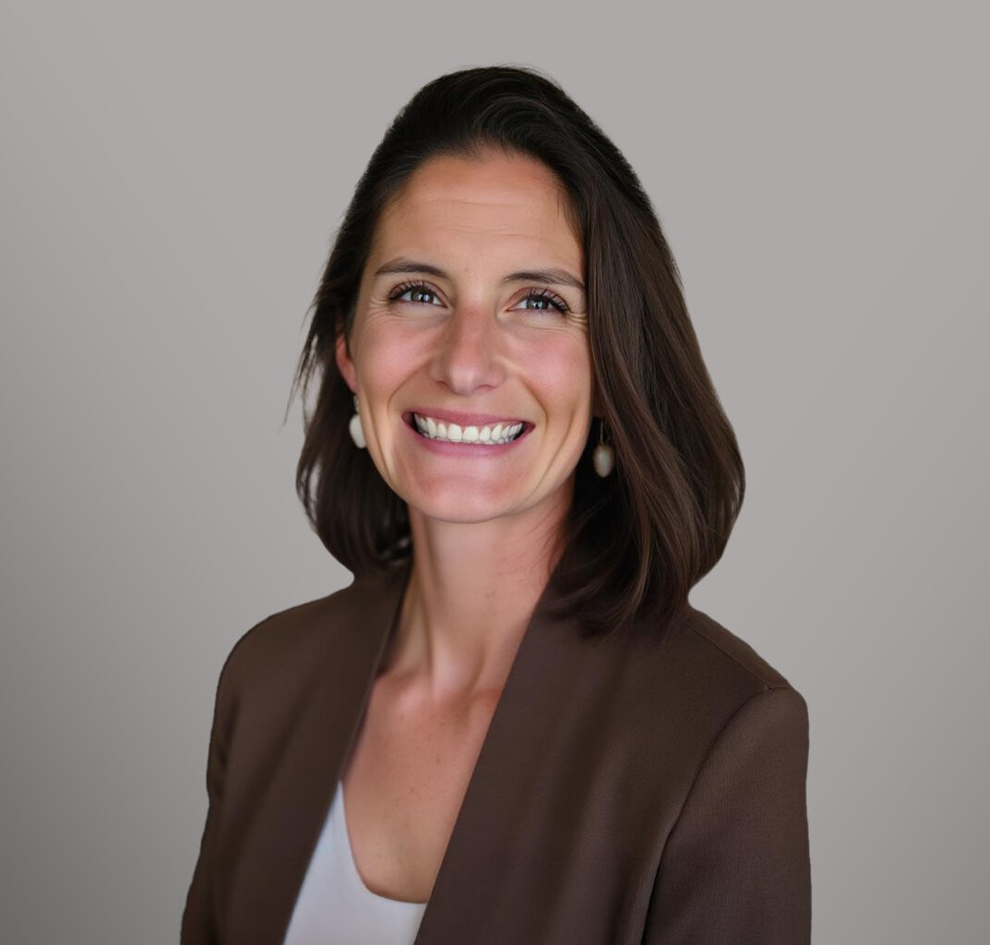

LINDSEY MORGAN

Of Counsel

[Business Litigation](https://www.fennemorelaw.com/services/business-litigation/)

[Fennemore Forward](https://www.fennemorelaw.com/contact-us/fennemore-forward/)

P: 208.956.0137 F: 602.916.5999

[lmorgan@fennemorelaw.com](mailto:lmorgan@fennemorelaw.com)

# LINDSEY MORGAN

Lindsey Morgan is an Of Counsel Attorney in Fennemore’s [Business Litigation](https://www.fennemorelaw.com/services/business-litigation/) practice group. A seasoned attorney, Lindsey has spent years defending multimillion-dollar litigation and resolving complex pre-litigation claims in the real estate, insurance coverage, and general business and corporate sectors. She has represented corporate entities, including national real estate

brokerages, insurance giants, and public utilities.

Prior to joining Fennemore, Lindsey provided strategic outside general counsel services and represented companies in litigation matters through her solo practice. She simultaneously handled litigation in Washington and California as Of Counsel for Fellner Law Group. She has extensive experience representing insurers in insurance coverage litigation and providing insurance defense for real estate brokerages and their employees and agents in civil litigation. Lindsey holds an inactive real estate broker license in both Idaho and California—offering valuable insights without competing with her clients’ interests.

She is an active member of the Rotary Club of Coeur d’Alene, where she serves on the grants

committee. Lindsey has a particular interest in using her civil litigation background to advise her clients on ways to proactively avoid future litigation.

After growing up in a wilderness area without electricity or refrigeration, Lindsey prefers to spend her free time outside. When she is not in the office, Lindsey is a boy mom, avid hiker and gardener, and enthusiastic non-fiction reader. Lindsey cultivates humility by regularly participating in Crossfit and is a late beginner to the game of golf.

# EDUCATION

J.D., University of Southern California Gould School of Law B.A., University of California, Los Angeles

# AREAS OF PRACTICE

Business Litigation

# REPRESENTATIVE MATTERS

Represented an insurance brokerage in pre-litigation and active litigation for claims related to improper coverage placement throughout the West Coast.

Defended a national company in a multi-million dollar commercial real estate dispute arising from a faulty sprinkler system in Washington state.

Defended dozens of property damage and personal injury claims against a privately owned public utility in San Francisco.

Obtained summary judgment on a non-disclosure case against a national real estate brokerage and its agent in Alameda, California.

Defended a CEO on appeal in a breach of contract action involving issues of international jurisdiction in applying a judgment.

Represented a national real estate brokerage and TV personality real estate agent in a multi- million dollar real estate commission dispute.

Acted as liaison counsel for the insurer defendants in *Montrose v. Canadian Universal Insurance Co.*, a pollution allocation matter which went to the California Supreme Court on the question of horizontal versus vertical allocation at the excess insurance level.

# ARTICLES AND PRESENTATIONS

Contra Costa Association of Realtors – Risk Management Seminar presentation, 2019-2020 North Idaho College Nursing Program – guest lecturer (“Legal Accountability”), Feb. 2024

# PROFESSIONAL AND COMMUNITY ACTIVITIES

Co-Chair, Grants Committee, Rotary Club of Coeur d’Alene Member, Idaho Women Lawyers

Member, Magnet Committee, Sorensen Magnet School

# ADMISSIONS

Idaho (state and federal) California (state and federal) Washington (state and federal) Ninth Circuit