
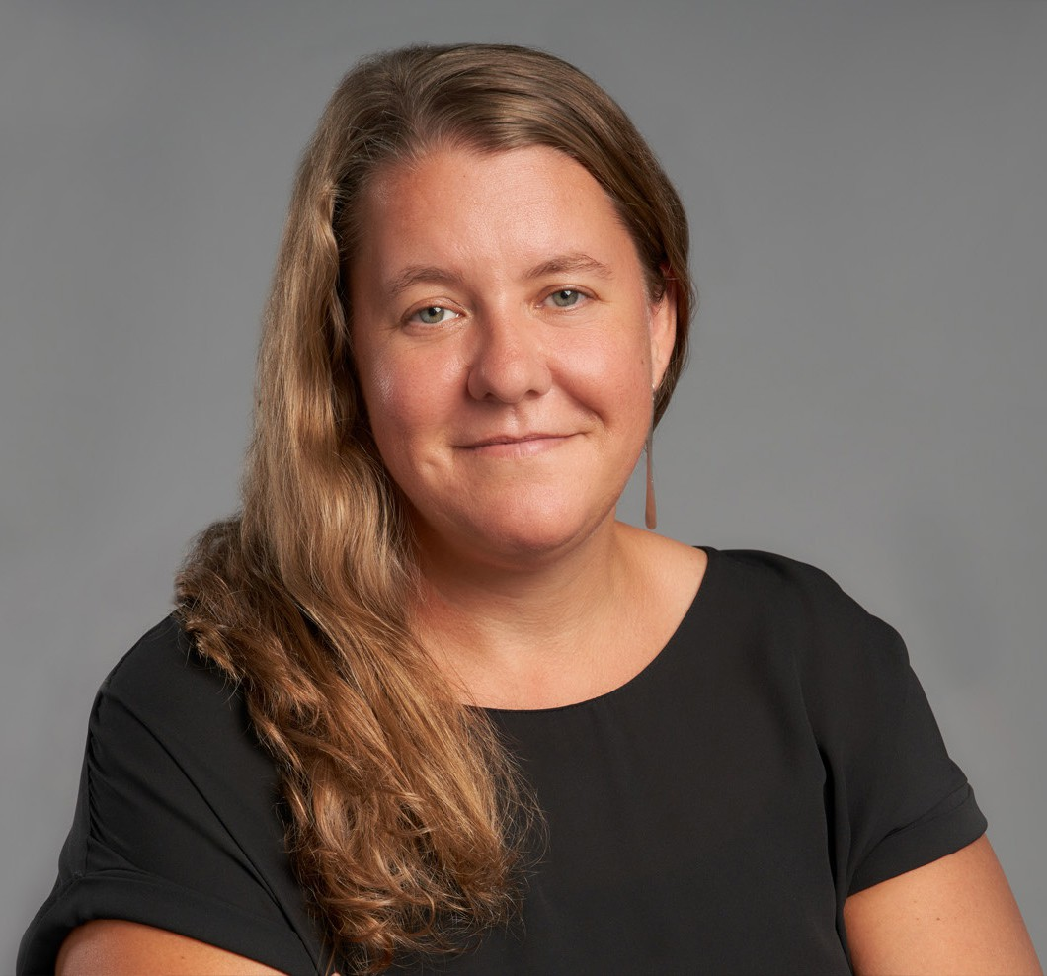
LISA LENHERR
Pronouns: she/her
Director
Financial Restructuring
Oakland
P: 510.834.6600 F: 510.834.1928
llenherr@fennemorelaw.com
“
Where all think alike there is little danger of innovation.
- Edward Abbey, Desert Solitaire
LISA LENHERR
”

A dedicated advocate, Lisa is recognized for her efficient, effective, and innovative work to solve clients’ complex challenges. She focuses her practice on creditors’ rights, business insolvency and restructuring issues, including Chapter 7 and 11 bankruptcy, out-of-court
workouts, debtor-creditor law, assignments for the benefit of creditors, bankruptcy appeals, and distressed business and financing transactions.
Lisa has extensive experience representing all constituents in the insolvency context, including Chapter 7 and 11 bankruptcy trustees, debtors, creditors, landlords, lenders, title companies,
equipment lessors, asset purchasers, and debtors and creditors as parties to non-dischargeability litigation.
Lisa is an active member of the Bay Area insolvency community. She is a past president of the Bay Area Bankruptcy Forum and has served as Chair of the Bar Association of San Francisco’s Commercial Law & Bankruptcy Section, Co-Chair of the Bench Bar Liaison Committee of the Bankruptcy Court for the Northern District of California, and as treasurer for the International Women’s Insolvency & Restructuring Confederation. During law school Lisa externed for the Honorable Robert E. Jones of the U.S. District Court for the District of Oregon and clerked for the Oregon Department of Justice in the antitrust unit.

EDUCATION
J.D., Lewis & Clark Law School, cum laude
B.A., Lewis & Clark College

AREAS OF PRACTICE

OTHER EXPERIENCE

Bankruptcy
Insolvency and Restructuring Financial Restructuring

ARTICLES AND PRESENTATIONS
Featuring, “Every case reads like its own unique story and can present a variety of complex and intertwining legal questions,” Fennemore Blog, July 20, 2023

AWARDS AND HONORS
Northern California Super Lawyers®, 2022 & 2023 Rising Star, Northern California Super Lawyers®, 2019

PROFESSIONAL AND COMMUNITY ACTIVITIES
Bay Area Bankruptcy Forum: Member, former President, former Vice President, Secretary, and Treasurer
Alameda County Bar Association: Member
Commercial Law & Bankruptcy Section, The Bar Association of San Francisco: Member, former Chair, Vice-Chair, and Treasurer
International Women’s Insolvency & Restructuring Confederation (IWIRC): Member, former Treasurer
Bench-Bar Liaison Committee, Bankruptcy Court for the Northern District of California: former Member and Co-Chair
Local Rules Subcommittee, Bench-Bar Liaison Committee, Bankruptcy Court for the Northern District of California: former Chair
30th Annual Insolvency Conference, California Bankruptcy Forum (CBF): Education Co-Chair 29th Annual Insolvency Conference, CBF: YIP Co-Chair
28th Annual Insolvency Conference, CBF: Producer 26th Annual Insolvency Conference, CBF: Producer California Bankruptcy Journal: Editor 2012-2018
90th and 91st National Conference of Bankruptcy Judges Next Generation Program: Committee Member
89th Annual National Conference of Bankruptcy Judges Next Generation Program: Participant

ADMISSIONS
California
U.S. District and Bankruptcy Courts, Northern, Eastern, and Central Districts of California
U.S. Court of Appeals, Ninth Circuit

