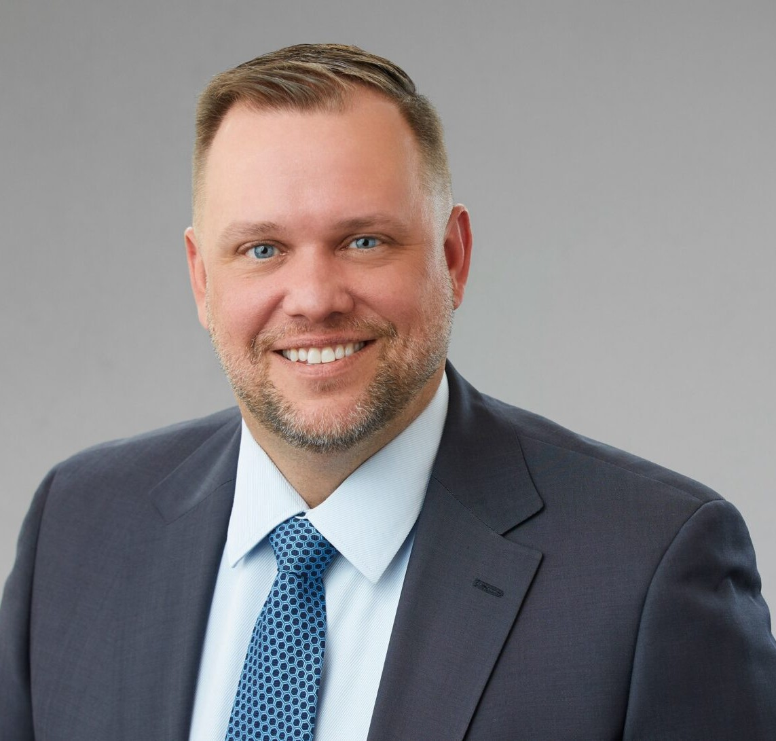

ROBERT E. MCPEAK

Director

[Real Estate](https://www.fennemorelaw.com/services/real-estate/)

[Las Vegas](https://www.fennemorelaw.com/contact-us/las-vegas/)

P: 702.692.8034

F: 702.692.8099

[rmcpeak@fennemorelaw.com](mailto:rmcpeak@fennemorelaw.com)

**ROBERT E. MCPEAK**

Robert’s areas of practice include real estate, real estate finance, and energy project development and finance. His comprehensive real estate practice covers all aspects of

property acquisition, financing, development, management, leasing, and sales. He has worked with a wide range of commercial property types, including retail, office, industrial, multifamily, planned communities, condominiums, mixed-use developments, casinos, hotels, and time-share projects throughout the State of Nevada. He is well-known for providing practical legal guidance on operational issues.

Additionally, Robert focuses on issues related to the advanced energy transition, and the opportunities available to his clients throughout Nevada concerning the development of solar, wind and geothermal resources. In this sector, he represents developers, lenders, and tax equity investors in connection with project development, permitting and financing of renewable energy projects across the state.

Further, Robert advises Nevada corporations, limited liability companies and partnerships and their shareholders, members, managers, and partners on matters of entity formation, governance and ongoing operations, including commercial credit and equipment finance.

Robert’s knowledge and skills are acknowledged by Chambers USA, The Best Lawyers in

America, and National Law Journal Trailblazers. He has earned the AV Preeminent Peer Review Rating™ from Martindale-Hubbell, marking him as a top-rated professional in his field. Feedback from clients to Chambers’ researchers highlights Robert as “intelligent, thorough and ensures our interests are protected.” Others note his “vast experience across the state, responsiveness, and serious approach to matters.” Praised for his “knowledge beyond his years, especially in

development projects,” he is considered highly respected. Clients find Robert to be a “smart and pleasant lawyer to work with” who is “fantastic from a technical perspective,” adept at navigating complex issues, and providing outstanding assistance in real estate lease matters.

For nearly eight years, Robert served as the general counsel, on a pro bono basis, for Legal Aid Center of Southern Nevada (LACSN). While he no longer serves as the organization’s general counsel, he continues to lend his legal skills to support LACSN’s Vegas Strong Resiliency Center which has grown into The Resiliency & Justice Center [(https://resiliencyandjustice.org/).](https://resiliencyandjustice.org/)) Here,

Robert assists LACSN with site acquisition, development matters, and the negotiation of design

and construction contracts for The Resiliency & Justice Center’s new campus, which will house comprehensive services and resources to support all survivors of violent crime in Nevada.

# EDUCATION

J.D., Boston University School of Law, *cum laude*

Managing Editor of the Annual Review of Banking and Finance Law Honors concentration in business organizations and finance law

A.B., University of Michigan, with distinction

# AREAS OF PRACTICE

Real Estate Advanced Energy Natural Resources Business & Finance

# REPRESENTATIVE MATTERS

**REAL ESTATE & FINANCE**

Represented a Las Vegas-based industrial developer in connection with site acquisition,

development, leasing and disposition of multiple industrial and logistics-focused projects in Henderson, Las Vegas and North Las Vegas, Nevada

Represented the buyer in connection with the acquisition and financing of multiple Class A office buildings in Las Vegas, Nevada

Represented a buyer in the $46 million acquisition of two single-tenant NNN-leased outpatient medical facilities in Clark County, NV and assumption of existing CMBS loan

Represented an investment management firm in the acquisition, financing and disposition of multiple unit value-add apartment complexes in Las Vegas, Nevada

Represented a global investment manager in nationwide leasing matters for a start-up healthcare portfolio company, including the negotiation of master construction and architectural contracts

Represented a major telecommunications company in the lease of a 104,000 square-foot facility in Las Vegas, Nevada

Represented borrowers, guarantors and lenders in commercial real estate loan transactions, including the borrowers in the acquisition of the underlying real property collateral

Represented the seller in the $27 million disposition of a 325-unit apartment complex in Reno, Nevada

Represented borrowers, guarantors, note-buyers, lenders, and loan servicers in workout and enforcement matters, including receivership sales, REO management, and disposition engagements involving over $3 billion of distressed commercial real estate loans in Arizona, California, and Nevada

Represented a syndicate of senior secured lenders in the workout and restructuring of a $470 million construction loan secured by a mixed-use retail and office center in Las Vegas Nevada

Represented a national homebuilder with the formation of common-interest communities and the negotiation of development agreements, shared-entry agreements, public offering

statements and other sales-related disclosures in southern and northern Nevada

Represented a national homebuilder in connection with state and local regulatory matters relating to its acquisition of another homebuilder

Represented a national homebuilder in the restructuring of its Nevada holdings

Represented a national developer of a master-planned community in various homebuilder bankruptcies and defaults under development and profit participation obligations

**ADVANCED ENERGY + NATURAL RESOURCES**

Nevada counsel for the developer in connection with the debt and tax equity financing of a 690 MW solar photovoltaic generating facility and 380 MW battery energy storage located in Clark County, Nevada, the largest single project of its kind to begin construction in the U.S.

Represented the developer, as local counsel, in connection with the financing of a 70 MW solar PV generation project, the financing of a 20 MW utility-scale solar power project, and the financing of and title issues with 5 MW solar project

Nevada counsel for the tax equity investor in connection with the successful closing of its

investment in a 300 MW solar photovoltaic generating facility located on tribal land in Clark County, Nevada

Nevada counsel for the tax equity investor in connection with the successful closing of its

investment in a 180 MW solar photovoltaic generating facility located in Boulder City, Nevada

Nevada counsel for the tax equity investor in connection with the successful closing of its investment in the repowering of a 37.1 MW geothermal plant located in Washoe County, Nevada

Nevada counsel for the developer in connection with project re-financing of a 152 MW wind power project located in White Pine County, Nevada — the largest project of its kind in

Nevada

Nevada counsel for the tax equity investor in connection with the successful closing of its

investment in a 101 MW solar photovoltaic generating facility and 100 MW battery energy storage located in Humboldt County, Nevada

Nevada counsel for the tax equity investor in connection with the successful closing of its

investment in a 250 MW solar photovoltaic generating facility located in Boulder City, Nevada

Nevada financing counsel for the developer in connection with the successful construction financing of a 100 MW solar photovoltaic generating facility located in Clark County,

Nevada, which will power the operations on a sizeable portion of the resorts on the Las Vegas Strip

Nevada counsel for the tax equity investor in connection with the successful closing of its investment in a 250 MW solar photovoltaic generating facility located in Clark County,

Nevada

Nevada counsel for the tax equity investor in connection with the successful closing of its

investment in a 179 MW solar photovoltaic generating facility located on tribal land in Clark County, Nevada

Nevada counsel for the developer in connection with a tax equity investment in a 20 MW solar photovoltaic generating facility located in Churchill County, Nevada

Nevada counsel for the tax equity investor in connection with the successful closing of its investment in a 24 MW geothermal plant located in Churchill County, Nevada

Represented the developer in connection with development and construction permitting of a 14 MW solar photovoltaic generating facility located in Henderson, NV

# ARTICLE AND PRESENTATIONS

Feature Q&A Interview, “Nevada Energy Attorney Sees Activity Uptick In Renewables Projects,” Law360 Real Estate Authority, July 27, 2023

Quoted, “Biden Eyes New Funds for Housing, End of 1031 Tax Program,” Law360, March 9, 2023 Quoted, “Interest Rates Top Real Estate Pros’ Federal Agenda for 2023“, Law360, Jan. 2, 2023

Leadership Interview, “Pay It Forward” (Globest.com, Nov. 22, 2022) and “How I Made Partner” (Law.com, Nov. 21, 2022)

Moderator, Shopping Center Business and Western Real Estate Business magazines webinar, “Las Vegas Retail Outlook: How is the Las Vegas Retail Sector responding to COVID-19,” Sept. 3, 2020

Moderator, NAIOP Workshop, “Building Bricks with Blockchain: The Latest in CRE and·Technology,” Oct. 12, 2018

Presenter, “Avoiding the Industry’s Top Legal Pitfalls,” ICSC ReCon, Las Vegas, Nevada, May 21, 2017

Presenter, “Inception to Courtroom: Legal Issues Facing Development Projects,” NAIOP Southern Nevada, Las Vegas, Nevada, Nov. 3, 2016

Presenter, “Landlord-Tenant Law from Start to Finish,” Sterling Educational Services, Las Vegas, Nevada, March 23, 2016

Presenter of continuing legal education seminars covering commercial real

estate·transactions, title insurance matters, and distressed loans and portfolio management

# AWARDS AND HONORS

Chambers USA: America’s Leading Lawyers for Business – Real Estate Law (Nevada), (2020- 2025)

Martindale-Hubbell – AV Preeminent Peer Review Rating, 2013-present

*Best Lawyers in America®* – Construction Law (2021-2025), Construction Litigation (2021-2025), Corporate Law (2025), Land Use and Zoning Law (2025), Real Estate Law (2021-2025)

National Law Journal – Real Estate/Construction Law Trailblazers, 2022

Vegas Inc – “Top Lawyers” in Southern Nevada in Environmental Law, 2023, 2022, the only lawyer on the Environmental Law list

Business Today – “Top 10 Influential Nevada Real Estate Lawyers Making Waves in 2023”

Mentor in Real Estate Recognition, Lied Center for Real Estate, Lee Business School at the University of Nevada-Las Vegas (UNLV), 2023-present

Mountain States Super Lawyers Magazine – Rising Star, 2012-2017 Desert Companion’s Southern Nevada’s Top Lawyers

# PROFESSIONAL AND COMMUNITY ACTIVITIES

Adjunct Professor, Lied Center for Real Estate, Lee Business School at UNLV Member, American Bar Association, Real Property, Trust and Estate Law Section

Member, State Bar of Nevada,

Member, Real Property Law Section

Member, Continuing Legal Education Committee (2005-2014)

Member, NAIOP (Commercial Real Estate Development Association), Southern Nevada Chapter

Member, Programs Committee and Education Committees Graduate, Developing Leaders Institute, Class of 2014

Graduate, Developing Organizational Leadership Institute, Class of 2025 General Counsel, Legal Aid Center of Southern Nevada (2016-2023)

# ADMISSIONS

Nevada