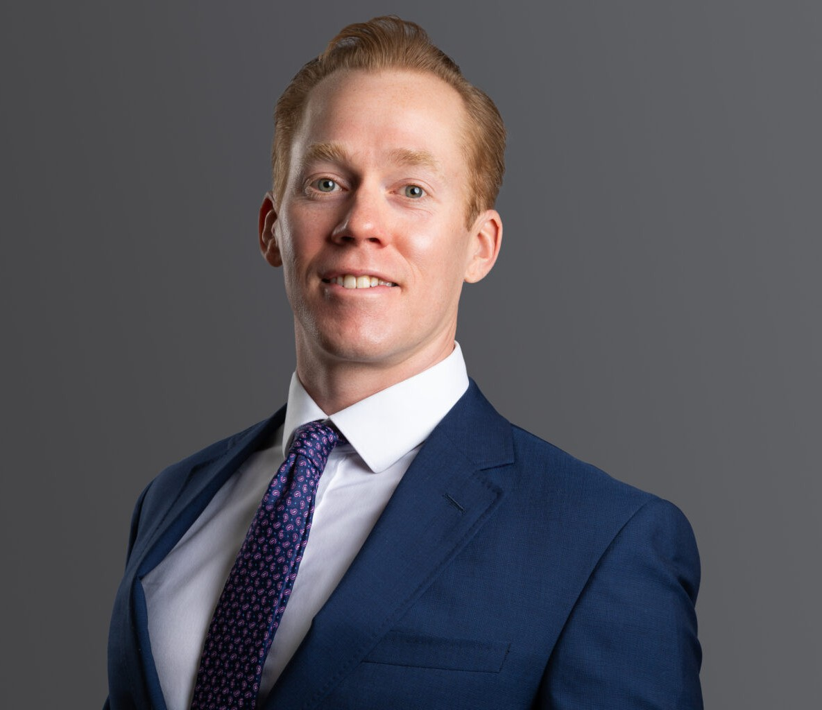

ANDREW T. FLYNN
Director
Business Litigation

Denver
P: 303.813.3817 F: 303.291.3201
aflynn@fennemorelaw.com

ANDREW T. FLYNN
Andrew is a director in the Business Litigation group and represents clients in a variety of commercial disputes. Andrew’s practice includes corporate and limited liability company
disputes, real estate disputes, title disputes, insurance coverage and recovery, and construction law. He has extensive deposition, mediation, and trial experience and has tried dozens of jury
trials, court trials, and arbitrations throughout Colorado. Although based in Colorado, Andrew has represented clients throughout the United States, including New York, Texas, California, and Pennsylvania, among others.
Andrew represents clients in state and federal courts, arbitrations, and bankruptcy adversary proceedings. An experienced trial attorney, Andrew represented a national property developer
in a dispute with another property developer in a multi-million dollar real estate deal. After a five- day court trial, Andrew’s client won specific performance of a contract for the sale of a valuable piece of real estate. He also represented an international automotive and trucking company in multiple lawsuits arising from a complex embezzlement scheme. The scheme resulted in two federal lawsuits, a state court lawsuit, and a bankruptcy adversary proceeding, in which Andrew recovered millions of dollars from various defendants for his client.
Andrew’s previous experience includes defending insurance companies and their policyholders from an array of claims. He now draws upon his extensive knowledge of the insurance industry to help corporate policyholders understand insurance coverage and maximize their recoveries. Additionally, Andrew also has experience bringing bad faith breach of insurance claims against insurance carriers.
Although his primary focus is litigation, Andrew also has experience in corporate transactions, including closing a stock redemption for a minority shareholder of a national food distribution company.

EDUCATION
J.D., University of Denver
B.A., University of Nebraska

AREAS OF PRACTICE

Business Litigation

REPRESENTATIVE CASES
Tried and won an adversary proceeding in United States bankruptcy court for a four million dollar non-dischargeable judgement and award of attorney fees.
Tried and won a five-day court trial for specific performance of a multi-million dollar real estate contract.
First or second chair for thirteen jury trials and numerous court trials.
Second chair for a four day preliminary injunction hearing that tripled the settlement amount for the client in a limited liability company dispute.
Successfully moved to dismiss a lawsuit and won ensuing appeal for personal injury claim involving a nuanced statute of limitations argument.
Managed multiple related litigations for a large national automotive and truck dealership in Colorado State Court, Federal District Court, and Federal Bankruptcy Court.
Won voluntary dismissal of spurious lawsuits against business owners based on the Americans with Disabilities Act

AWARDS AND HONORS
Colorado Super Lawyers®, General Litigation, 2025
Best Lawyers in America®, Insurance Law, Litigation – Insurance, 2023-2026
Best Lawyers in America®, Ones to Watch, Commercial Litigation and Insurance Law, 2022 and 2025
Benchmark Litigation, Future Star, 2020-2024
Colorado Super Lawyers®, Rising Star, General Litigation, 2018-2021

PROFESSIONAL AND COMMUNITY AFFILIATIONS
Member, Colorado Bar Association Member, Denver Bar Association
Member, Colorado Defense Lawyers Association

ADMISSIONS
Colorado
U.S. District Court – District of Colorado
U.S. Bankruptcy Court

