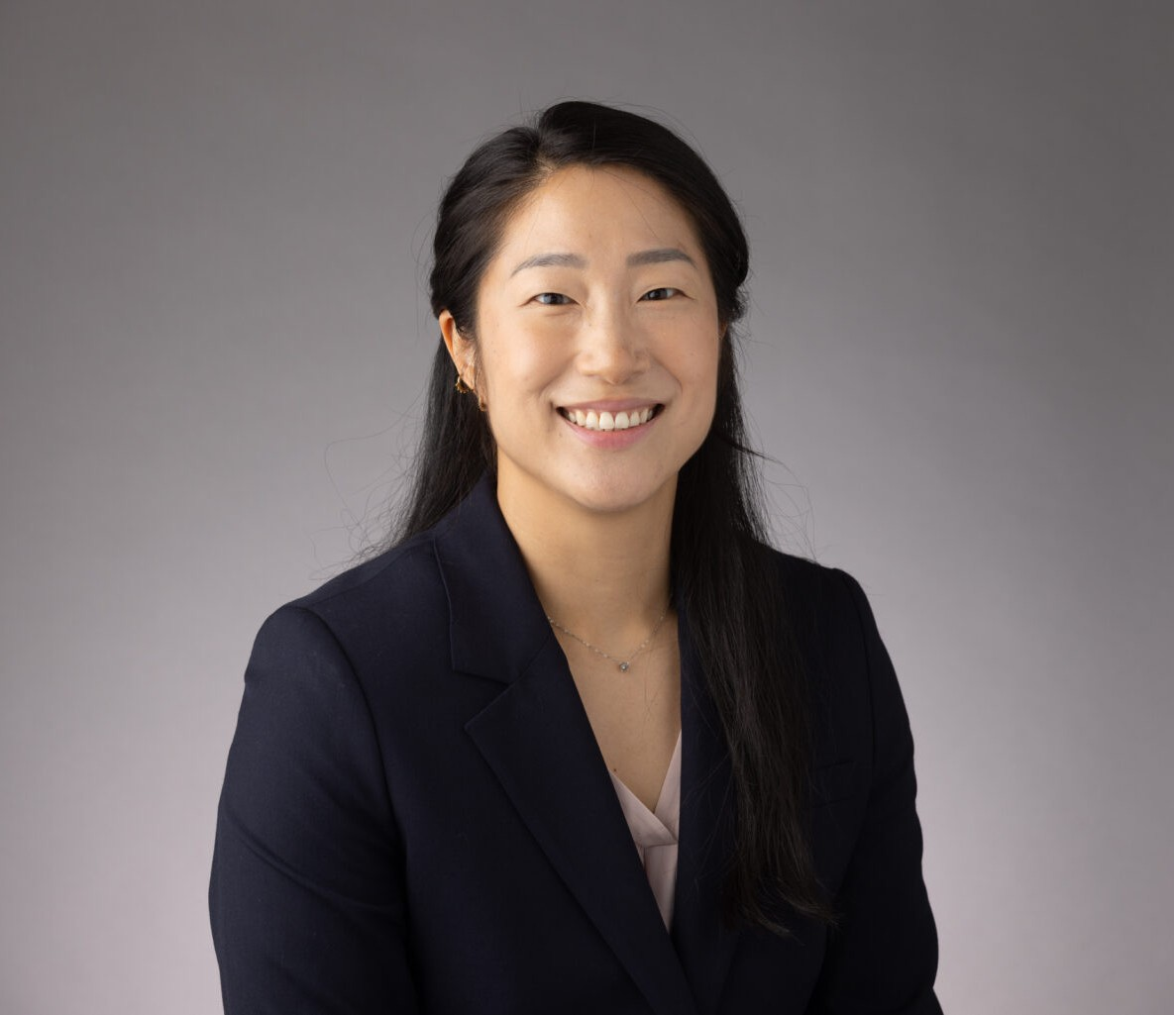

ANGELA HAN

Associate

[Business Litigation](https://www.fennemorelaw.com/services/business-litigation/)

[Oakland](https://www.fennemorelaw.com/contact-us/oakland/)

P: 510.622.7523 F: 510.834.1928

[ahan@fennemorelaw.com](mailto:ahan@fennemorelaw.com)

# ANGELA HAN

As a member of the firm’s [Business Litigation](https://www.fennemorelaw.com/services/business-litigation/) group, Angela assists clients with their most challenging commercial litigation disputes from pre-litigation case assessment to resolution. She has experience defending a broad range of civil matters, including product liability, mass torts, class actions, complex business and contract disputes, unfair competition, personal injury, premises liability, and more. In addition, Angela has experienced advising product manufacturers, retailers, and distributors on risk management, both state and federal regulatory compliance issues, and related litigation. Angela is adept in all litigation phases, including case assessment and early strategy development, pleadings, discovery, and dispositive motions.

Prior to joining the firm, Angela worked as a litigation and dispute resolution associate in the San Francisco Bay Area. During law school, she served as a judicial extern for the Honorable Judge William H. Orrick, United States District Court, Northern District of California.

# EDUCATION

J.D., University of California, Davis School of Law

Witkin Award, Academic Excellence in Legal Research and Writing Senior Editor, U.C. Davis Law Review

Staff Editor, U.C. Davis Business Law Journal

Korean American Law Students Association, President B.A., University of Washington

# AREAS OF PRACTICE

Business Litigation Health Care

# AWARDS AND HONORS

*Best Lawyers in America®,* Ones to Watch, Commercial Litigation, Health Care Law, 2026 California Lawyers Association, Wiley W. Manuel Pro Bono Legal Services Award, 2023

Leadership Council on Legal Diversity, Pathfinders, 2022

# ADMISSIONS

California

U.S. Court of Appeals for the Ninth Circuit

U.S. District Court for the Northern District of California

U.S. District Court for the Central District of California