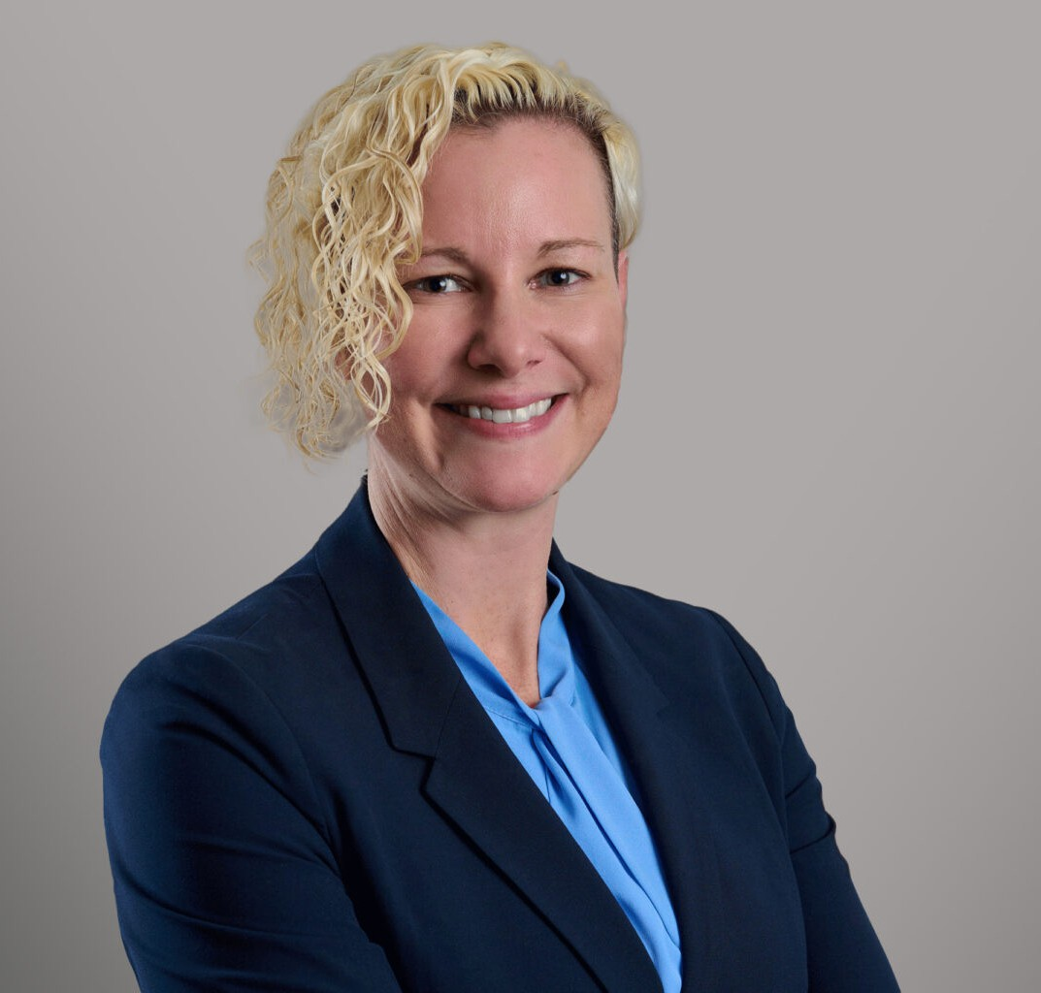

BRANDI BALANDA

Director

[Business Litigation](https://www.fennemorelaw.com/services/business-litigation/)

[Seattle](https://www.fennemorelaw.com/contact-us/seattle/)

P: 206.749.0500

F: 206.749.0600

[bbalanda@fennemorelaw.com](mailto:bbalanda@fennemorelaw.com)

“

Nothing has ever been achieved by the person who says, ‘It can't be done.

Eleanor Roosevelt

**BRANDI BALANDA**

”

Brandi Balanda has extensive experience successfully litigating complex commercial cases – from defending a senior executive against the largest trade secret claim asserted in Washington, to prosecuting fraud, contract and fiduciary duty claims related to the financing of major real estate projects, and obtaining emergency injunctive relief to protect businesses’ trademarks and other intellectual property. Brandi combines this commercial work with experience representing public entity clients in high-profile actions. Those disputes have involved defending against

employment and Washington Public Records Act claims, obtaining real property through eminent domain proceedings, and litigating real estate issues. She focuses on strategic advocacy to achieve client objectives. Brandi is adept at guiding and empowering clients

through the entire dispute resolution process – from risk assessment through litigation, obtaining relief, and in settlement negotiations. She is a passionate advocate, driven to achieve outstanding results for her clients through creative problem solving and collaboration.

Before joining Fennemore, Brandi was a partner at Savitt Bruce & Willey, LLP, and practiced law in Hawaii. She is a Boston College Law School graduate, where she participated in the European Law Moot Court team, arguing in English and French, and advancing as a regional

semi-finalist.

Outside of the office, Brandi enjoys sharing laughs with her family and friends, traveling, and outdoor adventures. She is inspired by Tolkien’s words, “Not all those who wander are lost” – although she now also carries a compass.

# EDUCATION

J.D., Boston College Law School

B.A., University of Washington

# AREAS OF PRACTICE

Business Litigation Intellectual Property Estate Litigation

Employment & Labor Real Estate Cannabis Business

Eminent Domain

# REPRESENTATIVE MATTERS

***Quackenbush et al. v. Lehua USA et al.*** Represented major cannabis industry player and senior executives in the prosecution of trade secret theft and trademark infringement claims against former executive and former employee, and in defending against employment and defamation claims; obtained preliminary injunction ordering the immediate return of intellectual property and equipment, and the cessation of the use of client trade secrets and trademarks, and then ultimately a permanent injunction against trade secret or trademark use and the dismissal of all claims against our clients.

***Move, Inc. v. Zillow, Inc.*** Represented executive defending against trade secret and employment claims in lawsuit seeking $2 billion in damages and career-ending relief;

obtained summary judgment on purported trade secret document, defended at evidentiary hearing spoliation allegations; all claims resolved with favorable settlement prior to trial.

***Continental Western, Inc. v. Crump; Continental Western, Inc. v. Ohmott et al.*** Prosecuted trade secret theft claims against former employees and competitor; demonstrated destruction of evidence and obtained favorable settlement.

***Confidential Arbitration***. Represented co-owner and founder of construction and design company in dispute in which client had signed contracts purportedly relinquishing ownership interests; defended against breach of fiduciary duty, fraud, and other claims and prosecuted counterclaims for declaratory judgment, breach of contract, and statutory violations; won rulings securing advancement of defense costs, which required plaintiff company to fund client’s defense; obtained favorable settlement.

***Asia Optical Co., Ltd. v. MicroVision, Inc.*** Defended publicly-traded company against tort and breach of contract claims and prosecuted conversion counterclaim in international

arbitration; obtained dismissal of tort claims, demonstrated absence of merit of remaining claims against client, and obtained favorable settlement.

***Irwin et al. v. City of Seattle***. Defended City of Seattle against wrongful termination claims seeking $10 million in damages brought by two former public disclosure officers; won rulings by the trial court upholding the City’s attorney-client privilege and work product protections and denial of appellate review, obtained attorneys’ fee award and favorable settlement.

***King v. Durkan et al.*** Defended the City of Seattle and Mayor Durkan against Washington

Public Records Act claims; obtained protective order prohibiting deposition of the Mayor and limiting the scope of discovery; obtained orders denying motions to compel discovery; succeeded on summary judgment on all claims.

***Wallace v. City of Bellevue.*** Defended the City of Bellevue in declaratory relief action regarding the interpretation and scope of utility easements in the downtown core; succeeded on summary judgment.

***City of Seattle v. Kaseburg et al.*** Represented the City in appeal of decree of public use and necessity in eminent domain action involving Open Public Meetings Act, appearance of fairness doctrine, and constitutional claims; obtained affirmance by the Court of Appeals and denial of review by the Washington Supreme Court.

***Sisley v. City of Seattle.*** Obtained decree of public use and necessity and rulings limiting the scope of discovery and prohibiting Apex depositions in contested eminent domain

proceedings, obtained affirmance by the Court of Appeals and denial of review by the Washington Supreme Court; defended the City against related Washington Public Records Act claims; succeeded on summary judgment; executed offer of judgment strategy to preclude recovery of certain attorneys’ fees.

***Vandeveer, et al. v. American Savings Bank*.** Defended federal savings and loan association against tort, statutory, and equitable claims in putative class action involving overdraft fees and related disclosure issues; filed pre-certification dispositive motion based on federal

preemption; obtained favorable settlement while federal preemption appeal was pending.

## *Gross, et al. v. University of Hawaii, et al.; University of Hawaii v. Lexington Insurance*

***Company.*** Defended state university system against putative class action regarding alleged data breaches; favorable settlement obtained after filing motion to dismiss; subsequently litigated claims on behalf of state university system against insurer for related coverage; favorable settlement obtained prior to any discovery.

***Pasion v. County of Kauai, et al.*** Represented appointed public official facing retaliation for whistle-blower activities and prosecuted subsequent related employment claims; obtained favorable settlement.

***Charles et al. v. Kapalua Bay, LLC, et al.*** Represented approximately forty purchasers of fractional ownership interests in a luxury development prosecuting consumer protection, tort, statutory, and equitable claims against developer, multinational hotel company, and related entities.

***Complex Multiparty Real Estate and Finance Litigation.*** Defended claims against personal guaranty of multi-million dollar revolving construction loan; developed and prosecuted claims for corporate fraud, breach of fiduciary duty, and breach of contract involving approximately $40 million of debt, mezzanine, and equity financed real estate projects; obtained favorable settlement for individual and developer entity clients.

# AWARDS AND HONORS

Best Lawyers in America, 2024 and 2025 Washington Super Lawyers, 2022-2025

Top Women Lawyers in Washington, Washington Super Lawyers, 2023 Washington Rising Stars, 2014-2020

Hawaii Rising Stars, 2014-2015

# ARTICLES AND PRESENTATION

Author, “[Fennemore attorney Brandi Balanda with insights on protecting trade secrets in a](https://www.bizjournals.com/seattle/news/2024/08/01/fennemore-attorney-brandi-balanda-with-insights-on.html) [generative AI world](https://www.bizjournals.com/seattle/news/2024/08/01/fennemore-attorney-brandi-balanda-with-insights-on.html),” Sacramento Business Journal, August 1, 2025

Author, “Litigation Overview: Washington,” Thomson Reuters, March 20, 2024 Author, “Mitigating Legal Risk in Today’s Business Climate – a Litigator’s Lens,” 2023

Presenter, “Beyond Oso: Understanding, Avoiding, and Mitigating Spoliation Issues, Landslides in Washington CLE Conference, Law Seminars International, 2017

Co-Author, “[Provisional Remedies: Washington, Practical Law](http://us.practicallaw.com/w-000-6380),” Thomson Reuters, August 2023 Author, “[Mitigating Legal Risk in Today’s Business Climate – a Litigator’s Lens](https://www.sbwllp.com/mitigating-legal-risk-in-todays-business-climate-a-litigators-lens/),” Firm Newsletter

# PROFESSIONAL AND COMMUNITY ACTIVITIES

Member, Federal Bar Association of the Western District of Washington Associate Fellow, Litigation Counsel of America

Member, Diversity Law Institute Member, Trial Law Institute

Young Lawyers Delegate, Federal Bar Association, Hawaii Chapter (2011-2012)

Board of Directors, Alexander Hamilton Scholars (formerly the Alexander Hamilton Friends Association)

# ADMISSIONS

Washington Hawaii

United States District Court of Appeals, Ninth Circuit United States District Court, Western District of Washington United States District Court, Eastern District of Washington United States District Court, District of Hawaii