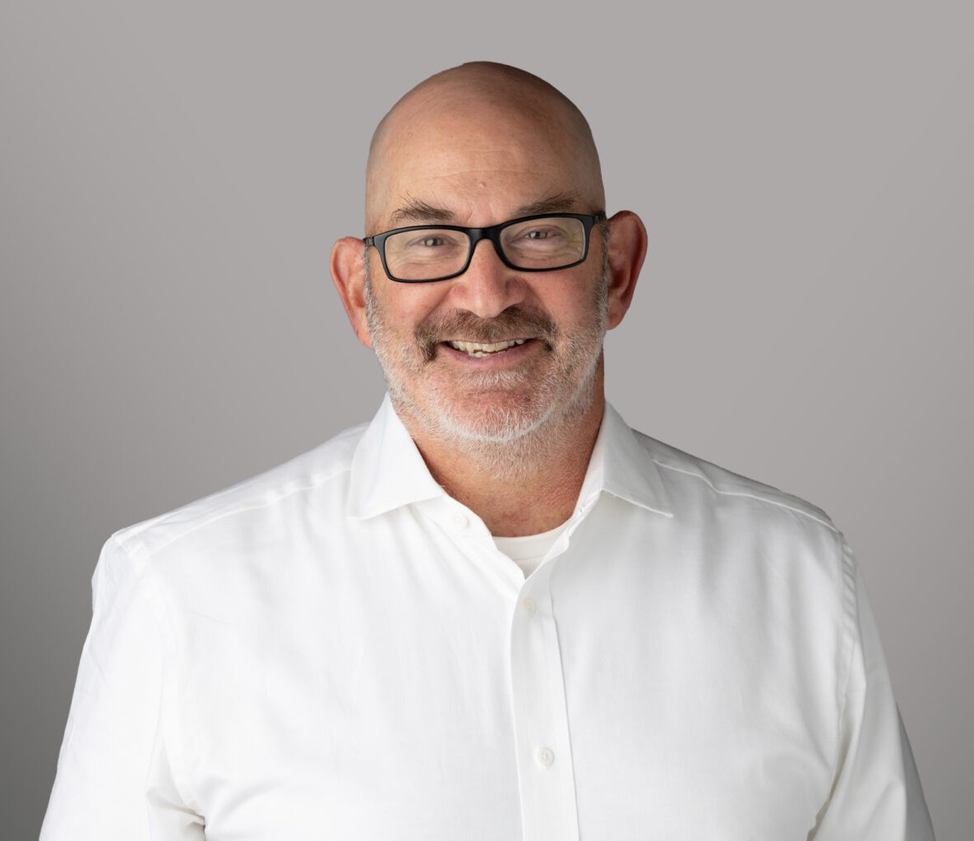

DALE FREEMAN

Director

[Business & Finance](https://www.fennemorelaw.com/services/business-and-finance/)

[Oakland](https://www.fennemorelaw.com/contact-us/oakland/)

P: 510.622.7562 F: 510.834.1928

[dfreeman@fennemorelaw.com](mailto:dfreeman@fennemorelaw.com)

# DALE FREEMAN

Dale Freeman is a Director in Fennemore’s [Business & Finance](https://www.fennemorelaw.com/services/business-and-finance/) practice group. He assists clients in a wide array of industries, ranging from medical devices to specialty foods, from construction infrastructure to digital media and AI tools. Dale assists his clients through every stage of their

business, from their initial formation to exit (M&A and IPO). He also helps clients with financing equity and debt, licensing, and a range of commercial transactions.

Prior to joining Fennemore, Dale was senior counsel at Brown Gee & Wenger LLP focusing on

corporate, securities and commercial transaction matters. He also spent a decade operating his own practice, Berkeley Business Law. Dale earned his law degree from Berkeley Law (formerly

Boalt Hall), where he served as Managing Editor of the *California Law Review*. He graduated with honors from Stanford University.

An active member of the East Bay community, Dale has served on the boards of several local nonprofit youth sports and community service organizations. A lifelong East Bay resident, he enjoys exploring the local food scene and is a big supporter of Bay Area collegiate and professional sports teams (especially for the ones with his daughters on their rosters).

# EDUCATION

J.D., University of California, Berkeley, School of Law Managing Editor, California Law Review

B.A., Stanford University, *with honors*

# AREAS OF PRACTICE

Business & Finance

# REPRESENTATIVE MATTERS

Sell-side representation of a software company in the area of catastrophic risk mitigation. Sell-side representation of an equipment manufacturing company.

Sell-side representation of a cloud-based software company that developed tools related to creating greater efficiencies for public- and quasi-public utilities.

Sell-side representation of a commercial food supply company.

Buy-side representation of a digital photography community company in the purchase of an AI tools company.

# PROFESSIONAL AND COMMUNITY ACTIVITIES

Board Member, ACC Mavericks Board Member, Inc. Soccer Club Board Member, Albany Little League

Board Member, Jewish Community Center of the East Bay

# ADMISSIONS

California