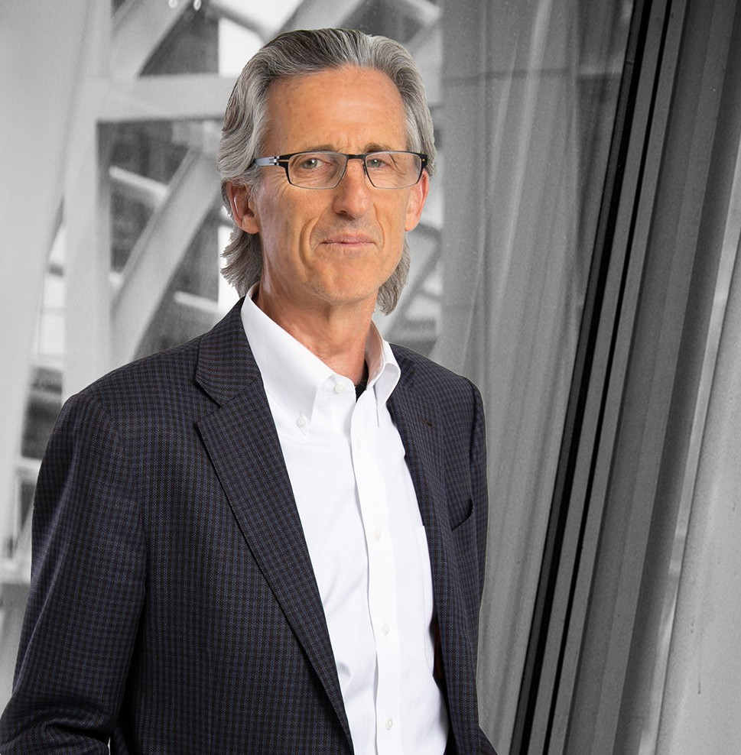

DANIEL M. REILLY

Director

[Business Litigation](https://www.fennemorelaw.com/services/business-litigation/)

[Denver](https://www.fennemorelaw.com/contact-us/denver-2/)

P: 303.764.3720 F: 303.291.3201

[Basalt](https://www.fennemorelaw.com/contact-us/basalt/)

P: 970.431.9060 F: 303.291.3201

[dreilly@fennemorelaw.com](mailto:dreilly@fennemorelaw.com)

**DANIEL M. REILLY**

Daniel Reilly is a civil trial lawyer with more than 30 years of trial experience as lead counsel in

complex cases around the country. He has been lead counsel for a broad spectrum of complex multi-jurisdictional commercial litigation matters, including both the prosecution and defense of class actions for individuals and major corporations. His cases have been throughout the United States. Dan has served as litigation counsel for the Denver Broncos Football Club, PERA, AIG, NOLHGA (National Organization of Life and Health Insurance Guaranty Associations), Liberty

Media, Medtronic and a number of other corporations and individuals. When representing plaintiffs, he has achieved multiple million-dollar jury verdicts.

Dan’s colleagues in the legal profession, judges as well as lawyers, value his courtroom skills and experience and eagerly attend his presentations. For many years, he addressed the Colorado Judicial Conference on timely subjects like the evidentiary issues raised by the use of technology in the courtroom, and the standards used to determine the admissibility of scientific and other

expert opinions.

Before joining Fennemore, Dan founded Reilly LLP in Denver with a commitment to being the best trial firm in the country.

## EDUCATION

J.D. University of Denver, Sturm College of Law

B.A., Michigan State University, *magna cum laude*

**AREAS OF PRACTICE**

# OTHER EXPERIENCE

Civil Trials

Complex Commercial Litigation Fiduciary Litigation

Tort Litigation Class Actions

Consumer Fraud Business Litigation

## REPRESENTATIVE CASES

Dan began his career handling personal injury cases for injured individuals. In his practice, Dan settled hundreds of cases for his clients, and tried dozens of cases successfully to jury verdicts. Many of the cases were complex and involved multiple defendants, novel questions of law and complex legal, procedural and medical issues.

Dan served as lead plaintiffs’ counsel in seven state class actions brought against regional phone provider U.S. West for installation delays experienced by 250,000 customers. The U.S. West cases settled for $36 million in settlement funds and $7.2 million in attorney’s fees.

Dan Reilly served as lead trial counsel in a dispute over the ownership of the Denver Broncos. In 1984, Edgar Kaiser sold his share of the Denver Broncos Football Club to our client Pat Bowlen – retaining “right of first refusal” on any future sale of a portion of the team. Fifteen years later, after Pat Bowlen had offered a stake in the club to former Broncos quarterback, John Elway, Kaiser sued Bowlen for breach of contract in both federal and state courts. Dan was able to obtain a successful jury trial verdict in the Federal case, which progressed to the

U.S. Court of Appeals for the Tenth Circuit, where a complete victory was obtained. In the related state district court, summary judgment was granted in favor of Mr. Bowlen. The

Colorado Court of Appeals affirmed the district court’s ruling, the Colorado Supreme Court denied certiorari—and Pat Bowlen maintained control of the NFL franchise. Dan also represents PDB Sports, Ltd. and Bowlen Sports, Inc. in a currently pending declaratory

judgment action concerning a right of first refusal granted in 1984.

Dan was a lead counsel on the trial team that successfully represented DCP Midstream, LP, one of the nation’s largest natural gas processing companies, in a jury trial involving complex oil and accounting issues. Successors to a gas purchase and processing agreement sought multi-million-dollar payments for natural gas processed out of the DJ Basin in Weld County.

DCP counterclaimed for overpayments, which the jury awarded.

Dan was lead counsel on the trial team representing a Colorado refinery owner seeking contractual indemnification from the refinery’s former owner for clean-up costs resulting from leakage from an underground pipe. Following a 3-week confidential arbitration that took place in April and May 2017, the parties reached an amicable settlement.

Dan was lead counsel and successfully represented Target Brands, Inc., a wholly-owned subsidiary of Target, which holds and protects all of the company’s trademarks, patents, and other intellectual property. The Colorado Department of Revenue sought more than $40 million in corporate income tax from TBI. After a two-week trial, the Court entered judgment reducing the tax assessment to $12.8 million

A group of automobile dealerships were facing a purported class action claiming that new cars were equipped in violation of the Colorado Consumer Protection Act and hired Reilly to defend its interests. After winning landmark reversals at the Colorado Court of Appeals and Supreme Court of the trial court’s initial approval of class treatment, Reilly team members were called on once again to defend against Plaintiffs’ renewed attempt at certification of two different proposed consumer classes. This five-year battle for class certification culminated in an extensive four-day evidentiary hearing. Agreeing with Reilly and its client

that individual examinations of each car purchase file were necessary and class wide

inferences could not be made, the Jefferson County District Court (Tidball, J.) denied Plaintiffs’ Second Motion for Class Certification on Rule 23 superiority and predominance grounds.

Dan was trial counsel to AIG and its insurance and broker-dealer subsidiaries in structured

finance, intellectual property, and unfair competition litigation, and in arbitration proceedings before the Financial Industry Regulatory Authority. This representation included protecting the rights of AIG as a certificate holder in connection with a proposed $8.5 billion settlement of

RMBS claims against Bank of America.

Dan headed a plaintiff’s jury trial team which obtained a multi-million dollar trademark infringement judgment in Colorado federal court against H.J. Heinz.

Seven state insurance guaranty associations sued a regional brokerage firm following the liquidation of MidWest Life. The claims were for fraud and breach of fiduciary duties. After three successful jury trials in Colorado, Washington and a three month trial in Iowa, the brokerage firm agreed to settle the cases for $30 million.

Dan represented Trane U.S. Inc. in the re-trial after appeal of a Colorado federal court action brought by a former franchisee of the company. In the re-trial, Dan and his team obtained a defense judgment which was affirmed in the U.S. Court of Appeals for the Tenth Circuit.

Dan represented Liberty Digital, a subsidiary of Liberty Media in a Colorado state court breach of contract dispute involving the cable music systems against a national cable company, Comcast Corporation. The case was successfully resolved after opening statements were made to the jury.

Dan headed the trial team which twice successfully defeated class certification on behalf of the Old Line Life Insurance Company in a consumer/uniform business practices case filed in state court in California. The matter settled prior to trial.

Dan served as lead counsel defending AIG Life in a multi-million dollar copyright infringement case filed in a Texas federal court which was successfully resolved prior to trial.

Dan was lead defense counsel representing a national life insurance company in a national class action brought in state court in New Mexico. The matter settled before trial.

Dan was lead counsel for multiple plaintiffs in highly-complex litigation against several bank trustees and numerous other defendants, securing significant recoveries through settlement and substantial judgments. The litigation arose out of a multi-state fraud scheme involving National Prearranged Services, Inc. (a Missouri-based preneed funeral contracts seller) and its two related insurance companies domiciled in Texas. Dan was retained by 35 state life and health insurance guaranty associations, NOLHGA, and the Texas Special Deputy Receiver to seek recoveries from over 40 defendants, including multiple bank trustees, an accounting firm, and the former officers and directors of NPS and the insurance companies. Plaintiffs’ claims included negligence and breach of fiduciary duty against the bank trustees for

allowing the preneed trust funds to be looted, accounting malpractice, and RICO (Racketeer Influenced and Corrupt Organizations Act) claims against the former officers and directors.

Settlements with most defendants were negotiated before trial, resulting in large recoveries for the clients. A five-week jury trial was held in federal court in Missouri in early 2015, where a jury verdict of $391 million (including a punitive damages award) was entered against PNC Bank. After the Eighth Circuit remanded the case against PNC Bank for a trial to the Court, Dan again served as lead counsel and head of the trial team that secured a combined $106 million judgment ($99 million in compensatory and punitive damages and $7 million in attorney fees and litigation costs) against PNC Bank for breach of trust. PNC’s appeal of the

$106 million judgment is currently pending.

## AWARDS AND HONORS

*Best Lawyers in America®,* Lawyer of the Year, Litigation – Bankruptcy, 2019, 2025

*Best Lawyers in America®,* Lawyer of the Year, Mass Tort Litigation / Class Actions – Plantiffs, 2025

*Best Lawyers in America®,* Commercial Litigation, Bet-the-Company Litigation, Litigation- Banking & Finance, Litigation – Bankruptcy, Litigation – Intellectual Property and Personal Injury Litigation, Litigation – Trusts and Estates, Mass Tort Litigation / Class Actions – Plaintiffs, 1995-

2026

Super Lawyers®, Business Litigation, 2006-2025

*Chambers USA,* Colorado, Litigation: General Commercial, Star Individual, 2013-2024

*Best Lawyers in America®,* Lawyer of the Year, Denver Litigation- Banking and Finance, 2015

*Best Lawyers in America®,* Lawyer of the Year, Denver Personal Injury Litigation, 2010 *Best Lawyers in America®* Lawyer of the Year, Denver Bet-the-Company, 2009 *Chambers USA,* Colorado, Litigation: General Commercial, 2006-2021

*5280 “Top Lawyers*,” Civil Litigation and Commercial Litigation, 2015

Top 10 Colorado *Super Lawyers®*, 2012, 2014, 2015 – 2nd top point earner; 2006, 2011, 2013 – 3rd top point earner

AV® Preeminent™ Peer Review Rated (the highest rating available), by Martindale-Hubbell “Hot List,” *National Law Journal Litigation Boutiques*, 2012

Named to Federal Judicial Selection Advisory Panel by U.S. Senators Udall and Bennet, 2009, 2012

Life Fellow, American Bar Foundation, since 2005

## ARTICLES AND PRESENTATIONS

Co-Author, “[Q&A: Lawyers Ted White and Dan Reilly reflect on Fennemore’s expansion and](https://www.bizjournals.com/denver/news/2025/03/01/lawyers-ted-white-dan-reilly-fennemore-expansion.html) [future footprint](https://www.bizjournals.com/denver/news/2025/03/01/lawyers-ted-white-dan-reilly-fennemore-expansion.html),” *Denver Business Journal*, March 1, 2025

Featured, “5280’s Hall of Fame,” 5820.com, July 2023

Quoted, “Broncos Sale Is ‘Free and Clear’ to Go on Following Settlement Between Estates,” Sports Illustrated, April 14, 2022

Interview, “Trial Attorney Daniel Reilly on business litigation trends, joining Fennemore and work-life balance,” Denver Business Journal, April 1, 2022

Quoted, “Court victory clears path for sale of Denver Broncos,” Centre Daily Times, January 12, 2022

Quoted, “Path for Broncos to be sold cleared with judge’s ruling,” Denver Gazette, January 11, 2022

Quoted, “Judge’s ruling clears hurdle for potential sale of Denver Broncos,” The Denver Channel, January 11, 2022

Presenter, “Show and Tell: Using Demonstrative Exhibits in Opening,” CTLA Annual Convention, 2015

Presenter, “The Power of Imagery: Using Demonstrative Evidence in Opening Statements,” Colorado Bar Association, Winning Trial Tactics, 2012

Presenter, “Opening Statements and Demonstrative Evidence, ” Colorado Bar Association CLE, Trial Skills, 2011

Presenter, “Potpourri of Evidence Issues: Scientific and Digital Evidence, Crawford Issues,” American Judges Association 51st Annual Conference– Making Better Judges, 2010

Panel Discussion: “Evaluating a Case, ” General Counsel Forum, 2009

Panel Discussion: “Unraveling the Mysteries of the Jury: Can a Consultant Help You Develop a Winning Trial Strategy,” Faculty of Federal Advocates Annual Meeting, 2009

Presenter, “Opening Statement and Demonstrative Evidence,“ Colorado Bar Association’s Litigation Boot Camp II, 2008

Presenter, “What to Do When a Commercial Case Comes into Your Office,“ CTLA Conference, 2008

Presenter, “E-Discovery in Colorado Courts,“ Colorado Judicial Conference, 2008

Presenter, “Five Ethical Land Mines You Really Want to Avoid in E-Discovery,“ AIG American General Life Insurance Company Law Conference, Houston 2007

Presenter, “Issues of Admissibility Raised by Electronically Stored Information,“ Colorado Judicial Conference, 2007

Presenter, “Using Your Opponent ‘s Witness to Build Your Theory of the Case,“ NOLHGA Annual Legal Seminar, 2007

Presenter, “Changing Horses: The Efficient Transition to New/Additional Counsel During Litigation“ and “The Corporation in Litigation: Developing the Allure of David Using the Strength of Goliath,“ Clifton Gunderson ‘s General Counsel Forum, 2007

## PROFESSIONAL AND COMMUNITY ACTIVITIES

Denver Bar Association (Member, Board of Trustees, 1986-1987; Inter-Professional Committee, 1981 and 1987; Drafting Committee for Revision of Joint Medico-Legal Plan for Arbitrating Professional Liability Cases, 1987; Chair, DBA Young Lawyers Executive Council, 1986; Chair, Sports Committee, 1989-1992)

William E. Doyle‘s American Inn of Court (President, 1993; Executive Committee, 1987-1994)

Colorado Trial Lawyers Association (Executive Committee, 1994-1995; Co-Chair Professionalism Committee, 1993-1994; Member, Board of Directors, 1987-1989; Long Range Planning

Committee, 1988; Legislative Subcommittee on Statute of Limitations, 1988) Denver Bar Association

Colorado Bar Association Sam Cary Bar Association

William E. Doyle‘s American Inn of Court Colorado Trial Lawyers Association Faculty of Federal Advocates American Association for Justice American Bar Association

American College of Trial Lawyers American Board of Trial Advocates

## ADMISSIONS

Colorado

U.S. District Court District of Colorado

U.S. Court of Appeals Sixth Circuit

U.S. Court of Appeals Tenth Circuit

U.S. Supreme Court