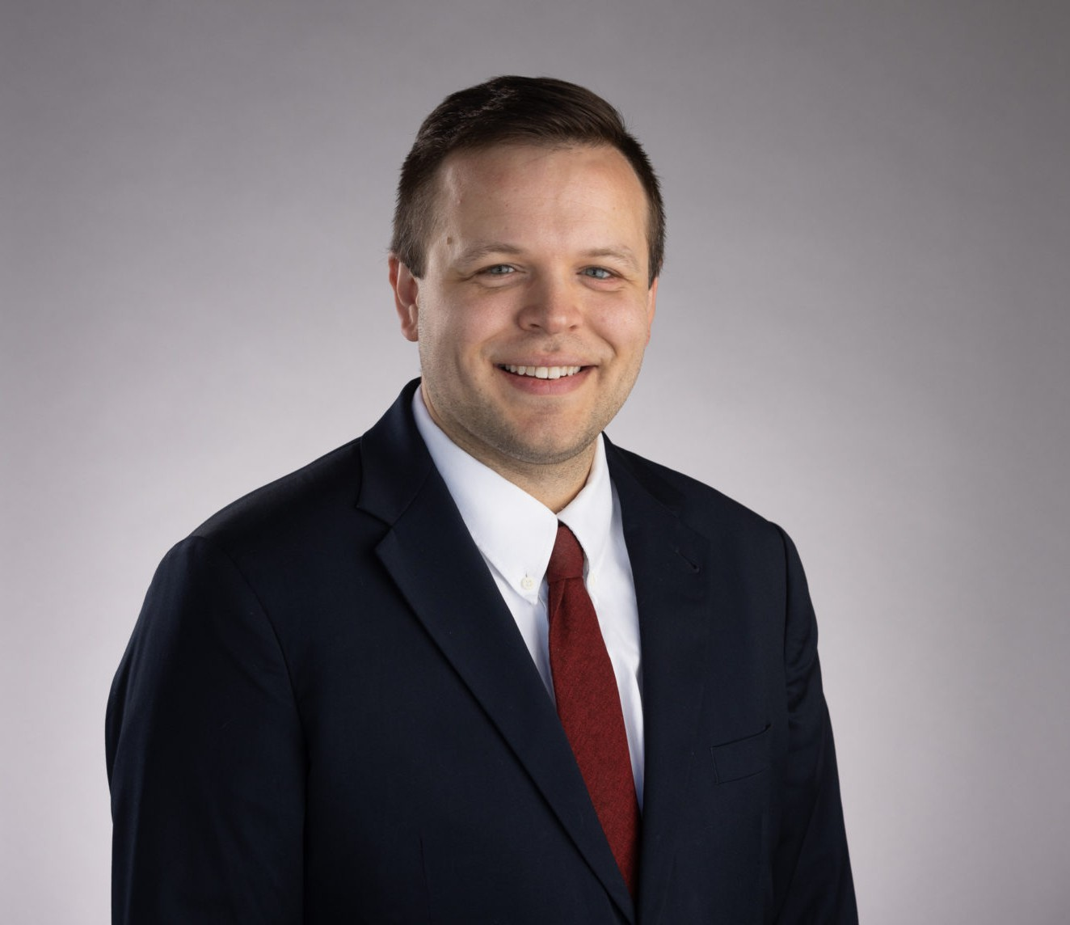

DARIEN KEY

Associate

[Land Use](https://www.fennemorelaw.com/services/land-use/)

[Oakland](https://www.fennemorelaw.com/contact-us/oakland/)

P: 510.834.6600 F: 510.834.6600

[dkey@fennemorelaw.com](mailto:dkey@fennemorelaw.com)

“

Happiness lies in the joy of achievement and the thrill of creative effort.

Franklin Delano Roosevelt

**DARIEN KEY**

”

Darien Key is an associate attorney who works out of our Oakland office in our Land Use and Natural Resources practice groups. Darien’s practice focuses on Land Use entitlement (such as the Subdivision Map Act, Housing Accountability Act, and Builder’s Remedy), CEQA (California Environmental Quality Act), municipal law (such as the Brown Act, Public Records Act, Conflicts of Interest, etc.), water (SGMA compliance and groundwater adjudications), and related environmental laws both on the transactional side but also in litigation.

Born and raised in Bakersfield, CA, Darien understands the importance of land use, water, and environmental regulations in California. His extensive experience in administrative rule-making and municipal processes ensures that clients receive knowledgeable and strategic counsel in addressing local land use, water, and environmental challenges. Additionally he helps his agricultural and industrial clients in developing and implementing effective strategies to obtain, maintain, protect and transfer water rights and supplies. Darien enjoys helping people,

businesses, and local governments solve their problems by translating “legalese” into everyday language that helps clients make the necessary decisions to push projects forward. In his role, he becomes the face of the law – forming solid relationships and making sure he cares for his clients business the same way they do.

Outside of work, Darien is a workout warrior who enjoys hiking, weight lifting, and rock climbing, as well as just relaxing with his two dogs and two cats. He’s also a great cook inspired by the creativity offered by his epicurean adventures – ask him about his go-to lasagna dish!

Land Use

Natural Resources

# EDUCATION

J.D., University of San Diego School of Law

B.A., San Diego State University, *cum laude*

# AREAS OF PRACTICE

Land Use

Natural Resources

# PROFESSIONAL AND COMMUNITY ACTIVITIES

Current Editor, California Land Use & Policy Reporter Previous Member, City of Pleasant Hill Planning Commission

Previous Member, Contra Costa Solid Waste Local Enforcement Agency Independent Hearing Panel

# ARTICLES AND PRESENTATIONS

Speaker “Managing Flood Control and New Storage Plans – Capturing Flood Flows Water— California’s Recent Legislative Efforts” September 30, 2024, California Water Law and Policy 38th Annual Conference

Author, “Recalibrating NEPA Compliance: The U.S. Supreme Court’s Clarification on the Purpose and Scope of Environmental Review,” July 2025, Western Water Law And Policy Reporter, <https://argentco.com/> (subscription required)

Co-Author, “Floodwater as Personal Property? Fifth District Court Clarifies Groundwater Classification,” July 2025, California Water Law And Policy Reporter,

<https://argentco.com/> (subscription required)

Co-Author, “First District Court Finds Combined Wastewater and Stormwater System is a

‘Sewer’ For Purposes of Proposition 218,” July 2025, California Water Law And Policy Reporter, <https://argentco.com/> (subscription required)

Author, “Recalibrating NEPA Compliance: The U.S. Supreme Court’s Clarification on the Purpose and Scope of Environmental Review,” July 2025, California Water Law And Policy Reporter, <https://argentco.com/> (subscription required)

Co-Author, “Ninth Circuit Finds City’s Distance Requirement for Group-living Facilities Survives Challenge that Regulation Discriminated Against Persons with Disabilities,” June 2025, California Land Use Law and Policy Reporter

Co-Author, “YIMBY Challenges City of Cupertino’s Alleged Violation of Builder’s Remedy Project Processing,” June 2025, California Water Law And Policy Reporter,

<https://argentco.com/> (subscription required)

Author, “Chowchilla Subbasin Potentially Avoids Probation Hearing,” June 2025, California Water Law And Policy Reporter, <https://argentco.com/> (subscription required)

Author, “Fourth District Court Invalidates San Diego County’s CEQA Thresholds for Infill and Small Projects,” May 2025, California Land Use and Policy Reporter,

<https://argentco.com/> (subscription required)

Co-Author, “Housing Advocacy Group Sues City of Lafayette Alleging City’s Housing Element Fails to Comply with State Housing Laws,” May 2025, California Land Use and Policy Reporter, <https://argentco.com/> (subscription required)

Author, “Sixth District Court Upholds Santa Clara Groundwater Charges Under Proposition 26,” May 2025, California Land Use And Policy Reporter, <https://argentco.com/> (subscription

required)

Author, “Sixth District Court Upholds Santa Clara Groundwater Charges Under Proposition 26,” May 2025, California Water Law And Policy Reporter, <https://argentco.com/> (subscription required)

Author, “California Court of Appeal Upholds Santa Clara Groundwater Charges Under Proposition 26,” May 2025, Western Water Law And Policy Reporter,

<https://argentco.com/> (subscription required)

Co-Author, “Superior Court Analyzes the Housing Accountability Act and a Vesting Tentative Tract Map,” April 2025, California Land Use Law And Policy Reporter,

<https://argentco.com/> (subscription required)

Author, “California High Speed Rail Authority Inspector General Issues Report and Proposes Eddiciencies to Control Costs and Expedite Completion of the Project,” April 2025, California Land Use Law And Policy Reporter, <https://argentco.com/> (subscription required)

Author, “Mendocino County Declines Proposed Groundwater Extraction Ordinance,” April 2025, California Land Use Law And Policy Reporter, <https://argentco.com/> (subscription required)

Author, “Mendocino County Declines Proposed Groundwater Extraction Ordinance,” April

2025, California Water Law And Policy Reporter, <https://argentco.com/> (subscription required)

Co-Author, “Reaffirming Taxpayer Protections: Fourth District Court Finds Water District’s Rate Structure Ran Afoul of the California Constitution,” March 2025, California Water Law And Policy Reporter, <https://argentco.com/> (subscription required)

Co-Author, “Reaffirming Taxpayer Protections: Fourth District Court Finds Water District’s Rate Structure Ran Afoul of the California Constitution,” March 2025, Western Water Law And Policy Reporter, <https://argentco.com/> (subscription required)

Co-Author, “Reaffirming Taxpayer Protections: Fourth District Court Finds Water District’s Rate Structure Ran Afoul of the California Constitution,” March 2025, California Land Use Law And Policy Reporter, <https://argentco.com/> (subscription required)

Author, “Executive Orders by Governor Newsom Expedite Rebuilding Efforts Following

California Wildfires by Relaxing CEQA and Coastal Act Requirements,” March 2025, California Land Use Law And Policy Reporter, <https://argentco.com/> (subscription required)

Co-Author, “California Supreme Court Addresses When the Conveyance of Land Actually Amounts to a Subdivision,” March 2025, California Land Use Law And Policy Reporter, <https://argentco.com/> (subscription required)

Author, “Executive Orders by Governor Newsom Expedite Rebuilding Efforts Following

California Wildfires by Relaxing CEQA and Coastal Act Requirements,” March 2025, California Water Law And Policy Reporter, <https://argentco.com/> (subscription required)

Co-Author, “California Expands Efforts to Capture Excess Flood Flows for Groundwater Recharge Via Governor Newsom’s Executive Order N-16-25,” March 2025, California Water Law And Policy Reporter, <https://argentco.com/> (subscription required)

Author, “Fourth District Court Affirms Upland Park Project Amid CEQA Challenges,” February 2025, California Land Use Law and Policy Reporter, <https://argentco.com/> (subscription required)

Co-Author, “Superior Court Orders Sonoma County To Cease Issuing Well Permits Except for Emergency Permits” February 2025, California Water Law And Policy Reporter,

<https://argentco.com/> (subscription required)

Author, “First District Court Addresses the Government Claims Act and the Discovery Rule in the Context of a Development Project with Bond Finanacing” January 2025, California Land Use Law and Policy Reporter, <https://argentco.com/> (subscription required)

Co-Author, “State Water Project Allocations Started at 5 Percent, Then Jump to 15 Percent After Late November Atmospheric Rivers Marking A Wetter Year Than Initially Forecasted” January 2025, California Water Law And Policy Reporter, <https://argentco.com/> (subscription required)

Author, “Bay Conservation and Development Commission Publishes Regional Shoreline Adaptation Plan Implementation,” January 2025, California Water Law And Policy Reporter, <https://argentco.com/> (subscription required)

Author, “Bay Conservation and Development Commission Publishes Regional Shoreline Adaptation Plan Implementation,” January 2025, Western Water Law And Policy Reporter, <https://argentco.com/> (subscription required)

Author, “Lawsuit Filed by California Attorney General Takes Aim at Defiant City and Alleged Non-Compliance with “Housing Element” Law, December 2024, California Land Use Law and Policy Reporter, <https://argentco.com/> (subscription required)

Author, “California Bill Could Transform Prime Agricultural Land Into Solar Farms,” July 2024, California Water Law And Policy Reporter, <https://argentco.com/> (subscription required)

Author, “California Flood Flows – New Legislative Attempts to Capture Precipitation under New Water Code 1242 After Another Wet Water Year,” June 2024, California Water Law And Policy Reporter, <https://argentco.com/> (subscription required)

Author, “California State Board Hosts Workshop On Revised Draft Proposed Regulation For ‘Making Conservation A California Way Of Life,’” May 2024, California Water Law And Policy Reporter, <https://argentco.com/> (subscription required)

Author, “California Department Of Water Resources Releases Draft California Water Plan Update 2023,” November 2023, California Water Law And Policy Reporter,

<https://argentco.com/> (subscription required)

Author, “Federal Open Access Evapotranspiration Data Act in Congress Proposes Significant Updates to Water Measurement and Management,” July 2023, California Water Law And

Policy, <https://argentco.com/> (subscription required)

Author, “California Legislature Introduces Bills Impacting The Elevated Status Of Pre-1914 And Riparian Water Rights,” March 2023, California Water Law And Policy Reporter,

<https://argentco.com/> (subscription required)

American Bar Association, Water Resources Newsletter, Mexican Sewage in American Waters: Who Is Responsible for Fixing the Sewage Crisis?

# AWARDS AND HONORS

*Best Lawyers in America®,* Ones to Watch, Land Use and Zoning Law, Natural Resources Law, 2026

CALI Awards (Highest Grade) at the University of San Diego School of Law in Ocean, Coast Law and Animal Law Classes

Donald Weckstein Scholarship, awarded annually to law students based on their contribution to the University of San Diego School of Law

# ADMISSIONS

Co-Author, “YIMBY Challenges City of Cupertino’s Alleged Violation of Builder’s Remedy Project Processing,” June 2025, California Water Law And Policy Reporter,

<https://argentco.com/> (subscription required)

Co-Author, “YIMBY Challenges City of Cupertino’s Alleged Violation of Builder’s Remedy Project Processing,” June 2025, California Water Law And Policy Reporter,

<https://argentco.com/> (subscription required)

California