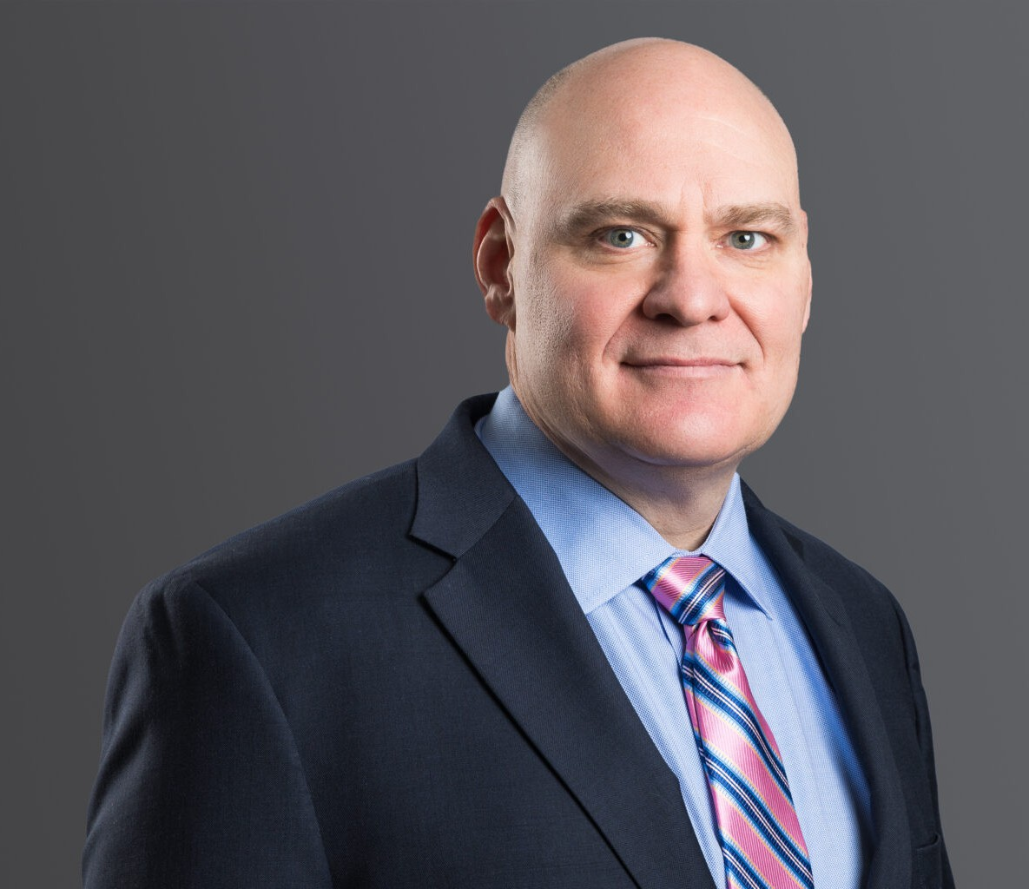

DAVID A. LAIRD

Director

[Business Litigation](https://www.fennemorelaw.com/services/business-litigation/)

[Denver](https://www.fennemorelaw.com/contact-us/denver-2/)

P: 303.813.3836 F: 303.291.3201

[dlaird@fennemorelaw.com](mailto:dlaird@fennemorelaw.com)

# DAVID A. LAIRD

With over 25 years of trial experience in state and federal courts, David is driven to find just and efficient results for his clients. David has found that many disputes can be resolved quickly if the issues at the heart of the matter are quickly identified and addressed. For those cases that

cannot be resolved quickly, David has the knowledge, experience, and determination to aggressively litigate disputes to a conclusion.

Much of David’s practice focuses on resolving lending and real estate disputes. Also, David litigates a wide variety of complex contract and commercial disputes, business torts, uniform commercial code disputes, insurance coverage disputes, fiduciary claims, oil and gas matters, and landlord/tenant issues, and commercial foreclosures. He also represents creditors in bankruptcy cases and clients involved in securities litigation.

With an eye toward efficient and positive solutions, David advocates for clients in court, administrative proceedings, on appeal, and via alternative methods of dispute resolution such as mediation and arbitration.

David prides himself on being responsive and proactive. His clients always know the “game

plan” and are kept apprised throughout the case. David understands that communication is the key to a successful attorney-client relationship.

# EDUCATION

J.D., University of Denver

B.A., University of Denver, Honors with distinction

# AREAS OF PRACTICE

Business Litigation Eminent Domain

# ARTICLES AND PRESENTATIONS

Author, “COVID-19 Fallout: Colorado Court Upholds Allocation of Risk in Lease,” *Firm Blog*, February 2023

Author, “Commercial Evictions in 2021 – Will There Be Calm After the COVID-19 Storm?,” *Mile High CRE*, March 2021

Author, “The Trouble with Forbearance Fees,” *Independent Report,* December 2020 Presenter, “Getting Coloradoans Back to Work,” Firm Webinar, May 2020

Co-Author, “Evictions in the Time of COVID-19,” *Colorado Real Estate Journal*, April 2020

Author, “Court Gives Teeth to Defense Waiver in Loan Documents,” The Independent Report,

*Independent Bankers of Colorado*, November/December 2014

Author, “At Risk: Secured Creditors’ Right to Credit Bid on Assets Sold at Chapter 11 Plan Sales,” *The Business Suit*, Volume 13, Issue 8, October 2010

Author, “New Colorado Law Allows Expedited Real Property Foreclosures,” Firm Opportunities and Challenges, June 2010

Author, “Duties to Pay Subcontractors Under the Colorado Trust Fund Statute,” Firm Opportunities and Challenges, March 2009

Author, “Commercial Loans: Using Litigation Effectively When Borrowers Default,” *Denver Business Journal*, Volume 60, No. 11, August 2008

# PROFESSIONAL AND COMMUNITY AFFILIATIONS

Volunteer, Ask a Lawyer

Colorado Bar Association, Litigation Section Executive Council and Annual Litigators’ Summit Planning Committee

Former Director, Colorado Bowhunters Association Former President, Contractors Council, Member Defense Research Institute

Denver Bar Association

First Judicial District Bar Association

Associate Member, Independent Bankers of Colorado

# AWARDS AND HONORS

[Benchmark Litigation: Local Litigation Star – General Commercial Litigation and Bankruptcy](https://benchmarklitigation.com/Lawyer/David-Laird/Profile/119530#profile) [Litigation, 2022 – 2024](https://benchmarklitigation.com/Lawyer/David-Laird/Profile/119530#profile)

[*Best Lawyers in America®,*](https://www.bestlawyers.com/lawyers/david-laird/326392)[Commercial Litigation and Litigation – Real Estate, 2023 – 2026](https://www.bestlawyers.com/lawyers/david-laird/326392) [Colorado Super Lawyers®, Business Litigation, 2017 – 2025](https://profiles.superlawyers.com/colorado/denver/lawyer/david-a-laird/845b15d0-bd8c-43c8-9030-a9a7e0441273.html)

[Colorado Super Lawyers®, Rising Star, Business Litigation, 2013](https://profiles.superlawyers.com/colorado/denver/lawyer/david-a-laird/845b15d0-bd8c-43c8-9030-a9a7e0441273.html) [Martindale-Hubbell Rating: AV® Preeminent™ (highest)](http://www.martindale.com/David-A-Laird/8450945-lawyer.htm)

# ADMISSIONS

*Best Lawyers in America®,*

Colorado

U.S. Court of Appeals for the Tenth Circuit

U.S. Court of Appeals – District of Colorado

U.S. District Court – District of Colorado

U.S. Supreme Court