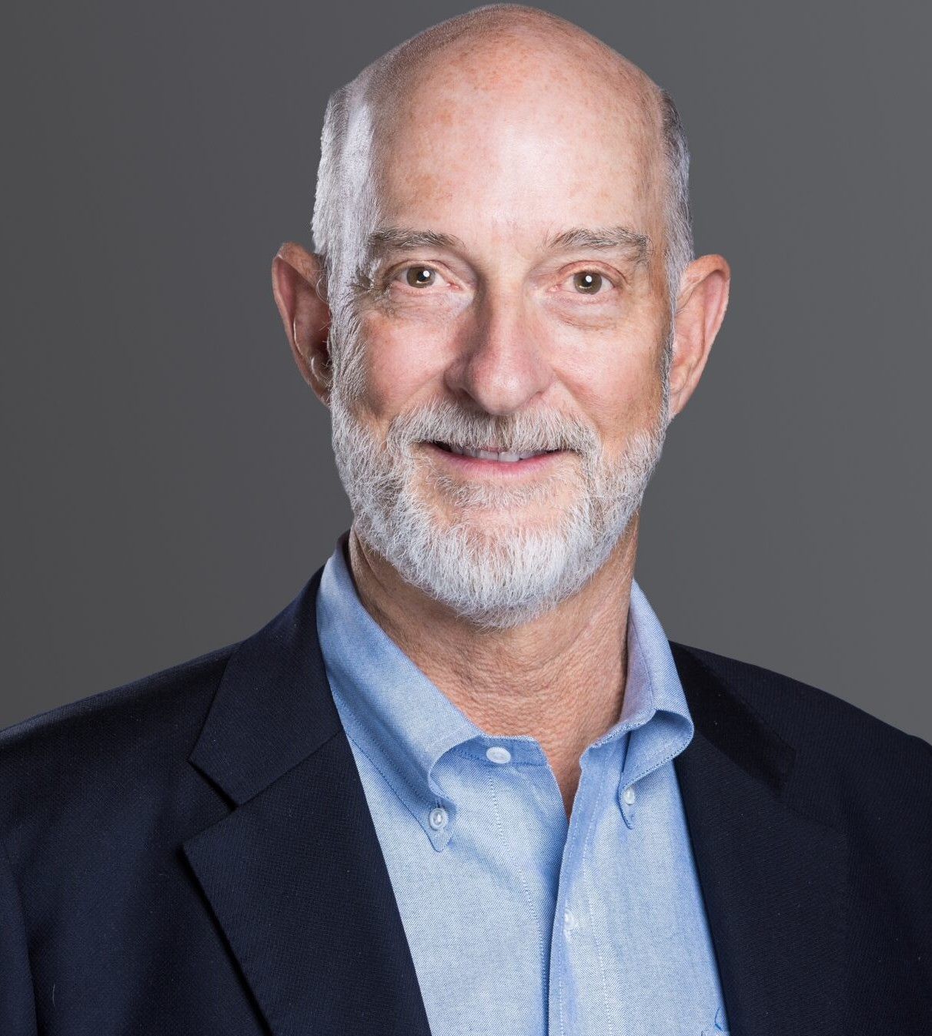

EDWARD D. “TED” WHITE

Director

[Business & Finance](https://www.fennemorelaw.com/services/business-and-finance/)

[Denver](https://www.fennemorelaw.com/contact-us/denver-2/)

P: 303.813.3896

F: 303.291.3201

[Basalt](https://www.fennemorelaw.com/contact-us/basalt/)

P: 970.431.9060

F: 303.291.3201

[twhite@fennemorelaw.com](mailto:twhite@fennemorelaw.com)

# EDWARD D. "TED" WHITE

Edward D. “Ted” White is Co-Chair of the firm’s Advanced Energy Group.

Ted’s practice focuses on corporate transactions such as mergers, acquisitions, and financings.

As a strategic partner, Ted helps clients discern opportunities and make strategic connections that add business value. He has specific experience with private capital funds and takes a

leadership role in fund formation and handling portfolio acquisitions and dispositions.

Ted currently serves as Senior Counselor for a prominent investor and philanthropist’s extensive business, policy, and philanthropic efforts. Ted is also the founder and advisory board chair for Estabrook Funds, a fund of global, multi-strategy absolute return hedge funds, one of the first of its kind in the United States. He is on the Limited Partner Advisory Committee of multiple

investment funds and serves on the board of directors or advisory boards of several funds and companies.

Ted is an arbitrator for complex commercial disputes through the American Arbitration

Association. He has resolved dozens of commercial claims relative to matters such as loans, securities fraud, mergers and acquisitions, professional sports contracts, and other complex business issues.

He is the author of Business Contracts (Bradford Publishing Co. 2010); Business Contracts: A Guide (Bradford Publishing Co. 2013); and Business Contracts: A Guide for Lawyers and Business

Owners, 2016 and 2025 Edition (CBA-CLE).

Ted has a strong record of civic leadership. He is a former Chair of the Boettcher Foundation, one of the largest privately endowed grant-making organizations in Colorado, and a former Director of Sustainability Accounting Standards Board Foundation (SASB). He serves as an officer and trustee of many community organizations, including the Rocky Mountain Institute (RMI) and the Advanced Energy Institute.

Ted is a former adjunct professor of law at the University of Colorado School of Law where he designed and taught the popular Business Transactions course. His other teaching efforts include

numerous CLE courses.

Before joining Fennemore, Ted was the name partner at the law firm Moye White LLP. Prior to that, he was the President and Managing Director of the law firm Dufford & Brown, P.C.

# EDUCATION

J.D., New York University

B.A., *with distinction*, Yale University

# AREAS OF PRACTICE

Business & Finance Advanced Energy

Family Office & Private Client Attorneys

# AWARDS AND HONORS

*Best Lawyers in America®,* Corporate Law and Leveraged Buyouts and Private Equity Law, 2005 – 2026; Mergers and Acquisitions Law 2020 – 2026

[500 Leading U.S. Energy Lawyers, Lawdragon, 2025](https://www.lawdragon.com/guides/2025-02-21-the-2025-lawdragon-500-leading-energy-lawyers?utm_medium=email&_hsenc=p2ANqtz--HFLvdnbgpdi3NnGPZ3o_AUue3govarMFrnXtEAtSwoyKLGG2xXRTFN2JP5Ny7dzE_DFu_LMG9nXKO6-lJXqIKqmwALQ&_hsmi=348398335&utm_content=348398335&utm_source=hs_email) Best of the Bar, International Law & Finance, 2005 Business for the Arts Award Finalist 2011

*Colorado Super Lawyers ®*, Business and Corporate, 2006 – 2025

*Denver Business Journal*, Power Book Winner, (Law Category) 2014; finalist in 2010 and 2011

*Denver Business Journal*, Who’s Who in Energy, 2017 – 2019 Denver Five Star Wealth Manager, 5280 Magazine, 2011 – 2013

*Law Week Colorado,* “Barrister’s Best” Mergers & Acquisitions Lawyer 2019, 2021, and 2023

*Law Week Colorado,* Private Equity Lawyer 2013 – 2018

*Law Week Colorado* Top Lawyer

Martindale-Hubbell Rating: AV® Preeminent™ (highest)

Martindale-Hubbell Rating: AV® Preeminent™ (highest) – Judicial Edition National Law Journal Trailblazer in Energy/Environmental Law 2021 Healing Hands Award Recipient, Judi’s House

# ARTICLES AND PRESENTATIONS

Author, “[Establishing a Family Office: 5 Essential Tips for Getting Started](https://www.fennemorelaw.com/establishing-a-family-office-5-essential-tips-for-getting-started/),” Fennemore Blog, July 10, 2025

Co-Author, “[Q&A: Lawyers Ted White and Dan Reilly reflect on Fennemore’s expansion and](https://www.bizjournals.com/denver/news/2025/03/01/lawyers-ted-white-dan-reilly-fennemore-expansion.html) [future footprint](https://www.bizjournals.com/denver/news/2025/03/01/lawyers-ted-white-dan-reilly-fennemore-expansion.html),” *Denver Business Journal*, March 1, 2025

Quoted, “Moye White’s New Managing Partner On Firm Strategy,” *Law360 Pulse*, August 2022

Co-Author, “Advanced Energy Success Depends on Interdisciplinary Team,” *Law Week Colorado*, December 2019

Co-Author, “Clean Energy Powers Colorado’s Economy,” *ColoradoBiz Magazine*, October 2018

Presenter, Business Contracts Continuing Legal Education, 2016

Author, “Business Contracts: A Guide for Lawyers and Business Owners,” CLE and Colorado, Inc. 2013

# PROFESSIONAL AND COMMUNITY AFFILIATIONS

Board of Directors, Advanced Energy Institute (AEI) Former Vice President, Ally Law

Former Trustee and Board Chair, Boettcher Foundation Corporate Code Committee, Colorado Bar Association Nonprofit Corporation Committee, Colorado Bar Association The Colorado Forum

Denver Bar Association

Colorado Bar Association

District of Columbia Bar Association

Former Board Chair, Biennial of the Americas Former Board Chair, Rocky Mountain Institute (RMI) Board of Advisors, Blackhorn Ventures

Former Trustee, Colorado History Museum

Former Trustee and Officer, Denver Botanic Gardens LPAC Member, Earthshot Ventures

Senior Counselor, Fahr LLC

Board of Directors, Finite Corporation, Inc.

Former Board President, Graland Country Day School

Founding Board Member, Judi’s House and Judith Ann Griese Foundation Former Board Member, Kent Denver School

Chair, Board of Directors, NextGen America LPAC Member, Power Sustainable Lios Fund LPAC Member, Roha Group Inc.

Senior Advisor, SidePorch Consulting

Licensed Broker, Colorado Real Estate Commission (Inactive)

# ADMISSIONS

Colorado

District of Columbia