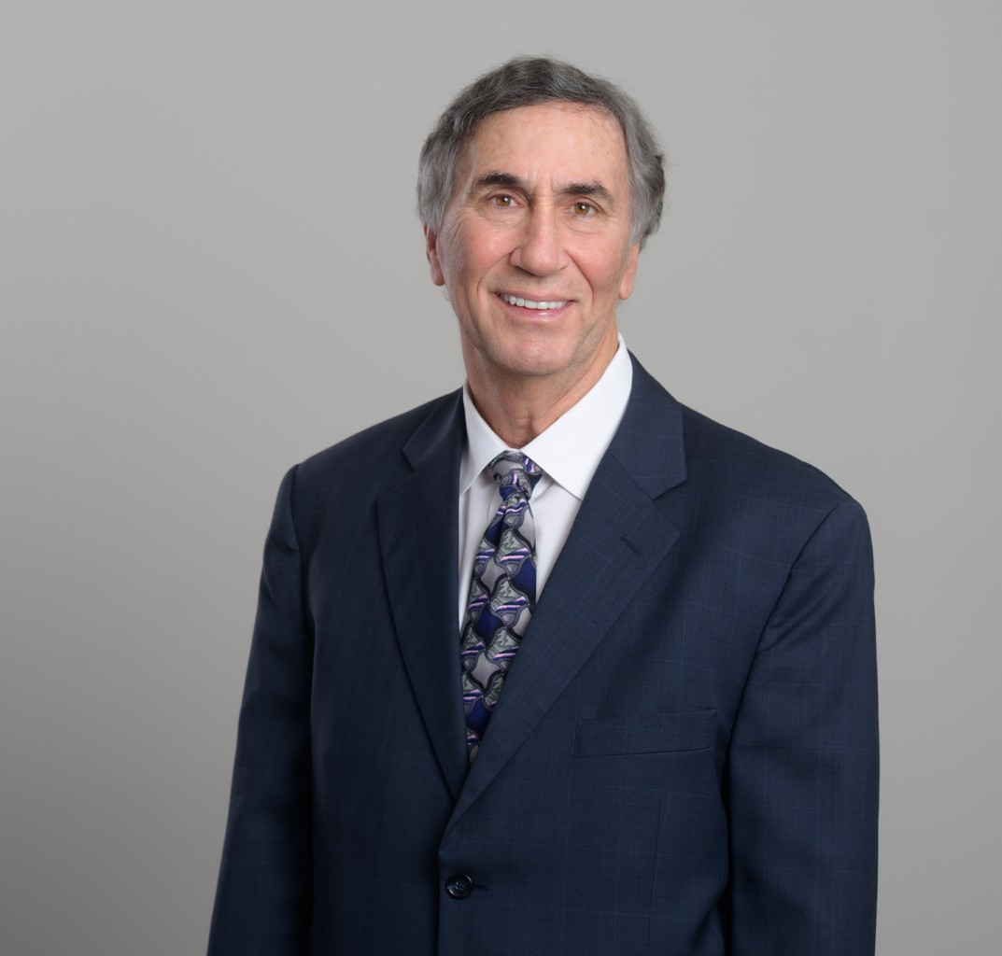

GARY B. RUDOLPH

Director

[Financial Restructuring](https://www.fennemorelaw.com/services/financial-restructuring-bankruptcy-creditors-rights/)

[San Diego](https://www.fennemorelaw.com/contact-us/san-diego/)

P: 619.595.3225

F: 619.231.4372

[grudolph@fennemorelaw.com](mailto:grudolph@fennemorelaw.com)

# GARY B. RUDOLPH

Gary B. Rudolph, active in bankruptcy and insolvency law, provides comprehensive financial analysis and personalized debt relief strategies. He works with trustees, creditors, creditor

committees, landlords, tenants, and debtors in corporate chapter 11 and 7 bankruptcies, alongside handling related litigation and representing state and federal court receivers.

Recognized for his mediation skills, Gary was honored as the outstanding mediator by the Southern District of California’s Bankruptcy Court Judges in 1991 and in 2019 he was honored for his volunteer service in the bankruptcy community by the Judges of the United States Bankruptcy Court, Southern District of California. He also brings experience as a bankruptcy examiner and expert witness in bankruptcy matters.

Beyond his practice, Gary is involved with the Business Law Section of the California Lawyers Association, having held leadership roles including secretary and chairing the Insolvency Law Committee. He is the past Chair of the Bankruptcy Law section of the San Diego County Bar

Association and is the Co-Chair of the National Rules Committee for the National Association of Bankruptcy Trustees and its local ambassador. He is also secretary for the California Receiver’s

Forum. This involvement underscores his commitment to the broader legal and financial realms.

# EDUCATION

J.D., California Western School of Law M.S., American University

B.S., American University

# AREAS OF PRACTICE

Financial Restructuring Business & Finance

# AWARDS AND HONORS

Martindale-Hubbell’s AV® Preeminent™ Peer Review Rating

AV Preeminent Attorney – Judicial Edition, Martindale Hubbell, 2025

Best Lawyers in America® – Bankruptcy and Creditor Debtor Rights/Insolvency and Reorganization Law

West Coast’s Top Rated Lawyers

Top Rated Southern California Lawyer by Martindale‐Hubbell and American Lawyer Media Top San Diego Lawyer, San Diego Magazine, 2016-2023, 2025

Top Lawyer in San Diego by The American Registry Top Lawyer in California by The Legal Network

“Best of the Best” by The Legal Network

# ARTICLES AND PRESENTATION

Co-Author, “[ILC Judicial Profile – Meet New Bankruptcy Judge J. Barrett Marum, U.S.](https://calawyers.org/business-law/ilc-judicial-profile-meet-new-bankruptcy-judge-j-barrett-marum-u-s-bankruptcy-judge-southern-district-of-california/) [Bankruptcy Judge, Southern District of California](https://calawyers.org/business-law/ilc-judicial-profile-meet-new-bankruptcy-judge-j-barrett-marum-u-s-bankruptcy-judge-southern-district-of-california/),” California Lawyers Association, July 2025

Author, “[In re Village Oaks Senior Care LLC](https://calawyers.org/business-law/in-re-village-oaks-senior-care-llc/),” California Lawyers Association, March 2025

Presenter, ” “Subchapter V Updates and the abc’s of ABCs,” San Diego Bankruptcy Forum, May 23, 2023

Presenter, “What You Need to Know About the Small Business Reorganization Act.” National Association of Credit Management (NACM), January 25, 2023

Presenter, “Subchapter V Turns Two: Recent Developments in SBRA Case Law,” National Association of Bankruptcy Trustees (NABT) 40th Annual Conference, June 9, 2023

Presenter, “Bankruptcy — From a 60,000 Foot View,” Legal Professionals Inc. (LPI), April 7, 2022

Presenter, “State of the Bankruptcy Court: Perspectives from Clerks of the Court,” San Diego County Bar Association, November 2, 2021

Presenter, “Litigation Funding in Bankruptcy Cases: How to Get it & Potential Pitfalls (Help Me Legalist, You’re My Only Hope),” California Lawyers Association, October 21, 2021

# PROFESSIONAL AND COMMUNITY ACTIVITIES

National Association of Bankruptcy Trustees

Legal Education Committee of the Federal Bar Association

Executive Committee of the Business Law Section (BLS) of the California Lawyers Association Insolvency Law Committee (ILC) of the BLS

San Diego County Bar Association’s Bankruptcy Law Section Member, Board of Directors of the San Diego Bankruptcy Forum Board Member, California Bankruptcy Forum

2023 Conference Chair, California Bankruptcy Forum

Advisory Committee, Local Rules of the United States Bankruptcy Court, Southern District of California

Ninth Circuit Lawyer Representative Selection Committee, Southern District of California

Advisory Panel, Bankruptcy Self-Help Center – Bankruptcy Court through the Legal Aid Society of San Diego

# ADMISSIONS

California

U.S. District Court, Northern District of California

U.S. District Court, Eastern District of California

U.S. District Court, Central District of California

U.S. District Court, Southern District of California Ninth Circuit Court of Appeals