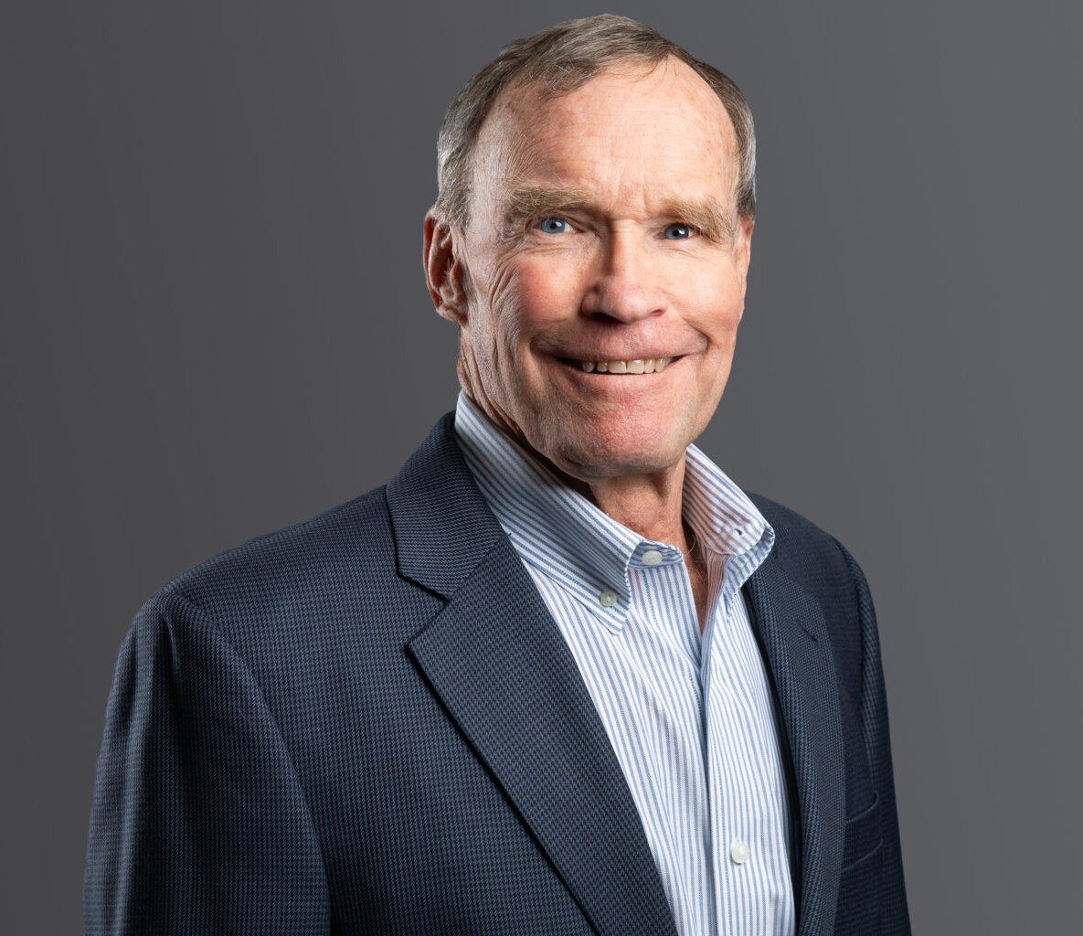

J. DAVID ARKELL

Of Counsel

[Construction Law](https://www.fennemorelaw.com/services/construction-law/)

[Denver](https://www.fennemorelaw.com/contact-us/denver-2/)

P: 303.813.3803

F: 303.291.3201

[darkell@fennemorelaw.com](mailto:darkell@fennemorelaw.com)

# J. DAVID ARKELL

David’s areas of practice include alternative dispute resolution and construction law. He arbitrates and mediates construction disputes as a trained and experienced neutral decision maker or facilitator. He advises owners and developers, general contractors, subcontractors, partnerships (public and private), suppliers and sureties on planning and dispute avoidance, as well as dispute resolution through negotiation, mediation, arbitration, and litigation. He drafts and negotiates construction contracts and other documents for both private and public construction projects.

David has arbitrated and mediated many construction disputes as a neutral for more than 30 years; claims have included:

* Contract interpretation · Lost productivity
* Breach of contract · Indemnity
* Construction and design defects · Changes
* Professional negligence · Differing site conditions
* Delays · Mechanics’ liens
* Damages · Surety and insurance issues

He is a member of the American Arbitration Association National Regular and Large and

Complex Arbitration panels and the American Arbitration Association’s Colorado Mediation

Panel. He also serves as a neutral mediator and arbitrator in “private” engagements. The size of disputes arbitrated and mediated has ranged from tens of thousands to tens of millions of

dollars.

# EDUCATION

J.D., University of Colorado

*Colorado Law Review*

B.A., Claremont McKenna College

# AREAS OF PRACTICE

Construction Law Advanced Energy

# REPRESENTATIVE MATTERS

## ARBITRATION, MEDIATION, AND CONSTRUCTION LITIGATION

David has more than 40 years’ experience helping construction clients resolve disputes through litigation, arbitration, and mediation. David’s experience includes representation of:

A public-entity owner of two major hospital projects in connection with disputes between the owner and the architect; issues included design defects, the standard of care, contractual interpretation and damages.

The public-entity owner of a significant power plant conversion project where issues included design defects and other defective performance by an engineer, bankruptcy in France of a major supplier, delays and inefficiency analysis, damages, and negotiation of contract

documents.

A private owner of a power generation facility in disputes with the general contractor; issues included delays, defective performance, damages, and contract interpretation.

A municipality in disputes with a general contractor on a highway project where issues included delays and inefficiencies, differing site conditions, defective performance,

damages, and contract interpretation.

A painting contractor in disputes with the owner of two large apartment complexes; issues included the statute of limitations and other procedural questions, technical analysis of coatings and other expert analysis, contract interpretation, and the measure of damages.

A major heavy-highway and paving contractor in disputes arising from the construction of runways at Denver International Airport; issues included compliance with specifications,

contract interpretation, technical materials testing disputes, damages, and alleged falsification of concrete test results.

A surety which took over a project upon default of the principal; issues involved the priority of different types of claims against contract balance, the propriety of payments under the

payment bond, and subrogation.

Two subcontractors in disputes arising from the construction of privately owned structures on a publicly owned property where issues included the validity, extent, and value of mechanics’

liens, performance and breach of contract, and the measure of damages.

The operator of an oil well in a dispute with a working interest owner arising from the original mislocation of the well; issues included validity and accuracy of the original government

survey, the effect of a government resurvey, interpretation of a joint operating agreement, and existence and measure of damages.

A mining engineering firm in disputes involving several Colorado gold mines; issues included mechanics’ liens, contract interpretation and performance, and damages.

A subcontractor in connection with a road project linked to the Mike O’Callaghan/Pat Tillman bridge below Hoover Dam in Arizona and Nevada; issues included differing site conditions, performance and interpretation of the contract, and entitlement to and the measure of

damages.

David also counsels contractors, subcontractors, suppliers, owners, and sureties in all aspects of the construction process from bidding and contract issues through performance and resolution of disputes.

## CONSTRUCTION CONTRACTS

David drafts and negotiates contracts for various entities involved in construction projects around the nation. Representative matters include:

Prepared a full suite of standard construction contract documents for a major sporting goods retailer for construction projects in all 50 states.

Drafted and negotiated a design-build general contract, including allocation of risk arising from known expansive soils, for the developer of a major condominium project in Colorado.

Represented a major regional hospital in connection with contracts for a large expansion program.

Provided pro bono representation of a private school in Denver in connection with drafting and negotiating a general contract for demolition and construction of several buildings.

## SPECIAL ENGAGEMENTS

Because of his extensive experience in construction contracts and disputes, David is from time to time called upon to serve in unique roles related to construction litigation. Special engagements include:

Engaged as an expert witness on attorneys’ fees and mechanics’ lien issues.

Appointed by District Court as a Special Master on disputes arising from a failed golf course project; issues included entitlement to and amount of mechanics’ liens and damages.

Appointed by the U.S. District Court as an Umpire in disputes between insurers and insureds over amounts of payments properly due.

# AWARDS AND HONORS

5280 Magazine, Top Construction Lawyer, 2015-2023

*Best Lawyers*®, Construction Law, 2007-2026

*Best Lawyers*®, Litigation, 2007-2026 *Best Lawyers*®, Arbitration, 2023-2026 *Best Lawyers*®, Mediation, 2023-2026

*Best Lawyers*® Lawyer of the Year, Construction Law Denver, 2012 and 2018

*Best Lawyers*® Lawyer of the Year, Litigation-Construction Denver, 2015 Colorado Super Lawyer®, Construction – Litigation, 2006-2010

Colorado Super Lawyer®, Construction – Litigation, 2012 – 2019

Colorado Super Lawyer®, Alternative Dispute Resolution, 2020-2025 Chambers USA, Construction Law – Colorado, 2005-2014 Chambers USA, Construction Law – Colorado, 2017-2024

# ARTICLES AND PRESENTATIONS

Author, “5 Critical Clauses Contractors Should Know,” *Construction Business Owner*, February 2024

Author, “The Lowdown of Significant Risk-Allocation Clauses,” *Construction Business Owner*, January 2024

Author, “Part 2: Allocation of Construction Risks Through Contract Clauses,” *Colorado Real Estate Journal*, November 2023

Author, “Part 1: Allocation of Construction Risks Through Contract Clauses,” *Colorado Real Estate Journal*, October 2023

Author, “Uncertainty in Arbitration Agreements for Contractors,” ENR, October 2016

David has presented numerous seminars on construction law topics for clients, construction trade groups, and related construction organizations. Topics include delays, damages, differing site conditions, contract clauses, mechanics’ liens, bonds, inefficiencies, construction and design defects, scheduling, bid protests, and dispute resolution procedures.

# PROFESSIONAL AND COMMUNITY AFFILIATIONS

American Arbitration Association National Construction Industry Arbitration Panels for Regular and Large and Complex Cases; Construction Industry Mediation Panel

Forum on the Construction Industry, American Bar Association

Board Member, Legislative Committee Member, Associates Council Past Chair, and Legal Advisory Committee Past Chair, Associated General Contractors of Colorado

Chair Construction Law Section and Alternative Dispute Resolution Section Member, Colorado Bar Association

Chair Alternative Dispute Resolution Section and Construction Law Section Member, Denver Bar Association

# ADMISSIONS

Colorado

U.S. Court of Appeals for the Tenth Circuit

U.S. District Court, District of Colorado

U.S. District Court, District of Nevada, pro hac vice

U.S. District Court, District of Utah, pro hac vice

U.S. District Court, District of Wyoming, pro hac vice