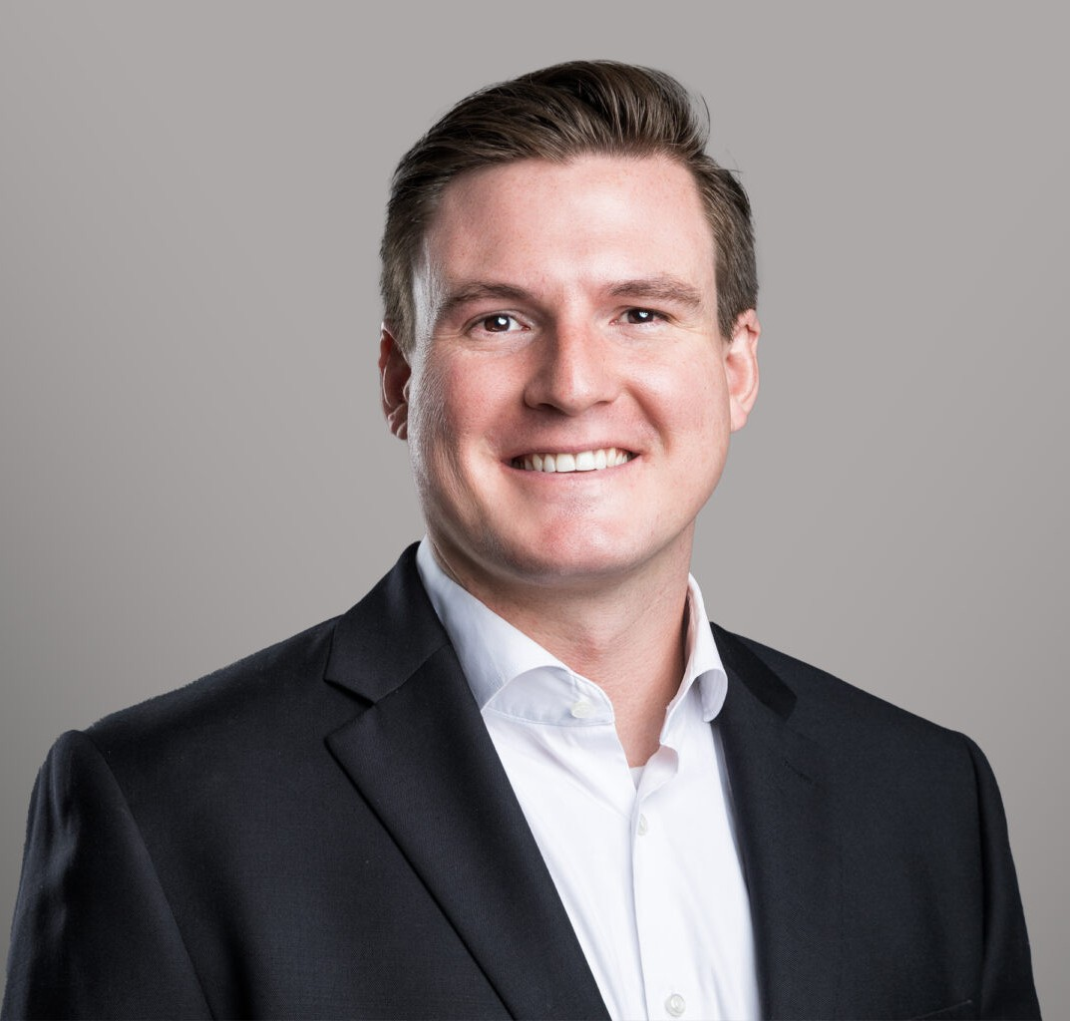

JAMES C. GOLDEN

Associate

[Business Litigation](https://www.fennemorelaw.com/services/business-litigation/)

[Phoenix](https://www.fennemorelaw.com/contact-us/phoenix/)

P: 602.916.5346 F: 602.916.5999

[jgolden@fennemorelaw.com](mailto:jgolden@fennemorelaw.com)

## JAMES C. GOLDEN

James C. Golden is an experienced litigator in Fennemore’s Phoenix office, helping people and companies navigate commercial litigation matters, probate, trust, and estate disputes, construction claims, partnership disputes, and various other civil litigation matters. James understands the financial and emotional toll of litigation and focuses on solving problems for his clients while aggressively pursuing their strategic and litigation goals. From initial pleadings, to motion practice, to trial, mediation, or arbitration, James is highly skilled in every phase of

litigation.

Prior to joining Fennemore, James worked as a litigation attorney at a mid-sized Arizona firm specializing in commercial, construction, and estate litigation matters. There, he directly managed and acted as first-chair litigator on numerous matters from the outset to arbitration or settlement, recovering millions for his clients.

He earned his law degree from Arizona State University, Sandra Day O’Connor College of Law, where he was a member of the Jurimetrics Law Journal, Post-Conviction Relief Clinic, and the Homeless Law Assistance Project.

Outside of the office, James loves traveling, cooking, appreciating the great outdoors by birding and rockhounding, and learning about history.

## EDUCATION

J.D., Arizona State University, Sandra Day O’Connor College of Law Jurimetrics Law Journal

Post-Conviction Relief Clinic

Homeless Law Associate Assistance Project B.A., Tufts University

**AREAS OF PRACTICE**

# OTHER EXPERIENCE

Civil Litigation

Commercial Litigation Business Litigation

Trusts & Estates

## REPRESENTATIVE MATTERS

Recovered over $700,000 on behalf of a civil contractor in arbitration against the City of Scottsdale.

Defeated a multi-million dollar undue influence claim following an evidentiary hearing in Mojave County.

Procured a full reversal from the Arizona Court of Appeals regarding the trial court’s grant of summary judgment on breach of contract, breach of the implied covenant of good faith and fair dealing, and nuisance claims.

As a Rule 38 Limited Practice Attorney, second-chaired a fraud case representing the defendant, resulting in defense verdicts as to 11 of 21 plaintiffs.

Settled numerous cases on favorable terms for his clients, recovering more than $3 million through negotiated settlements.

## AWARDS AND HONORS

*Best Lawyers: Ones to Watch®in America:* Commercial Litigation, Construction Litigation, Trusts and Estates Litigation, 2024 – 2025

Phoenix Magazine, *Top Lawyer*, 2024

## ARTICLES AND PRESENTATIONS

Presenter, “Legal Strategies for Managing Cost Escalation and Force Majeure Issues,” American Subcontractors Association of Arizona, January 2025

Chair, “Tips and Tricks for Getting the Upper Hand in Construction Arbitrations,” Arizona State Bar Construction Section, December 2024

Presenter, “Balancing Risk Through Smart Contracting in the Post-Covid Era,” Arizona Builders Alliance, February 2023

Author, “The Darkening Storm of Cyberterrorism: International Policy Adaptation for Automatic Cybersecurity Regulations,” 59 Jurimetrics J. 267, 2019

## PROFESSIONAL AND COMMUNITY ACTIVITIES

State Bar of Arizona, Construction Section Executive Council, 2024-2025 Term, 2025-2026 Term American Bar Association, Construction Section, Member

Federal Bar Association, Member

State Bar of Arizona, Probate and Trust Section, Member Urban Land Institute, Member

## ADMISSIONS

Arizona

U.S. Federal District Court, District of Arizona

## LANGUAGES

French, Intermediate Mandarin, Basic