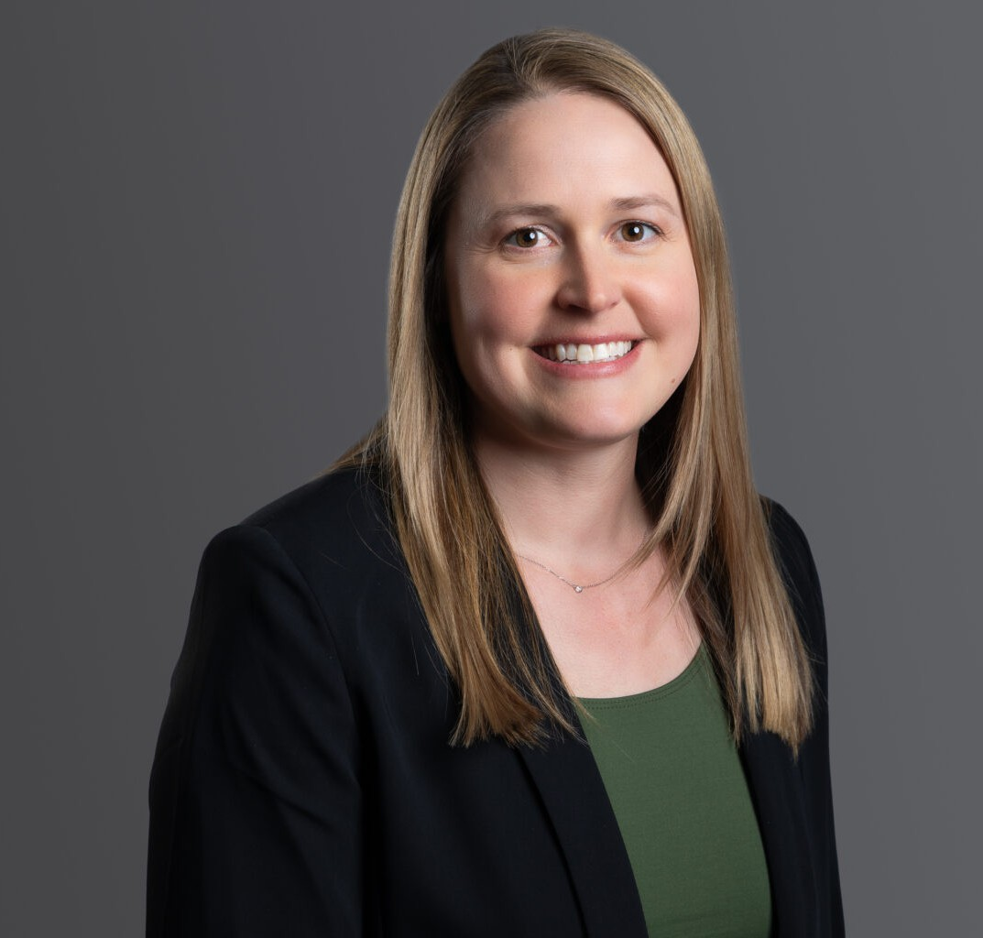

JENNIFER KNIGHT LANG

Of Counsel

[Business Litigation](https://www.fennemorelaw.com/services/business-litigation/)

[Denver](https://www.fennemorelaw.com/contact-us/denver-2/)

P: 303.813.3835

F: 303.291.3201

[jlang@fennemorelaw.com](mailto:jlang@fennemorelaw.com)

# JENNIFER KNIGHT LANG

Jennifer is a skilled litigator focusing on construction and real estate matters. She combines her knowledge of the real estate and construction industries to provide comprehensive representation for matters including contract rights and remedies, nonpayment actions, delay claims, lien and bond claims, and property rights issues. She works closely with her clients as a counselor and advisor to help navigate risk in contentious situations. She has experience litigating complex construction matters involving single and multifamily residential as well as commercial and industrial developments. Jennifer focuses on understanding your business and goals to aggressively advocate for you toward resolving disputes, whether in or out of the courtroom.

Prior to joining Fennemore, Jennifer worked for a boutique law firm focusing on the construction industry and the Denver office of a national firm, where she defended corporate clients on various civil litigation matters. Jennifer clerked for the Honorable Judge John Dailey of the

Colorado Court of Appeals.

Outside work, Jennifer enjoys skiing and hiking across Colorado and Wyoming, playing ice hockey, visiting family along the New England coast, and spending time with her husband, children, and border collie.

# EDUCATION

J.D., University of Colorado Law School

M.P.S., University of Denver, University College B.A., University of Denver

# AREAS OF PRACTICE

Business Litigation Construction Law

# AWARDS AND HONORS

*Best Lawyers in America®,* Ones to Watch, Construction Law, and Insurance Law, 2023, Commercial Litigation, 2023, 2026, Litigation – Construction, Litigation – Real Estate, 2023-2026

Colorado Super Lawyers® Rising Star, Construction Litigation, 2024-2025 Colorado Super Lawyers® Rising Star, Business Litigation, 2023

# ARTICLES AND PRESENTATIONS

Author, “Filing a Mechanic’s Lien: Understanding the Process,” *Mile High CRE*, September 2023 Co-Author, “Mechanic’s Lien Checklist (CO),” *LexisNexis | Practical Guidance*, March 2022

Co-Author, “Disappearing Data: Avoid Losing Electronic Information to Avoid Losing the Case,” *Construction Executive*, January 2022

Co-Presenter, “Commonly Litigated Site Civil Engineering Related Construction Defects,” CBA- CLE, February 2021

# PROFESSIONAL AND COMMUNITY AFFILIATIONS

American Bar Association Colorado Bar Association

Colorado Women’s Bar Association Denver Bar Association

Advisory Board Member, The Numbers Holding Company

Downtown Denver Leadership Program 2024 graduate, Downtown Denver Partnership

# ADMISSIONS

Colorado

United States District Court, District of Colorado United States Court of Appeals for the Tenth Circuit