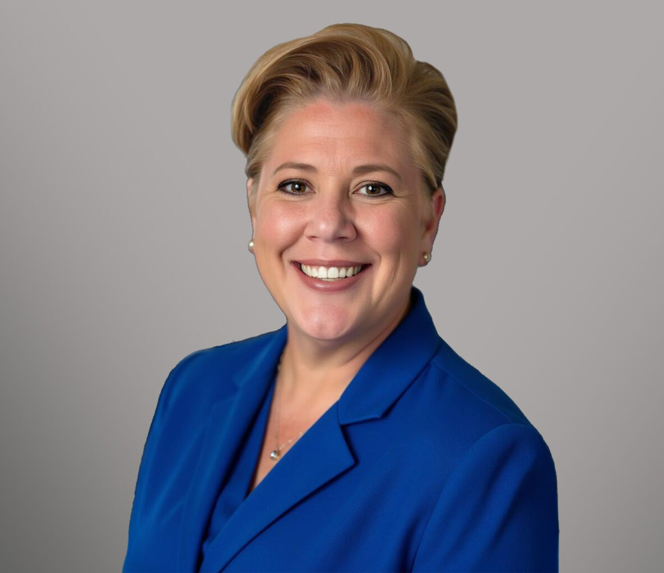

KELLY BLACK

Director

[Land Use](https://www.fennemorelaw.com/services/land-use/)

[San Diego](https://www.fennemorelaw.com/contact-us/san-diego/)

P: 619.595.3243 F: 619.231.4372

[kblack@fennemorelaw.com](mailto:kblack@fennemorelaw.com)

# KELLY BLACK

Kelly Black is a Director in Fennemore’s [Land Use](https://www.fennemorelaw.com/services/land-use/) group. Her practice focuses primarily on land use, entitlement, and environmental regulatory issues for residential and commercial

development projects in Southern California.

Kelly has extensive experience managing land use, entitlement, environmental, and

development matters. She frequently collaborates with landowners, developers, homebuilders, resource agencies and government agencies — including the Army Corps of Engineers, California Department of Fish and Wildlife, United States Department of Fish and Wildlife and Caltrans—on regulatory permitting, real estate transactions, conservation mitigation measures and agreements and access agreements. She regularly advises clients on all aspects of the California Environmental Quality Act (CEQA), including the preparation and review of environmental documents, mitigation and monitoring programs, project-specific agreements and minimizing litigation exposure and risks. She is especially well-versed in the Western Riverside Multiple Species Habitat Conservation Plan (MSHCP), where she has represented private

developers, both commercial and residential, on issues with MSHCP compliance and conservation.

She has served on teams providing outside General Counsel advice to agencies such as the Sanitation Districts of Los Angeles County, the Chino Basin Watermaster (Non-Agricultural Pool), and the San Gabriel Valley Mosquito and Vector Control District. Kelly’s work includes drafting staff reports, resolutions, and CEQA findings, and advising on permitting and compliance matters tied to Habitat Conservation Plan (HCP) requirements.

Her legal counsel extends to Native American consultation and cultural resource preservation under Section 106 of the National Historic Preservation Act, California Senate Bill “SB” 18, and California Assembly Bill “AB” 52. Kelly frequently participates in discussions with tribal representatives and has worked extensively on developing mitigation measures, cultural mitigation and monitoring agreements, cultural resource preservation agreements, and other measures to allow for the development of property and the preservation of important historical and archaeological resources.

In addition to her practice, Kelly previously served as an adjunct professor at the University of San Diego School of Law and has presented on land use and CEQA topics through the environmental leadership program at California State University, San Marcos. She has also served

on the board of directors of Kids Included Together and the Rivers and Lands Conservancy, and she remains active in the local legal and civic community.

# EDUCATION

J.D., University of San Diego School of Law

B.A., Washington University, St. Louis, *cum laude*

# AREAS OF PRACTICE

Land Use

Government Relations & Regulatory Real Estate

# REPRESENTATIVE MATTERS

Led the team on entitlement of a 2,200 Acre Master Planned Community in the City of Coachella, California

Negotiated entitlements and CEQA mitigation and monitoring measures for a 972-acre specific plan in the City of Murrieta, California

Negotiated a Cultural Resources Management Plan, Tribal Mitigation and Monitoring

Agreement, and other measures for a specific plan project in the City of Temecula, California.

Successfully entitled over 4 million square feet of industrial and warehouse uses across multiple projects in the Town of Apple Valley, California.

Negotiated a biological conservation easement that included tribal resource preservation measures for a residential project in the City of Murieta, California

# PROFESSIONAL AND COMMUNITY ACTIVITIES

Member, California Bar Association

Past Board President, Kids Included Together

Past Member, Community Advisory Board, Safe Alternatives for Everyone Past Member, Board of Directors, Riverside Land Conservancy

# ADMISSIONS

California

# LANGUAGES

Spanish, Conversational French, Conversational