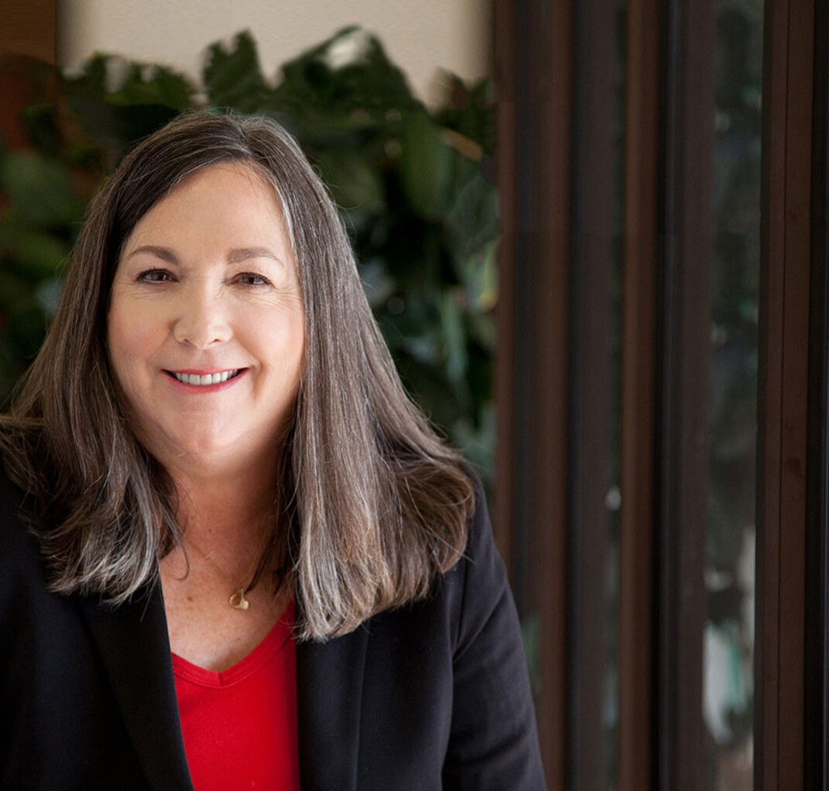

KIMBERLY A. ARANA

Director

[Business & Finance](https://www.fennemorelaw.com/services/business-and-finance/)

[Nogales](https://www.fennemorelaw.com/contact-us/nogales/)

P: 520.281.3481

F: 520.281.3495

[karana@fennemorelaw.com](mailto:karana@fennemorelaw.com)

**KIMBERLY A. ARANA**

Kim Arana’s practice focuses on agricultural, international, and corporate law. She is the Chair of our Agribusiness Industry Group and completed a five-year term as a member of our

Management Committee. This seasoned business attorney especially enjoys the opportunity to help her clients with cross-border business transactions and business dealings in the U.S. and in Mexico. Kim also counsels businesses involved in the growing and distribution of perishable agricultural commodities and in manufacturing and maquiladora (twin plant) operations.

Kim has been a resident of Nogales since 1982 when she moved to the area to join her husband. She quickly became a part of the fabric of the community, especially the business community, after joining us in 1999. Fluent in Spanish, this business attorney regularly works in conjunction with Mexican counsel to prepare agreements for international commercial transactions, including secured transactions. In addition to her background negotiating cross-border deals, this Arizona business lawyer is also an expert negotiator who balances the Sun Devils-Wildcats rivalry under one roof; having earned her Bachelor of Arts degree in Spanish, *magna cum laude*, from

Arizona State University, followed by a Juris Doctor degree from the University of Arizona’s James

E. Rogers College of Law.

Outside of work, Kim enjoys spending ample time with her five children and grandchildren. She uses her weekends to focus on cooking and being active by golfing, biking, playing tennis, and hiking.

## EDUCATION

J.D., University of Arizona, James E. Rogers College of Law B.A., Spanish, Arizona State University, *magna cum laude*

Phi Beta Kappa

**AREAS OF PRACTICE**

# OTHER EXPERIENCE

International

Business & Finance Real Estate Agribusiness

## AWARDS AND HONORS

*Best Lawyers in America®,* International Trade and Finance Law, 2010-2026

AV® Preeminent™ Peer Review Rated (the highest rating available), by Martindale-Hubbell

## ARTICLES AND PRESENTATIONS

Interview, “[A conversation with Kim Arana about Fennemore’s cross-border agribusiness](https://www.fennemorelaw.com/a-conversation-with-kim-arana-about-fennemores-cross-border-agribusiness-practice/) [practice](https://www.fennemorelaw.com/a-conversation-with-kim-arana-about-fennemores-cross-border-agribusiness-practice/),” Fennemore Blog, March 28, 2024

[Interview, “At the Crossroads of International Trade Between the United States and Mexico,”](https://www.fennemorelaw.com/insights/blogs/2021/at-the-crossroads-of-international-trade-between-the-united-states-and-mexico) [Fennemore Blog, March 25, 2021](https://www.fennemorelaw.com/insights/blogs/2021/at-the-crossroads-of-international-trade-between-the-united-states-and-mexico)

[Quoted, “Let’s Celebrate Random Acts of Kindness Day,” Fennemore Blog, February 18, 2021](https://www.fennemorelaw.com/insights/blogs/2021/let-s-celebrate-random-acts-of-kindness-day)

[Author, “New Tomato Suspension Agreement Signed,” Fennemore Client Alert, October 16,](https://www.fennemorelaw.com/insights/newsletters/2019/new-tomato-suspension-agreement-signed) [2019](https://www.fennemorelaw.com/insights/newsletters/2019/new-tomato-suspension-agreement-signed)

## PROFESSIONAL AND COMMUNITY ACTIVITIES

Member, State Bar of Arizona

Member, Santa Cruz County Bar Association

Member, Law Student Division, American Bar Association

## ADMISSIONS

Arizona

U.S. District Court, District of Arizona

U.S. Court of Appeals, Ninth Circuit

U.S. Supreme Court

U.S. Tax Court

## LANGUAGES

Spanish, Fluent