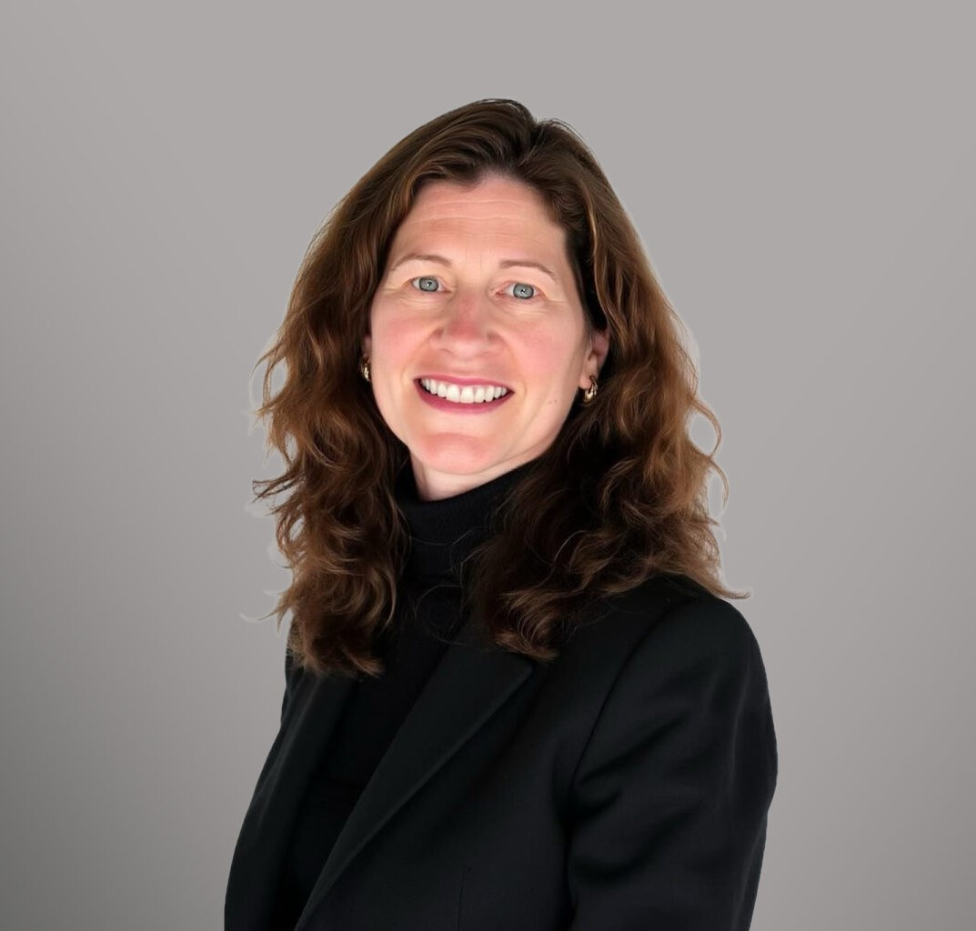

MELISSA OOSTMEYER

Director

[Business & Finance](https://www.fennemorelaw.com/services/business-and-finance/)

[Denver](https://www.fennemorelaw.com/contact-us/denver-2/)

P: 303.764.3706

F: 303.291.3201

[moostmeyer@fennemorelaw.com](mailto:moostmeyer@fennemorelaw.com)

# MELISSA OOSTMEYER

Melissa Oostmeyer is a Director in Fennemore’s [Business & Finance](https://www.fennemorelaw.com/services/business-and-finance/) practice group. She has worked on a wide variety of commercial transactions and has extensive in-house counsel

experience. Melissa is a dedicated business partner, who understands her clients’ needs and provides practical solutions to their complex legal problems

Melissa has over 25 years of experience working as a business transactions attorney where she drafted and negotiated a wide variety of commercial contracts including merger and

acquisition, commercial real estate purchase, commercial real estate development, supply,

distribution, master services, and construction agreements. Her experience also includes working with franchisors, including the preparation of franchise agreements and franchise disclosure

documents. Melissa has also successfully applied for and obtained tax abatements and government grants for a commercial manufacturing development project. Prior to joining Fennemore, she performed in-house general counsel work for the U.S. division of a medical delivery device manufacturer and a commercial roofing company. Melissa also served as a Senior Counsel at a Fortune 500 Oil and Gas Company and Director and Senior Commercial Counsel for a Fortune 500 Building Materials Company.

Melissa earned her law degree at the University of Detroit Mercy School of Law. She earned her

M.B.A. at Eastern Michigan University, a B.A. at Spring Arbor College, and an international studies certificate while working as a goodwill ambassador in Japan for the State of Michigan as part of a Sister Cities International program.

In her free time, Melissa enjoys traveling, skiing, hiking, biking, running, reading, and volunteering with people with disabilities.

# EDUCATION

J.D., University of Detroit Mercy School of Law M.B.A., Eastern Michigan University

B.A., Spring Arbor College

Certificate of International Studies, Kyoto English Center/Lansing Community College

# AREAS OF PRACTICE

Business & Finance Mergers & Acquisitions Real Estate

General Counsel Services

# ADMISSIONS

Colorado Michigan Ohio