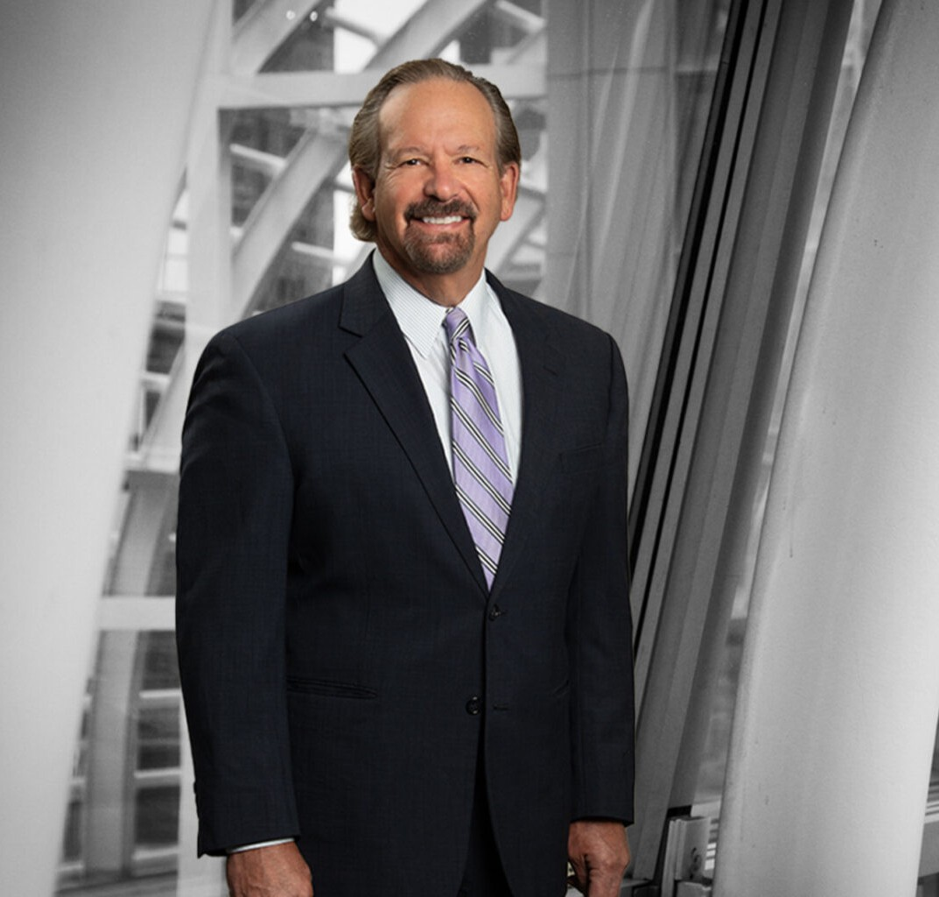

ROBERT D. COMER

Of Counsel

[Natural Resources](https://www.fennemorelaw.com/services/natural-resources-energy-and-environmental/)

[Denver](https://www.fennemorelaw.com/contact-us/denver-2/)

P: 303.764.3708

F: 303.291.3201

[rcomer@fennemorelaw.com](mailto:rcomer@fennemorelaw.com)

**ROBERT D. COMER**

Bob Comer is an Of Counsel Attorney in the firm’s Natural Resources, Energy and the Environment practice group and is resident in the Denver office. His natural resource and environmental practice focuses on mining, oil, gas, renewables, water, and energy

development on federal, tribal, state and private lands. Bob has particular expertise in public land management and sensitive resource protection involving endangered species, wetlands, cultural resources and Native American law.

During his distinguished career, Bob has held senior leadership positions with businesses and the federal government, and is well known for his ability to design and implement effective legal and practical solutions to overcome project permitting and compliance challenges. During his tenure with the US Department of the Interior, Bob served as Associate Solicitor (now the Deputy Solicitor position) in Washington, D.C., where he directed legal strategy nationwide on matters pertaining to mining, oil, gas, energy, renewables, land use and water. As Rocky Mountain Regional Solicitor, he led one of the most active NEPA and energy and litigation portfolios in the Department. Bob also has served as General Counsel and Chief Administrative Officer for a dual-listed gold company and as Associate General Counsel for a Fortune 500 mining, mineral processing and specialty metals company, where he had legal responsibility at most operating units, and more than 30 superfund/NRD properties.

Bob also is a leading authority in natural resource permitting, compliance, mining law and mineral leasing. He has testified before the U.S. Congress on the Mining Law, prepared the first North American Justified Deviation under the Equator Principles (version 4) and has advanced numerous resource projects. Bob counsels industry and government executives on a wide array of sensitive resource issues involving the Equator Principles, tribal and native American concerns, cultural resources, energy transmission, public land access, federal land exchanges, rights of

way, wilderness, endangered species, water quality and rights, wetlands, mineral leasing, title security, royalties, superfund, toxics, environmental and land use compliance, enforcement,

litigation, and NEPA, permitting and government relations strategies.

From the days when he served as in-house counsel, Bob has enjoyed working with Fennemore– and is now excited to be a part of our firm’s natural resources team at this critical time for sustainable development in the American west.

## EDUCATION

J.D., University of Colorado School of Law

M.F.S., Natural Resource Management and Ecology, Yale University

B.A., Environmental Biology and Conservation, University of Colorado, Boulder, *cum laude*

**AREAS OF PRACTICE**

# OTHER EXPERIENCE

Oil, Gas and Pipelines Native American Law Sensitive Resources Environmental Natural Resources

## AWARDS AND HONORS

*Best Lawyers in America®,* Mining Law, Natural Resources Law, 2024-2026 500 Leading U.S. Environmental Lawyers, Lawdragon, 2021, 2023 and 2025

Legal 500 USA, Recommended Lawyer, Industry focus – Energy Litigation: Oil and Gas, 2016, 2018-2019, 2021

Legal 500 USA, Recommended Lawyer, Industry focus – Energy Regulation: Conventional Power, 2021

Legal 500 USA, Recommended Lawyer, Industry focus – Energy Regulatory: Oil and Gas, 2018 Who’s Who in Energy – Denver, The Business Journals, 2016-2019

Environmental Achievement Award, EPA, 2000 Distinguished Service Award, Yale University, Class of 1980

Environmental Achievement Award, Thorne Ecological Institute, 1986

## ARTICLES AND PRESENTATIONS

Featured, “The 2023 Lawdragon 500 Leading Energy Lawyers,” Lawdragon, March 17, 2023

Featured, “The Lawdragon Green 500: Leaders in Environmental Law,” Lawdragon, February 3, 2023

## PROFESSIONAL AND COMMUNITY ACTIVITIES

Member, Colorado Bar Association, Natural Resources and Energy Law Section, Chair, 2014- 2015 and Vice-Chair, 2013-2014

American Exploration & Mining Association, President (2018) and Board of Trustees, 2013- present

Board of Advisors, Western Energy Alliance, 2013-present

American Bar Association, Former Chair, Mining, Public Lands and Resources, and Water Quality and Wetlands Committees; Former Vice-Chair, Endangered Species and Annual Program Committees

Colorado Mining Association, Former Director and Officer

Advisory Board, University of Colorado, Energy Innovation Initiative, 2011-present

Board of Directors, Colorado Association of Manufacturing and Technology, 2012-present

Editorial Board, American Bar Association, Natural Resources and Environment Journal, 1991- 2001

University of Colorado, Law Review, 1985-1987

## ADMISSIONS

Colorado